Huron VB Club
Online Officiating
Due: March 20th (Turn final certificate into coach)
*This is a requirement from North Country Region and Huron VB Club.
Plan to get it done a week early. Younger players will need parental help.

Go to the following website: https://webpoint.usavolleyball.org/Welcome.wp
**Must enter PLAYER information.
**Must enter the “email” from the PARENT listed as parent 1 on the Huron VB Club registration.

- Request a login account. (Please contact Jen or Shelly if you have any issues.)

- STEP 1 – Login to Webpoint and select “Region Clinics” from the options on the left side of the screen
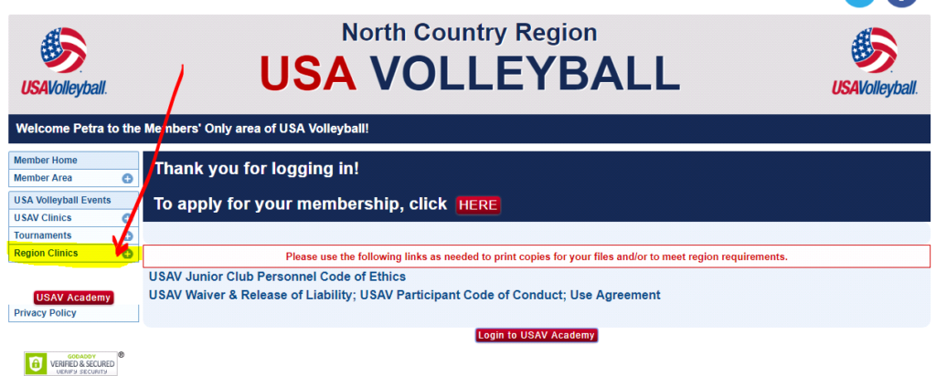

- STEP 2 – Select “Region Ref/Score clinics” and ensure the region is “North Country.”
  - Should state North Country up top as you see in the picture above.

- STEP 3 – Select the trainings based on your division:

  - 6th grade and younger (must register for 3 parts and can only register for 1 at a time)
    - Junior Player R2 training
      - Click the “+ Participant Registration”
      - Click Submit (red button on bottom of the screen)
      - Click Register (red button at the bottom of the screen)
      - Then go back to the “Region Ref/Score clinics” to register for the next one.
    - Junior Player Scorer training
      - Click the “+ Participant Registration”
      - Click Submit (red button on bottom of the screen)
      - Click Register (red button at the bottom of the screen)
      - Then go back to the “Region Ref/Score clinics” to register for the next one.
    - Junior Player Line Judge and Libero training
      - Click the “+ Participant Registration”
      - Click Submit (red button on bottom of the screen)
      - Click Register (red button at the bottom of the screen)

  - 7th grade and older (must register for 4 parts and can only register for 1 at a time)
    - Junior Player R1 training
      - Click the “+ Participant Registration”
      - Click Submit (red button on bottom of the screen)
      - Click Register (red button at the bottom of the screen)
      - Then go back to the “Region Ref/Score clinics” to register for the next one.
    - Junior Player R2 training
      - Click the “+ Participant Registration”
      - Click Submit (red button on bottom of the screen)
      - Click Register (red button at the bottom of the screen)
      - Then go back to the “Region Ref/Score clinics” to register for the next one.
    - Junior Player Scorer training
      - Click the “+ Participant Registration”
      - Click Submit (red button on bottom of the screen)
      - Click Register (red button at the bottom of the screen)
      - Then go back to the “Region Ref/Score clinics” to register for the last one.
    - Junior Player Line Judge and Libero training
      - Click the “+ Participant Registration”
      - Click Submit (red button on bottom of the screen)
      - Click Register (red button at the bottom of the screen)

  - Coaches
    - Junior Coach officiating training (do NOT select anything that starts with Paid Official)
      - Click the “+ Participant Registration”
      - Click Submit (red button on bottom of the screen)
      - Register (red button at the bottom of the screen)

    - In addition to your officiating, please do the following and register for your SafeSport Training.
      - On the far left, under USAV clinics go to USAV Coaching Clinics
      - Register for Safe Sport on Demand: Two Season Training (it is under Nov. 2107)
        - Click the “+ Participant Registration”
        - Register (red bottom at the bottom of the screen)

STEP 4 - Once you have registered for all the courses you need listed above. Click the RED USAV ACADEMY button on the far left and that will take you to your courses.

*You do not have to complete everything in one setting. However, make sure you write down your “login” that you were presented and password. You will need that to log in again.

*There is a help desk once you have gained access to the USAV Academy. For any issues once you’ve started the training courses please utilize this option.

STEP 5 – Print your certification. Hand in to your coach before the deadline.

