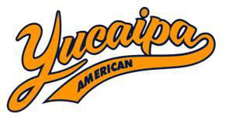
Dear Sponsor:
Yucaipa Valley American League (YVALL) invites you to participate in sponsoring the 2018 Baseball Season by supporting our Youth and promoting your Business.
Attached is the YVALL Sponsorship Form with 6 options to choose from. If you are able to support the YVALL league, please complete and send the Sponsorship Form along with your Company’s’ Donation and Business Card to YVALL. Mailing information is located on the bottom of page 2 for your convenience. All donations need to be received by February 21, 2018.
Thank you in advance for supporting Yucaipa Valley American Little League 2018 Season. The many YVALL Players and Families greatly appreciate your support.

Sincerely,
Beth Scott
Director of Sponsorship
Yucaipa Valley American League
(909) 213-4658

