Roll Call: Terry Johnson, Jay Stark, Adam Hoffman, Travis Steele, Jesse Viall, Tom Johnson, Sean McCabe, Bernadette Schaffer, Josh Colvin, Jaimie Schuster, Shannon Callahan, Erik Goettl, Shane Lanning, Josh Colvin
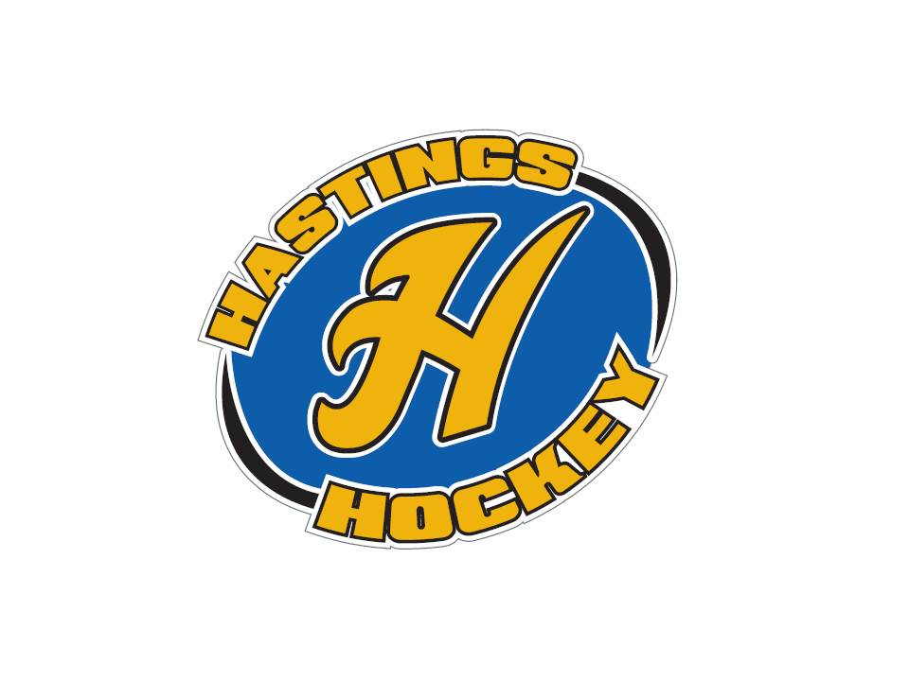

Not in attendance: John Klimek, Jason Stoffel, Randy Kruse, Jason Stoffel, Adam Welch

- Approval of Agenda Travis made the motion, Jay seconded the motion was passed
- Approval of Minutes Adam made the motion, Jesse seconded the motion was passed

Coordinator Reports
- Referee – John Klimek
- Registrar – Shannon Callahan nothing to report
- Technology – Jay Stark/Randy Kruse
- Tournament Director –
- Sponsorships – Erik Goettl nothing to report
- District 8 – Jay Stark
Auto ice – will talk in July about black out dates
Red Wing will be in D-8 possibly looking to coop with us???
Voted out Stickstats – going with SportNgin
July – Presidents meeting happening – it is a rule change year. Coaches meetings are mandatory this year.
Looking at adding a Squirt B2
Tabled the idea of no checking in the C level bantams, so it will stick around
High performance on lines – early August
HP teams play through October – so no tryouts while they are still playing
Looking for a place for C.E.P. clinics – possibly will host this
League dates – Bantam and peewee A and B, U12, U15 Nov 6 start dates and goes through February 12th Districts are February 19-26th
Squirts and C levels starts November 24 and goes through Feb 25th Playoffs March 5-11

- Goalie – Josh Colvin
Nothing new – numbers are always a concern. Squirts are a concern at this point
Missing a bag – it was here at the end of the season and is now missing – please return it ASAP
Little short on chest protectors and gloves for next year
Recruiting people – we have 8 people interested and will work on offering DIBS for these jobs
- Secretary – Bernadette Schaffer nothing to report

Officer Reports:
- President – Terry Johnson
Tuesday meeting with Moose to talk with Strauss and will meet with another vendor before the next meeting to discuss jersey options
- Vice President – Jay Stark
Working on the schedule with auto ice and they want it 1 month earlier this year. Coaches please remember that we can’t pay for tournaments until after July 1st.
PeeWee Regions is March 3,4 – so we need to decide if we hold the tournaments the week before or after
- Treasurer – Jaimie Schuster (Approval of the Financial Statements)
Jesse makes the motion to approve April and May financials, Adam seconds and the motion passed

Director Reports:
- Volunteers – Shannon Callahan
Parade – looking for volunteers to help DIBS are awarded – please email Terry
- Director of Hockey – Adam Welch not in attendance
- Operations – Adam Hoffman
Nothing to report
Let’s get people together to physically inventory everything so we know where to start next year
- In-House Girls – Shane Lanning
Basic recruiting will help with any kids of recruiting
- Travel Girls – Travis Steele
Nothing to report
- TerMites – Tom Johnson
Nothing to report
- Mighty/Super Mites – Jesse Viall
Will pass out flyers on the last day of T-Ball
- Squirts – Jason Stoffel not in attendance
- Peewees – Sean McCabe
Nothing to report
- Bantams/Jr. Gold/U16 – Don Huemoeller
On the verge of having a new director

Old Business:

New Business:
- Tournament coordinator
Erik Goettl is offering to do this position if he can now be a voting member. He is willing to not get the stipend. He will also continue with the sponsorships position. This will be tabled for a vote for the next month’s meeting
- Registration Advertising Coordinator
No interest in this position so it will be added to the recruitment position
- Head Coaching approvals
Girls Traveling Coaches - Jeff Hubbard Jim Zaccardi Ryan Scheifer
Sean made the motion, Jesse seconded the motion – motion was passed
Schauer - Travis made the motion and Jesse seconded – with 2 abstains votes motion was passed
Peewees – AA Blake Johnson, B2 Rick Navarro Motion was made Sean seconded by Travis – motion was passed
Bantam AA – Sean McCabe Motion made by Jesse seconded by Travis motion was passed
Junior Gold – Jason McCarville motion made by Travis, seconded by Adam – motion was passed
- Budget

Board Comment
Membership Comment
Adjournment

Next Meeting: July 9th, 2017

