******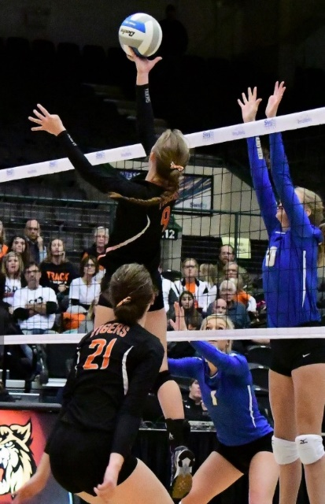**

***2018***

***Nordby Center***

***Winter Skills***

***Volleyball Academy***

***2018 Winter Skills Volleyball Academy Staff***

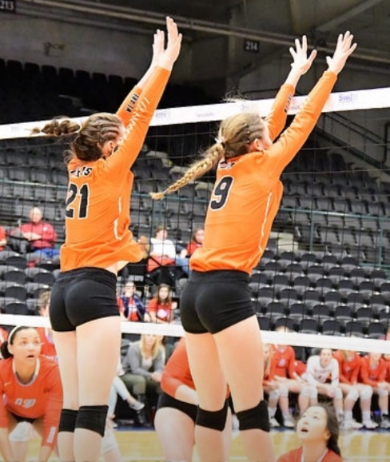

This VB Academy, in conjunction with Huron VB Club coaches, offers athletes the opportunity to achieve success on the volleyball court through training. We are striving to help the players gain the skills and confidence to bring their game to the next level.

The Winter Skills Academy sessions are similar to volleyball lessons. Training each week is designed with the intent of individual growth based on assessments of strengths and weaknesses. We will challenge the players to grow, learn and develop into stronger players. Unlike team practices and camps, we want to be able to spend time with each individual and player to identify strengths and weaknesses.

Our staff takes great pride in teaching the fundamentals and challenging the athletes to grow as a volleyball player. We think volleyball is more than just an experience.

**TyAnn Buddenhagen** – former Huron Tiger

Miss “AA” Volleyball 2010, 1st Team All-State, current DWU Graduate Assistant.

**Jacey Hupp** – Huron Tiger VB alumni. 1st Team All-State.

**Kahlie (Eckmann) Smith** – Huron Tiger VB alumni. Huron VB Club Coach 7 years.

**Shelly Buddenhagen** – Huron Tiger VB Coach & Coordinator of Winter Skills VB Academy

January 14, 21, 28,

February 4, 11, 18

*\*\*February 18th is a make-up date due to inclement weather*

**Training Sessions:**

1:00-2:30 PM Beginners. Grades 4-6

2:45-4:15 PM Intermediate/Advanced.

Grades 7-11.



**Grades 4-11**