What’s Up
December 2017?

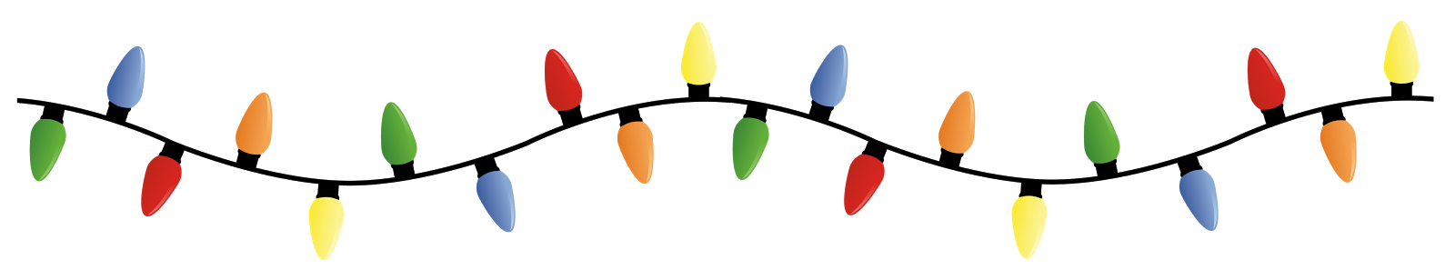

President’s Message
“All things are good in the end, and if its not good, then it is not the end.” These are the words of the hotel proprietor at The Best Exotic Marigold Hotel. Well, the end of the year is coming and hopefully it is a good end of the year. Some things probably went really well. Some things not so well. Probably a number of things you got push back on—and maybe you perceived that negatively at the time. But think of two athletes competing to better the other, in turn pushing each to refine and rebuild to be stronger, or faster, or… Let’s enjoy the push backs as we refine, rebuild, and prepare for an awesome 2018.

TGfU Resource Books

Six TGfU Resource Books
FOR ONLY
$100.00 + TAX and SHIPPING

Visit the following link to view 105 amazing slides (including videos) that progressively take you through the four areas of the TGfU Approach!
http://www.ciraontario.com/tgfuproject
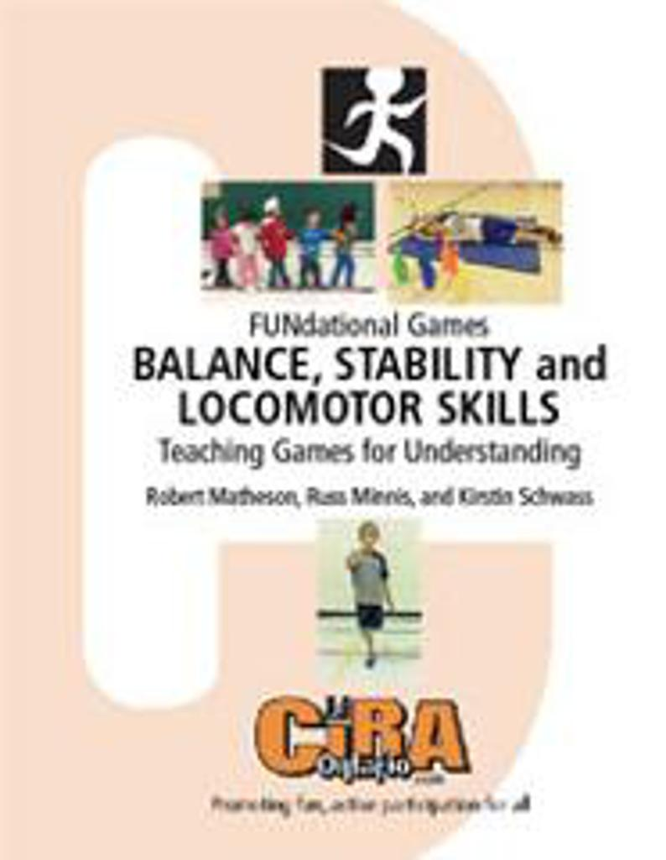
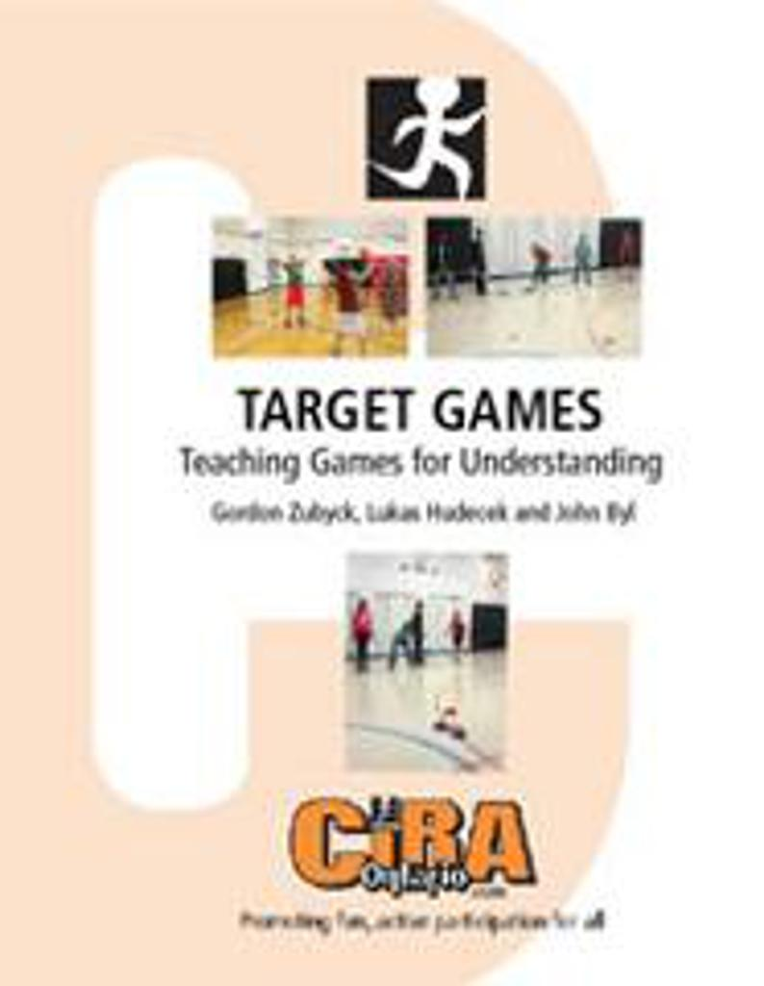
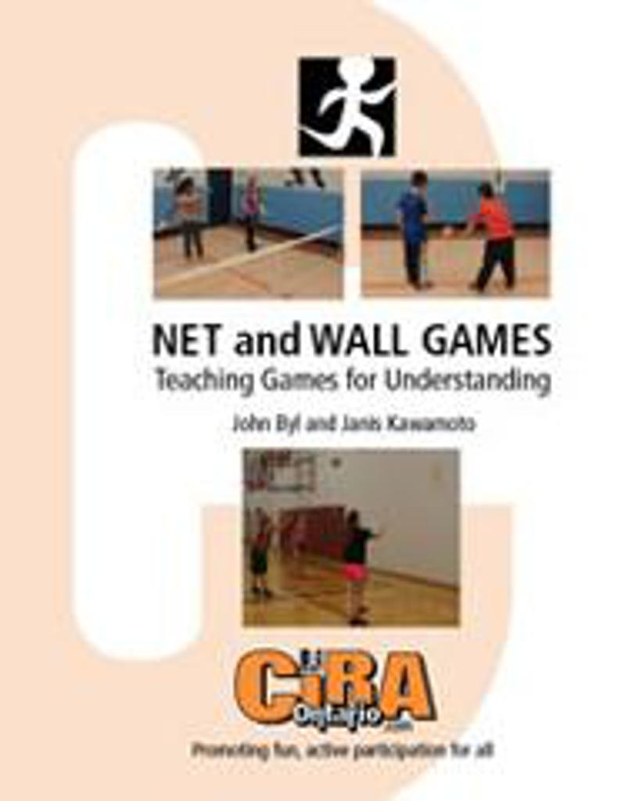
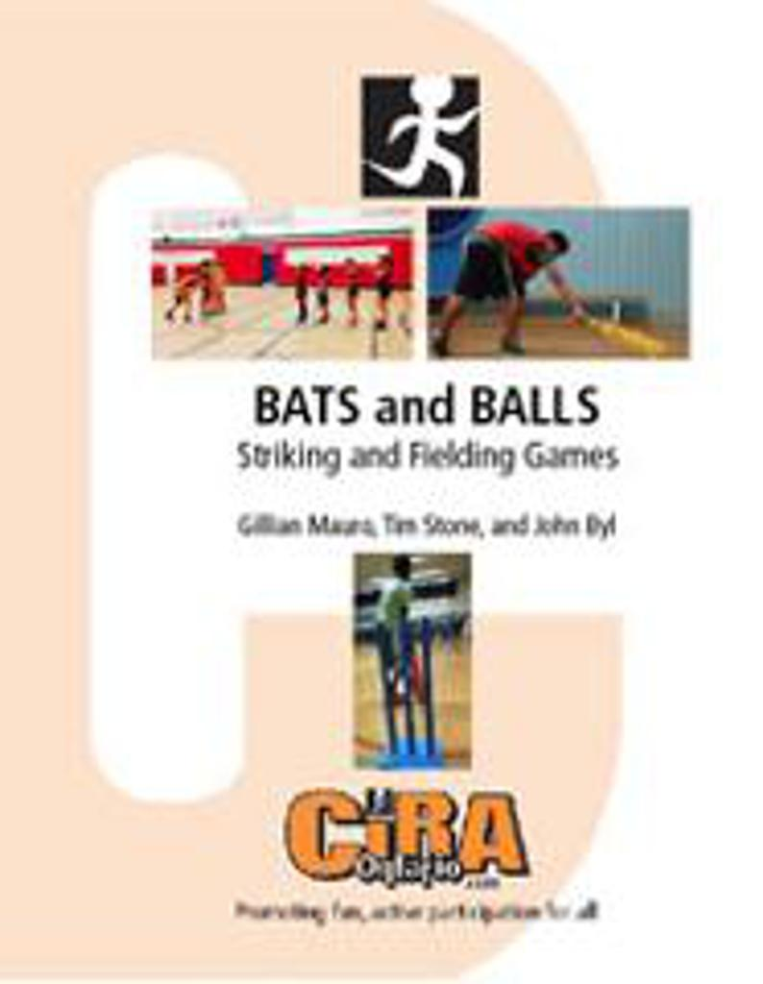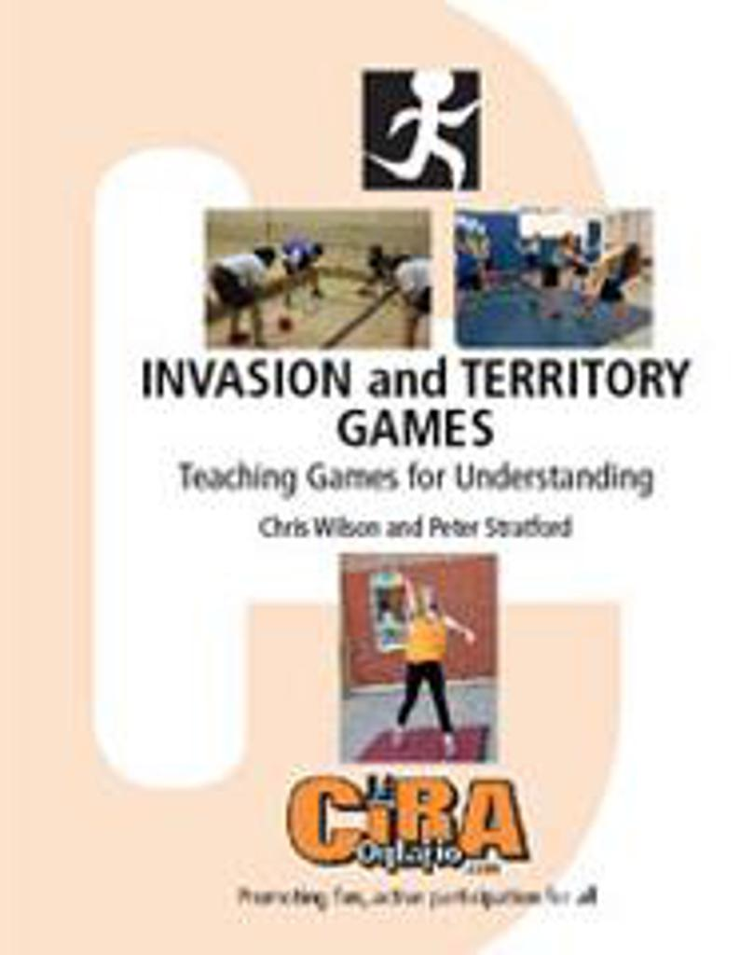

Christmas Games
Christmas themed games will be posted on
Facebook closer to Christmas. Don’t miss them!
Winter Games
Get on a Roll
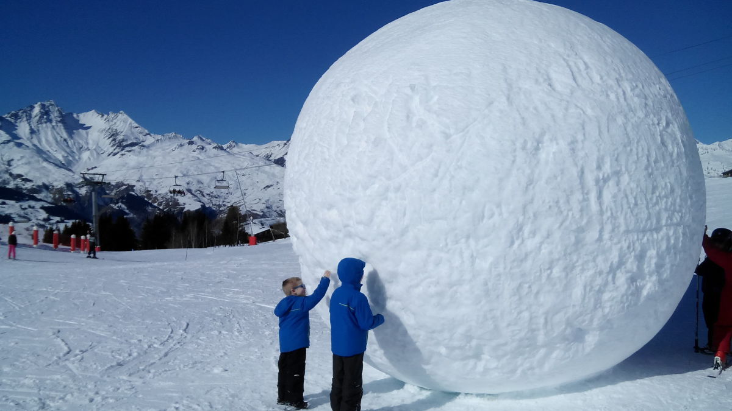
http://www.ciraontario.com/getonaroll
Pair up for a contest in which the object is to finish with the biggest snowball. The contest ends when the teams can no longer roll their entries, when they run out of snow or after a predetermined amount of time.

Snow Bowl
http://www.ciraontario.com/snowbowl
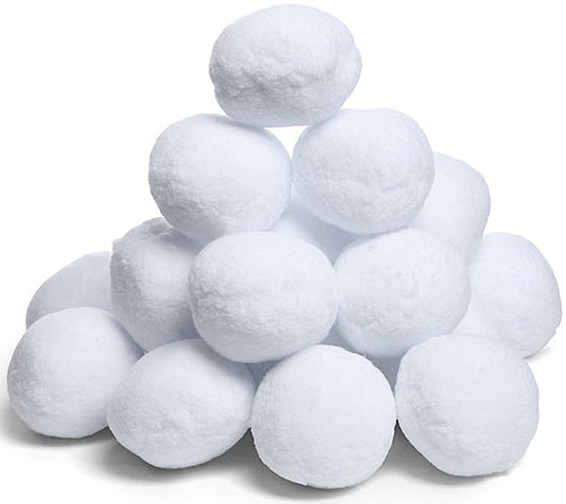
Equipment: plastic bowling pins, snowballs
How to Play: Have students create snowballs and try to bowl at the pins in order to knock them over.

ONCE in a LIFETIME EXPERIENCE
….that is - unless you’ve gone before….
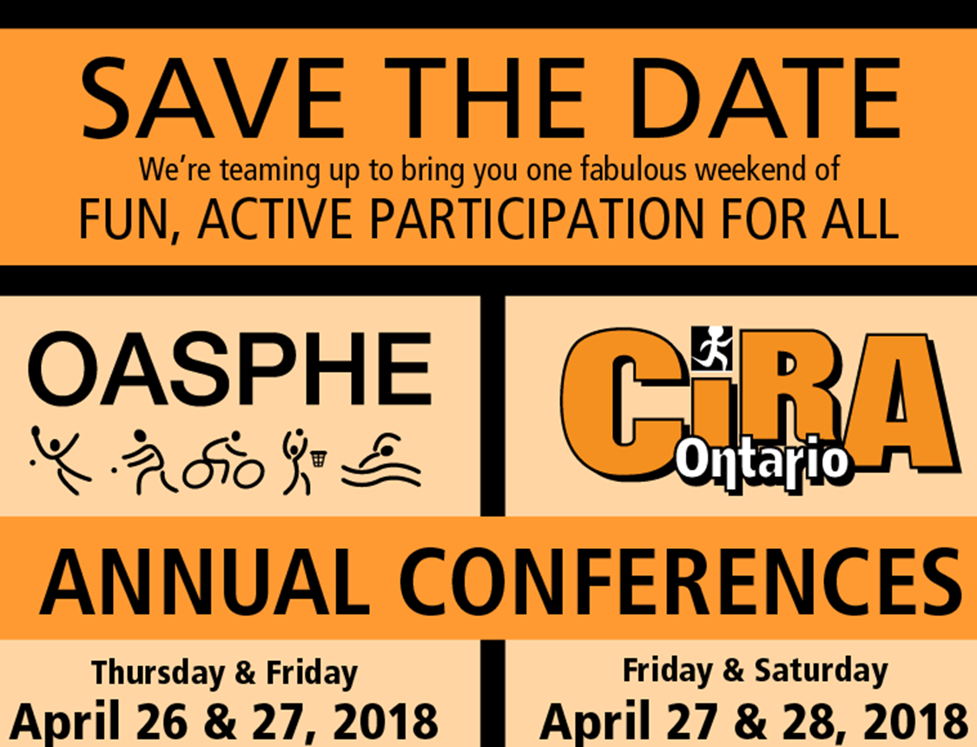

Register at:
http://www.ciraontario.com/conference

