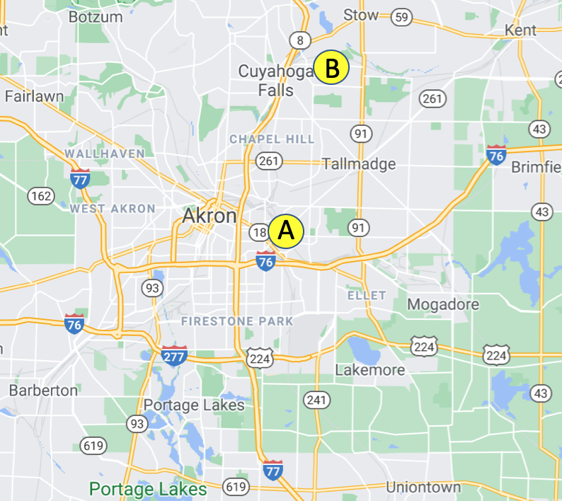

2025 TOURNAMENT MAP AND KEY LOCATIONS
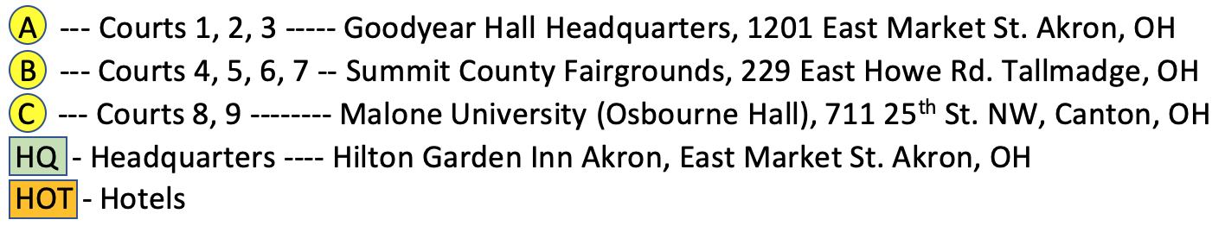


Futsal Coach/Ref Social, Saturday, January 18. 8:00-12:00am
Hilton Garden Inn on East Market Street
The distance from A – B Goodyear Hall to Summit County Fairgrounds is:
5.4 miles, 13 minutes

The distance from A – C Goodyear Hall to University of Akron is:
2 miles, 8 minutes

Courts 8, 9, 10 --- University of Akron Student Wellness Center Akron, OH

C
- Download the iSports 2 app.
- Click TOURNAMENTS at the bottom.
- Scroll down to find 2023 Great Lakes
- Futsal Regional Championships.
- Use this app for schedules, venues,
directions, rules & scores.

