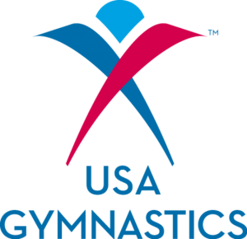

R103 HOTSA COURSE
hosted by Rose’s Gymnastics
Greenville, NC

A training course for your rec staff, just in the nick of time for the Olympic surge!
Friday, August 26, 9:00 AM – 4:00 PM
Send everyone on your staff!
Get everyone Rio ready!
Register online at www.usagym.org
Spend a day, get information and experience for a life time in the gym!

Located at
1802 Old Fire Tower Road
Greenville, NC 27858
252-321-7264


