Illinois Coaches Association Shrine All Star Game
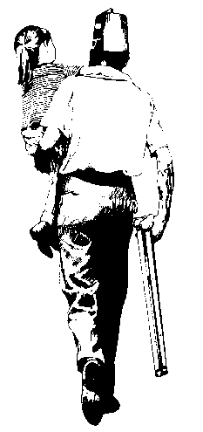
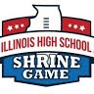
BENEFITING SHRINE HOSPITALS FOR CHILDREN

East-West Charity All-Star Football
“Strong Legs Run So That Weak Legs May Walk”

Dave Jacobs Eric Tjarks
ICA Football Chairman Shriners Game Chairman
(217) 622-1615 (217) 781-2400
davejacobsfb1@gmail.com tjarkse@gmail.com
FAX (618) 462-3826

Dear Coach,
Last year over 240 players were nominated for the 2017 ICA Shrine Game. Of those 240, a committee of over 20 high school head coaches from all over the state used the information supplied by nominating coaches to select the final number of 88.
The prestige of being recognized by their coach is quite an honor in itself. Therefore, every player will be notified of the selection in late December, with a copy to their coach. We have been told that being selected to play in this game is a highlight in the player’s high school career.
Please nominate the players from your school you would like to have considered for the 2018 ICA Shrine All-Star Football Game. Your input is needed to make the selection fair and equitable. ICA Shrine Game rules limit the roster to one player per school, so please make sure to nominate the caliber of men that will represent your school and team well. Your nominations should be players you consider among the top football players of character, talent, and academics in the entire state of Illinois. We are looking for All-State, First Team All-Conference, and Academic All State Players. A nominated & selected player must graduate with his class and had played in at least four games in 2017 season. They also must accept our invitation to participate within 30 days of notification.
In order for your nomination to get proper consideration by the selection committee, we need to have your input in my office by December 1st. Late nominations sent to us from December 1st to December 9th will not be included for selection on the initial roster but can be included for replacement players. No nominations will be accepted after December 9th.

Sincerely,

Dave Jacobs
ICA Football Chairman

