
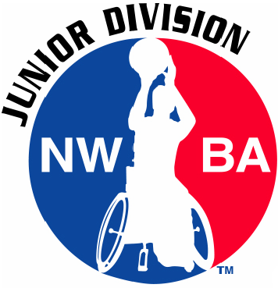
2016 Courage Kenny Classic
Northern Regional Qualifier
National Wheelchair Basketball Association (NWBA)
Junior Division

November 5-6, 2016
Hastings, Minnesota

Dear NWBA Junior Division Teams:

Thank you for your interest in attending the 2016 Courage Kenny Classic Saturday, Nov. 5 through Sunday, Nov. 6, in Hastings, Minn. The event serves as the 2016 NWBA Junior Division Northern Regional Qualifying Tournament. Two bids to the 2017 NWBA National Championships in Louisville, Ky., will be available for the 10’ teams competing.

The 2016 Courage Kenny Classic will be composed of Varsity (10A/10B) and Prep levels of play. Each attending team is guaranteed to play at least four games. The registration fee for a single team is $300; the registration fee is $225 per team for those organizations bringing both a 10’ and Prep team. Thus, an organization bringing two teams will save $150!

Included in this packet are team registration forms that must be submitted prior to your first game on Saturday. This packet also includes a summarized tournament schedule, tournament details, host hotel information and transportation information.

The registration deadline is Friday, Oct. 14. Please submit the team registration form, registration fee, photo release and waivers prior to the deadline. Completed forms and payment should be sent to:

Cara Gulbronson, Sports and Recreation Dept.
Courage Kenny Rehabilitation Institute
3915 Golden Valley Road, MR 78003
Minneapolis, MN 55422
Cara.Gulbronson@allina.com
Fax: 612-262-6718 │P: 612-775-2278 │ C: 952-240-5211

Please feel free to contact me with any questions. Tournament supporters and I look forward to hosting a fun and competitive tournament!

TOURNAMENT SCHEDULE
A complete competition/games schedule will be provided once team registration has concluded.

Day Time Location
Saturday, Nov. 5
Tournament play 8 a.m. - 8 p.m. Hastings High School
Five Court Fieldhouse
Sunday, Nov. 6
Tournament play 8 a.m. - 3 p.m. Hastings High School
Five Court Fieldhouse
Travel arrangements for flights should be made for after 3 p.m. on Sunday

TOURNAMENT INFORMATION
Rules
As a regional qualifying tournament the 2016 Courage Kenny Classic will be played according to the rules of the National Collegiate Athletic Association (men) and the NWBA.
Additional rules to note are as follows:
- All athletes and coaches must turn in a signed waiver form to participate.

Games Guaranteed
Each team attending the 2016 Courage Kenny Classic is guaranteed to play at least four games. Additional games will be dependent on results.

Jerseys (home/guest team)
The team listed first on the schedule is the home team and will wear their white/light jersey.

All-Tournament Team/MVP Awards
Players at the 10’ A, 10’ B and Prep levels of play will be selected to the 2016 Courage Kenny Classic All-Tournament Team. A Most Valuable Player (MVP) award will be given to each gender for both levels of play. Each team will receive one ballot to submit for their level of play.

Food
Concessions will be available for purchase both days of competition. Lunch will be provided for athletes and coaches on Saturday.

Code of Conduct
Courage Kenny Rehabilitation Institute asks that team representatives help ensure that team members, families and friends act in an appropriate manner toward other team members, opponents, officials, volunteers and all others in attendance.

NWBA Sanctioned Tournament
This tournament is sanctioned under the NWBA Tournament Sanctioning guidelines.

HOTEL & TRANSPORTATION INFORMATION

Host Hotel
Please be sure to book your rooms at one of the following hotels, listed in order of preference:

Hampton Inn Eagan
3000 Eagandale Place, Eagan, MN 55121
$89 / night plus tax
To book, call 651-688-3343 and mention the Courage Kenny Classic (CKC)
For more information click here.

Hilton Garden Inn
1975 Rahncliff Ct, Eagan, MN 55122
$89 king and $99 2 queen / night plus tax
To book call at 651-686-4605 and mention Courage Kenny Block (CKC)
For more information click here.

Holiday Inn Express
3434 Washington Drive, Eagan, MN 55122
$115.99 / night plus tax
To book, call 651-452-3400 and mention Courage Kenny Classic (CKC)
For more information click here.

Reservations must be made by Friday, Oct. 14, to guarantee room availability and rate. Please only book the fully accessible rooms if it is truly needed. We hope you enjoy your stay!

Transportation
There will be NO transportation provided by the tournament host. If accessible transportation is needed please make arrangements with one of the following options:

Cummings Mobility Roseville
1755 W. County Road C
Roseville, MN 55113
651-633-7851

Rollx Vans
6591 Hwy. 13 W
Savage, MN 55378
952-890-7851

Rental Cars/Airport
If you are flying in from out of town you will be flying into MSP International Airport. There are two terminals depending on the airline you chose. Rental car facilities are available at the airport. Click here for all of the vehicle vendors.

TOURNAMENT LOCATION ADDRESS
Hastings High School
Fieldhouse
200 General Sieben Drive
Hastings, MN 55033

Parking
There is an easy access drop off loop on location. However, please don’t park in the drop off loop as it is a fire lane.

Ample parking is available at Hastings High School. Parking options include:
- The main parking lot and entrance located on the west side of the high school. The main parking lot and entrance are on the gym level.
- The south parking lot is also available but has stairs and only one elevator available to access the gym level.

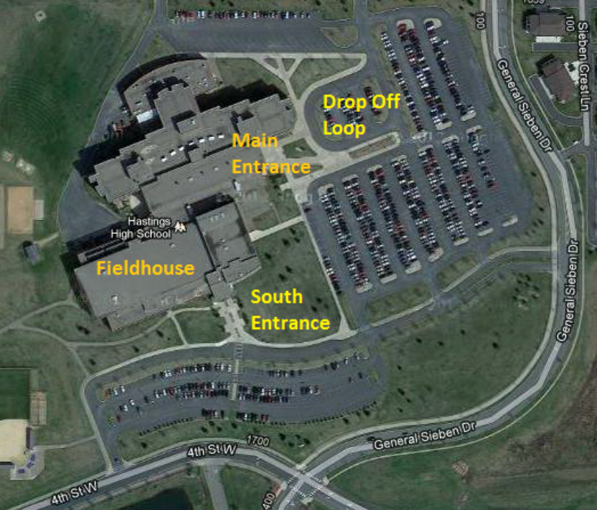

TEAM REGISTRATION FORM
2016 Courage Kenny Classic, November 5-6 at Hastings High School, Hastings, Minn.

LEVEL OF PLAY

____10’ A ____10’ B ____Prep

Team name Team colors

Coach/team rep name # of asst. coaches
Home/work phone Cell phone
Email

TOTAL NUMBER ATTENDING: (parents, players, coaches)
JERSEY # | PLAYER/COACH NAME | HOMETOWN/STATE | DATE OF BIRTH | T-SHIRT SIZE
T-shirt sizes: YS, YM, YL, AS, AM, AL, AXL, A2XL and A3XL
TOURNAMENT INVOICE
2016 Courage Kenny Classic, November 5-6 at Hastings High School in Hastings, Minn.

Registration Deadline is Friday, Oct. 14, 2016: Receipt of your team registration and fees will confirm your entry into the tournament per an available team slot at identified level of play.

Registration Fee:

$300 per team
$225 per team, if registering both a 10’ and Prep team

Cancellation Policy: No refunds given after October 14, 2016.

1st team
2nd team
3rd team
TOTAL

Make checks payable to:
Courage Kenny Sports and Recreation

You can pay online via check or credit card. Follow the link below and instructions on screen.
Please use class code CKC when registering your team.

Payment website

Return Registration and Payment to:
Cara Gulbronson, Sports & Recreation Dept.
Courage Kenny Rehabilitation Institute
3915 Golden Valley Road, MR 78003
Minneapolis, MN 55422

OR

Fax: 612-262-6718
Attn: Cara Gulbronson
Sports and Recreation Department

OR

Cara.Gulbronson@allina.com

