Diego Lemus – IFA U12 & U15 Head Coach

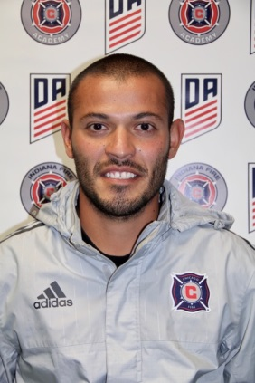

License: USSF “C” License

Education:
Bachelor of Science, Sports Management (10')
Bachelor of Arts, Spanish (10')
Masters of Science, Sports Management (17')

Coaching Experience:

First Assistant and Recruiting Coordinator at UIndy in 2010, 2015-2017

U12, U13, U19, U23, boys Head coach and Jr. DOC (St. Francis, 2015-2017)

U14, U15, U18, boys Head coach (Tippco, 2012-2014)

U15 boys Head coach (Center Grove, 2009)

Playing Experience:
Invited for 3 month trial with Leones Negros UdeG (Mexico-2011)
UIndy- (2006-2010)
-Team Captain 2008,2009
EuroSoccer Academy of USA-2006, 2008, 2009)-trained with Anderlecht U17 (1st Div.Belgium), trained with G.D. Estoril Praia Reserves (1st Div. Portugal), Team captain vs Al-Ittihad first team (1st Div. Saudi Arabia), Invited to tryout with FC. Snagov (2nd Div. Romania)
FC Indiana (2009,2010)
Scecina Memorial High School (2002-2006))

