Roll Call: Terry Johnson, Jay Stark, Adam Hoffman, Travis Steele, Jesse Viall, Tom Johnson, Randy Kruse, Adam Welch, Sean McCabe, Donny Huemoeller, Bernadette Schaffer, Josh Colvin, Jaimie Schuster
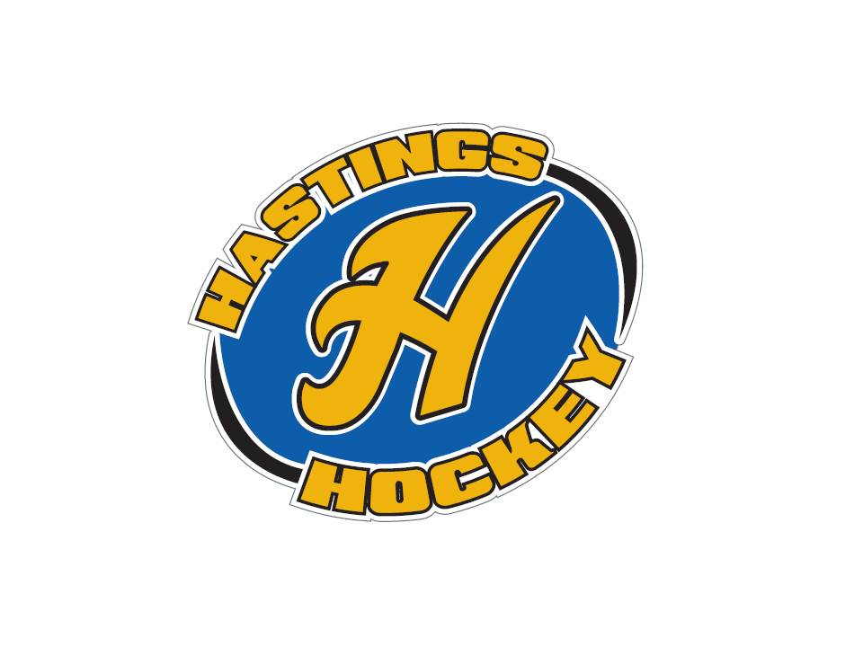

Not in attendance: Shannon Callahan, John Klimek, Erik Goettl, Jason Stoffel, Shane Lanning, Josh Colvin

- Approval of Agenda Donny made the motion – Jesse seconded and the motion passed.
- Approval of Minutes Will be voted on next month

Coordinator Reports
- Referee – John Klimek not in attendance
- Registrar – Shannon Callahan not in attendance
- Technology – Jay Stark/Randy Kruse nothing to report
- Tournament Director – NA
- Sponsorships – Erik Goettl not in attendance
- District 8 – Jesse Viall no meeting, nothing to report
- Goalie – Josh Colvin
- Secretary – Bernadette Schaffer nothing to report

Officer Reports:
- President – Terry Johnson 2 Spring conferences coming up – Good director conference end of April, and another in May- Board members, coaches let Terry know if you are in interested in going. Talking to district about rules/changes for D8 next year.
- Vice President – Jay Stark ice hours are all done – used 75 more hours than last year
Sent out projected numbers for next year to directors
- Treasurer – Jaimie Schuster (Approval of the Financial Statements)
Donny made the motion to approve financials, Sean seconded the motion – motion passed

Director Reports:
- Volunteers – Shannon Callahan not in attendance
- Director of Hockey – Adam Welch coaches meetings will be coming up, talking about shot club for next year – this year we will extend the program
Donny made the motion to continue the program, Jesse seconded the motion – motion passed
- Operations – Adam Hoffman seems to be going fine so far
- In-House Girls – Shane Lanning not in attendance
- Travel Girls – Travis Steele U10 finished up districts – good successful season
- TerMites – Tom Johnson trying to track down a few jerseys still
- Mighty/Super Mites – Jesse Viall good turn out for spring clinics
- Squirts – Jason Stoffel not in attendance
- Peewees – Sean McCabe Spring skate in full swing now – 2/3 of skaters are attending
- Bantams/Jr. Gold/U16 – Don Huemoeller Spring clinics running so far so good

Old Business:

New Business:
- Tournament coordinator – Need someone for this
- Registration Advertising Coordinator – Brian Jones will help you, you will earn all of your dibs, email Terry if you are interested in this position. It will require hours in the beginning of the season.
- Coaching Surveys This will be open until April 9th. Positive feedback so far
- By the next meeting – look into your own section and look it over for the next meeting – update the duty of your position
Off Season Hours – We will be meeting starting at 7 at the Green Mill next month until September

Looking for a committee to head up the golf tournament in September – email Terry if you are interested Just golf – no party that night.

Board Comment
Membership Comment
Adjournment Jay made the motion, Donny seconded – motion to adjourn passed 9:16

Next Meeting: May 7th, 2017

