View hundreds of FREE game descriptions & videos!

What's New—March 2017?
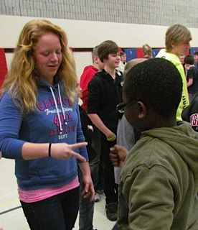

President’s Message:
Making Love
I took care of our grandkids for a few days. Took them to school and met amazing teachers that were energetic and positive. After school the kids played on the school playground and I watched and listened. I heard lots of loving and fun laughter and game talk… I also heard phrases like, “Na, Na, Na, Na;” and “I’m the King of the castle;” and snidely, “Why are you wearing that coat again.” It reminded me that school playgrounds are places of both positive and negative play.

As my mind wondered, my mind when to the 1969 tunes of Three Dog Night, and their song Easy to be Hard. One of the main lines in the song is, “I just need a friend.” Let’s keep reminding young people under our care that all people need friends, and no people need to be belittled.

$1,000 gift card to be given away in April. Register for free.

CIRA Ontario history as follow up from last month

We are thinking of Canada’s 150 years, but in 2019 CIRA Ontario will celebrate 50 years since it’s conception. Will need to plan a big party? Check out:
- For more on CIRA Ontario history

Want to make your recess better?
Download this document to guide you step-by-step through the process.

No equipment? No Problem with games from these two resources
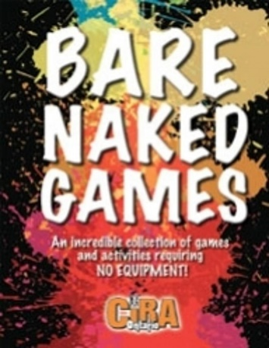 | 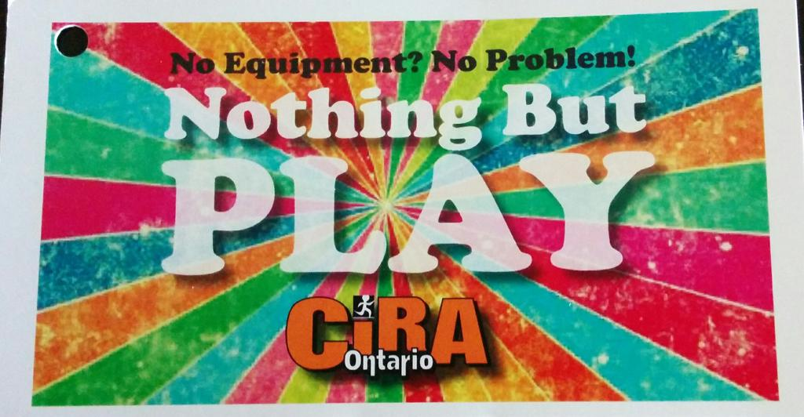
Download eleven games from Bare Naked Games | Download six sample games from Nothing But Play
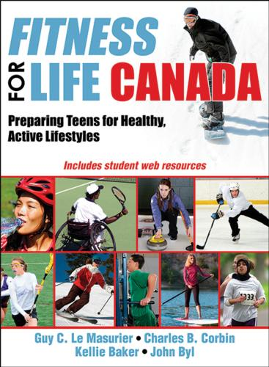 | Fitness for Life Canada is new book that is an evidence-based junior-high program focused on shifting teens from dependence to independence when it comes to healthy behaviours, including physical activity, fitness, and healthy eating. It includes an array of web-based resources for students and teachers and more than 100 lesson plans.

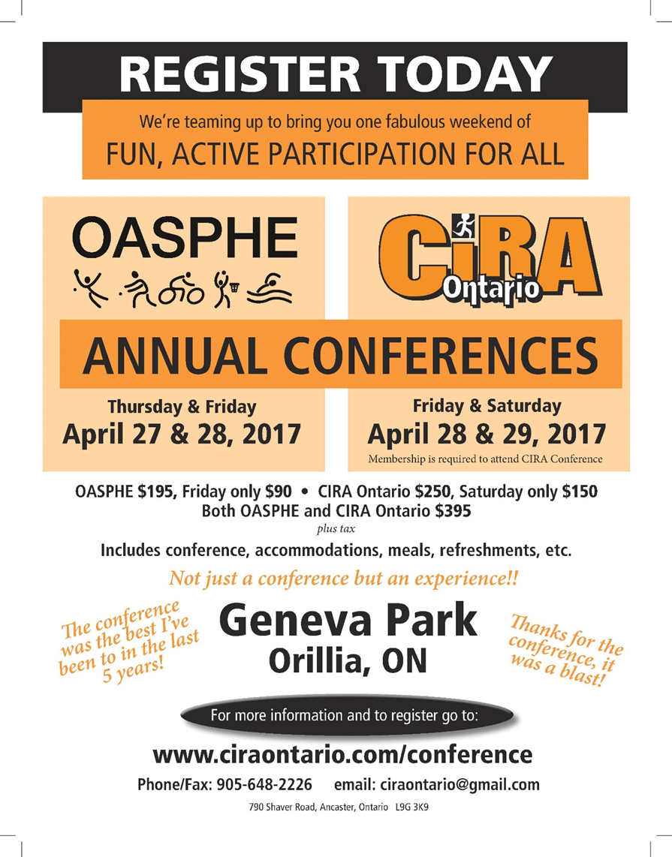

Click on the icons to like us at:

