1999 USAG Region III Championships  Emerald City Gymnastics  Steve Glickley - Meet Director  9848 West 87th St  Overland Park, KS 66212  Class 5 - 12-13  Session 5 | 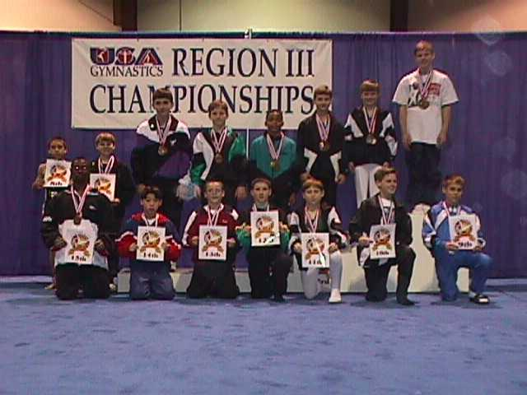

Place | Num | Name  USAG Gym | Floor | Pommel | Rings | Vault | P Bars | H Bar | AA
1 | 288 | Scott Higgins  542651 Flips, TX | 9.200  1T | 8.700  3T | 8.200  7T | 9.450  3T | 8.800  4T | 8.500  3 | 52.850  1
2 | 327 | Stephen Petree  553500 High Tumblers, TX | 9.000  3T | 8.600  5T | 8.100  9T | 9.100  11T | 8.900  2T | 7.800  11 | 51.500  2
3 | 393 | Stephen Mackie  542557 Palm Valley, TX | 8.600  11 | 8.900  2 | 8.100  9T | 8.650  26 | 8.900  2T | 8.000  6T | 51.150  3
4 | 350 | Carl Linzy  550930 Juergen's, TX | 9.000  3T | 8.300  7 | 8.900  1 | 9.400  5 | 7.600  25 | 7.700  12 | 50.900  4T
4 | 268 | Kyle Wells  538850 Emerald City, KS | 8.900  6T | 8.700  3T | 8.200  7T | 8.900  16T | 8.600  8T | 7.600  13T | 50.900  4T
6 | 116 | Shane Floyd  562463 Acrotex, TX | 9.200  1T | 6.700  28T | 8.300  3T | 9.300  7T | 9.100  1 | 8.100  5 | 50.700  6
7 | 207 | Light Townsend  558914 Central Texas, TX | 8.700  9T | 8.000  8T | 8.300  3T | 8.750  23 | 7.900  18T | 8.300  4 | 49.950  7
8 | 395 | Nicholas Salter  542556 Palm Valley, TX | 8.400  14T | 7.500  19T | 8.300  3T | 9.450  3T | 8.200  15T | 7.900  9T | 49.750  8
9 | 381 | Andrew Carter  532959 North Shore, LA | 8.900  6T | 6.500  30T | 8.000  12T | 8.900  16T | 8.700  7 | 8.700  1T | 49.700  9
10 | 394 | Steven Doyle  542555 Palm Valley, TX | 8.400  14T | 9.100  1 | 7.600  24T | 8.900  16T | 8.600  8T | 6.900  22T | 49.500  10
11 | 328 | Max Silver  506781 High Tumblers, TX | 8.400  14T | 6.700  28T | 7.900  14T | 9.300  7T | 7.700  20T | 8.700  1T | 48.700  11
12 | 386 | Sam Rohr  557081 Oklahoma Gold, OK | 9.000  3T | 8.000  8T | 7.300  28T | 8.800  21T | 8.600  8T | 6.700  27T | 48.400  12
13 | 301 | Paul Wombel  532647 Folger's, KS | 8.200  19 | 7.900  12T | 7.600  24T | 9.300  7T | 7.700  20T | 7.600  13T | 48.300  13
14 | 200 | Jordan Iwami  539082 Capital, TX | 8.300  17T | 8.000  8T | 8.000  12T | 8.950  15 | 8.400  12 | 6.200  31T | 47.850  14
15 | 451 | Darias Strong  557088 Sunburst, TX | 7.600  28T | 6.000  34 | 7.800  18T | 9.550  1 | 8.800  4T | 8.000  6T | 47.750  15
16 | 368 | Dan Rottler  554963 Meyer's, MO | 7.000  37T | 8.000  8T | 8.300  3T | 8.400  32T | 8.600  8T | 7.400  16T | 47.700  16
17 | 259 | Trevor Taylor  547993 Elite, LA | 7.600  28T | 7.400  21T | 7.600  24T | 8.700  24T | 8.800  4T | 7.500  15 | 47.600  17
18 | 159 | Stephen Curtis  508542 All American, TX | 7.700  26T | 7.900  12T | 6.700  40T | 8.900  16T | 8.300  13T | 8.000  6T | 47.500  18
19 | 313 | Josh Loeser  558852 Gulf, TX | 8.100  20T | 7.900  12T | 7.700  22T | 8.600  27T | 7.700  20T | 7.400  16T | 47.400  19
20 | 351 | William Hall  559114 Juergen's, TX | 7.500  31* | 7.400  21T | 8.700  2 | 8.300  36T | 7.700  20T | 7.200  20T | 46.800  20T
20 | 476 | Michael Fetterly  524326 Texas Elite, TX | 7.500  31* | 7.900  12T | 7.900  14T | 8.400  32T | 8.300  13T | 6.800  24T | 46.800  20T
22 | 201 | Jon-Clay Poston  539108 Capital, TX | 8.700  9T | 7.800  16* | 8.100  9T | 8.500  30T | 6.800  37T | 6.800  24T | 46.700  22T
22 | 228 | Richard McFarland  547921 Crenshaw, TX | 8.500  12T | 7.800  16* | 7.700  22T | 8.400  32T | 8.100  17 | 6.200  31T | 46.700  22T
24 | 477 | Aaron Cohen  507512 Titan's, TX | 8.100  20T | 6.200  33 | 7.900  14T | 9.150  10 | 7.200  30T | 7.900  9T | 46.450  24
25 | 419 | Talon Houston  526290 Sonshine, AR | 8.500  12T | 7.000  25T | 7.300  28T | 8.600  27T | 7.500  26T | 6.800  24T | 45.700  25
26 | 369 | Mike Brotske  555323 Meyer's, MO | 8.300  17T | 7.500  19T | 7.100  31T | 8.700  24T | 6.500  41 | 7.400  16T | 45.500  26
27 | 478 | Aaron Viles  512913 Titan's, TX | 8.800  8 | 4.700  39 | 7.800  18T | 9.500  2 | 7.000  33T | 7.200  20T | 45.000  27
28 | 133 | Michael Fooshee  556661 Action Gym, OK | 7.700  26T | 7.600  18 | 7.100  31T | 9.000  14 | 7.900  18T | 5.400  39 | 44.700  28
29 | 275 | Jake Holton  545682 Flame, AR | 6.700  39T | 7.400  21T | 7.100  31T | 8.900  16T | 7.200  30T | 6.900  22T | 44.200  29
30 | 387 | Ryan Rains  540509 Oklahoma Gold, OK | 7.600  28T | 7.000  25T | 6.900  35T | 8.500  30T | 7.400  28T | 6.700  27T | 44.100  30
31 | 132 | Steven Lindberg  556672 Action Gym, OK | 7.900  24 | 6.400  32 | 7.800  18T | 8.600  27T | 7.500  26T | 5.800  36T | 44.000  31
32 | 388 | Tavish O'Keefe  557080 Oklahoma Gold, OK | 8.100  20T | 4.800  38 | 7.900  14T | 9.350  6 | 7.400  28T | 6.200  31T | 43.750  32
33 | 131 | Alex Chaney  559287 Action Gym, OK | 8.100  20T | 8.600  5T | 6.800  38T | 8.100  38T | 7.700  20T | 4.100  42 | 43.400  33
34 | 270 | Colin Newbold  538864 Emerald City, KS | 7.500  31T | 7.000  25T | 7.200  30 | 8.300  36T | 6.600  39T | 5.800  36T | 42.400  34
35 | 475 | Nick Thompson  524348 Texas Elite, TX | 7.100  35T | 6.500  30T | 7.400  27 | 7.200  41 | 6.800  37T | 7.300  19 | 42.300  35
36 | 421 | Josh Tratz  562123 Sonshine, AR | 7.800  25 | 5.800  36T | 6.600  42 | 8.800  21T | 6.900  35T | 5.900  35 | 41.800  36
37 | 269 | Matthew Schmidtlein  538863 Emerald City, KS | 7.100  35T | 5.800  36T | 7.800  18T | 8.400  32T | 6.600  39T | 5.600  38 | 41.300  37T
37 | 227 | Eric Marburger  547928 Crenshaw, TX | 7.500  31T | 7.200  24 | 7.000  34 | 6.500  42 | 7.000  33T | 6.100  34 | 41.300  37T
39 | 322 | Luke Knowles  553193 Heartland, KS | 7.000  37T | 4.400  40T | 6.700  40T | 9.100  11T | 7.100  32 | 5.300  40 | 39.600  39
40 | 420 | Nicholas Roland  526288 Sonshine, AR | 6.700  39T | 5.900  35 | 6.900  35T | 7.500  40 | 5.800  42 | 6.700  27T | 39.500  40
41 | 408 | Joey Cusachs  547201 Riverbend, LA | 6.600  41 | 4.000  42 | 6.800  38T | 9.050  13 | 8.200  15T | 4.800  41 | 39.450  41
42 | 355 | Dustin Ward  543274 Kansas School, KS | 6.000  42 | 4.400  40T | 6.900  35T | 8.100  38T | 6.900  35T | 6.300  30 | 38.600  42
This web page was generated by ProScore ™

