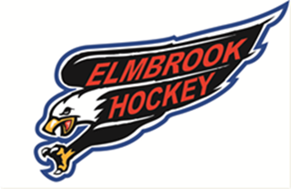
Elmbrook Youth Hockey Association
Introducing Business Development through Sponsorship

On behalf of the Elmbrook Youth Hockey Association (EYHA), I am proud to share news that we have launched a sponsorship program to support our youth hockey program and offset costs associated with running the organization. Until recently, the majority of EYHA was funded by donations, registration fees and fundraisers. And while we’ve continued to strengthen our non-profit association through the work of volunteers and your registration fees, EYHA can become a more vibrant organization with the support of local businesses in our communities.
With a 12-percent annual growth rate, regular representation in the Wisconsin Amateur Hockey Association’s state tournament and hosts to state tournaments for the next 2 years (2016-17 and 2017-18 seasons), EYHA provides a tax-deductible opportunity for local business owners to grow and develop their business.
To begin our sponsorship program, we are inviting our EYHA community of families – business owners as well as friends, families, employees and neighbors of business owners – to become the first to partner in our work to develop young hockey players in a safe and enjoyable environment. Please consider supporting the Elmbrook Youth Hockey Association through one of the following sponsorship packages.

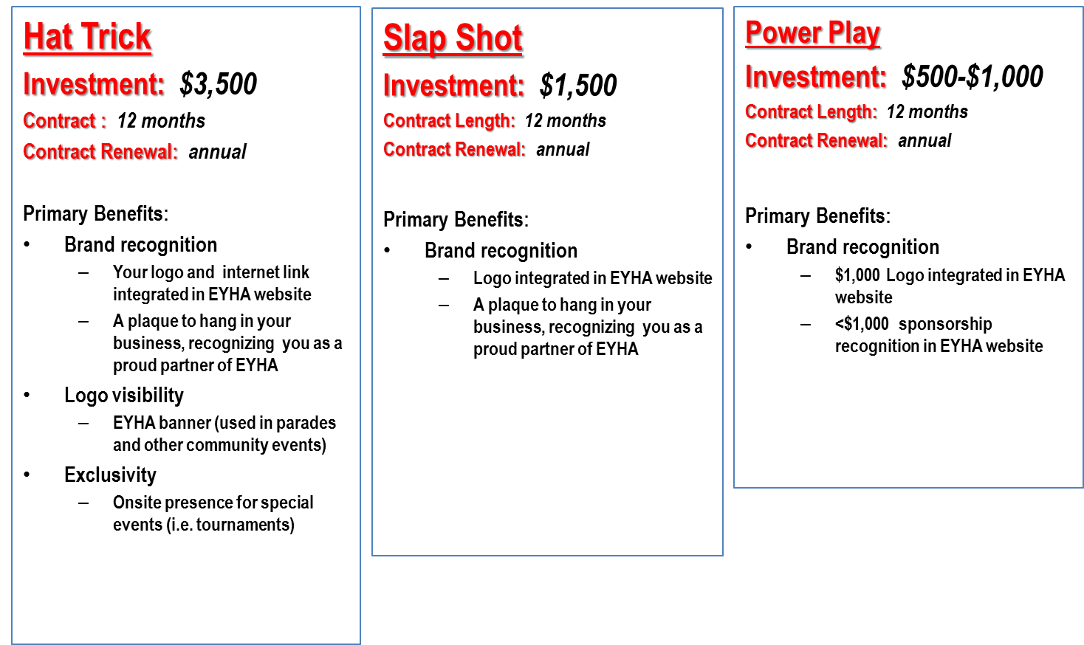

Thank you for your consideration. For more information, please contact Andy Hillig at 414-750-2283 or hilligam@gmail.com

