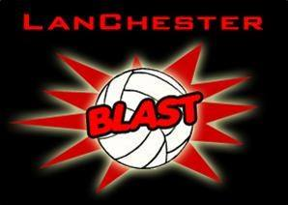
DONATION LEVELS
For more information, please visit our website at www.lanchesterblastvolleyball.com or contact a
Lanchester Blast Director

Bronze | Silver | 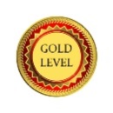  Gold | 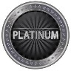  Platinum
$25 - $99 | $100 - $199 | $200 - $499 | $500 +
- Their name put on our website - Bronze box, w/out clickable link  - Their name put on our sponsor shirts (small lettering)  - Their name or logo put on our sponsor banner (small lettering)  - Their name only put on our sponsor poster | - Their name put on our website - Silver box, w/clickable link  - Their name put on our sponsor shirts (medium lettering)  - Their name or logo put on our sponsor banner (medium lettering)  - Their name or small logo put on our sponsor poster | - Their name put on our website - Gold box, w/clickable link  - Their name put on our sponsor shirts (large lettering)  - Sponsor receives a shirt  - Their name or logo put on our sponsor banner (large lettering)  - Their name or large logo put on our sponsor poster | - Their name put on our website - Platinum box, w/clickable link  - Their logo put on our sponsor shirts  - Sponsor receives a shirt  - Their name or logo put on our sponsor banner (x-large lettering)  - Their name or x-large logo put on our sponsor poster
Player Receives:  If a player brings in $1000, she earns: 1 sponsor shirt, 4 work bonds, and $600 toward her dues. | - $100 - $199:  - 1 sponsor shirt  - 1 work bond per hundred (4 max) | - $200 - $400:  - Same as Silver  - 100% of all sponsor money earned after $400 will go towards player’s dues. | - $500 +  - Same as Silver  - 100% of all sponsor money earned after $400 will go towards player’s dues.

