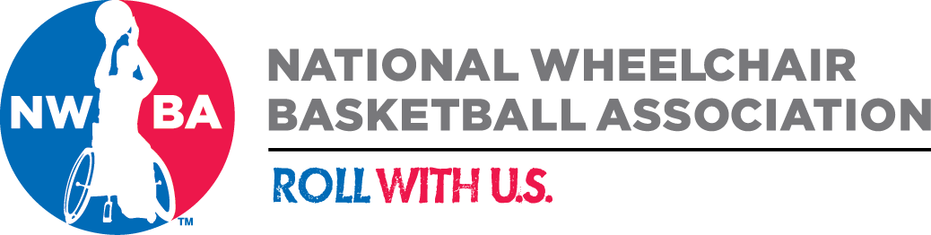

2017 U.S. Women’s Wheelchair Basketball Team

The NWBA is accepting applications for the 2017 U.S. Women’s Wheelchair Basketball Team. This team will consist of 12 athletes that will travel to Columbia, in July or August, to participate in the America’s Zonal Qualifier.

All athletes interested in trying out for the U.S. Women’s National Team must attend team tryouts January 22-26, 2017, in Colorado Springs, Colorado. Players are responsible for their own transportation to and from (air or driving) to the Olympic Training Center in Colorado Springs. Housing, meals and ground transportation once in Colorado Springs will be provided by the NWBA. To be eligible for the 2017 U.S. Women’s National Team you must be a U.S. Citizen and must be able to have a United States Passport no later than January 26, 2017.

The player must be willing and able to up to five (5) mandatory training camps and a competition during the winter and spring of 2017 and the IWBF America’s Zone Qualifier in July or August of 2017.

All interested players must fill out the attached application and submit to Brandon McBeain at BrandonMcBeain@nwba.org by December 19, 2016, for consideration. Submitting your application does not guarantee that you will receive an invitation to the tryout camp.

About U.S. U23 Men’s Wheelchair Basketball Team

The U.S. Women’s National Team regained its position atop the podium by winning the 2016 Paralympic Games gold medal, its third in the last four Paralympics. The Women’s team is considered by many the top country to contend with on an annual basis. The NWBA is now building towards the Tokyo 2020 Paralympic Games, and the 2017 U.S. Women’s National Team is the first step to maintaining our position.

NWBA High Performance
Player Application

Please print or type legibly

Player Information
Legal First Name __________________ Last Name _____________________ M __ F __
Preferred Name ___________________
Address ____________________________________________________________
City ___________________________ State ____ Zip ________ - _______
Home Phone (____) _____-_______ Work (____) _____-__________ Mobile (____) _____-__________
Email Address __________________________________
Date of Birth __/__/__ last four digits of your SS# _____ U.S. Citizen? Yes __ No ___
U.S. Passport? Yes __ No ___ Passport # ________________________
Name as it appears on Passport ___________________________________________
Passport Issue Date: Passport Expiration:

Parent/Guardian Contact Information
Parent/Guardian First Name ___________________ Parent/Guardian Last Name ___________________
Home Phone (____) _____-_______ Work (____) _____-__________ Mobile (____) _____-__________
Email Address __________________________________

Player Profile Information
Place of Birth (City/State) ______________________ Hometown (City/State) ________________
Current Club _________________________________ City of Current Club __________________
Club Coaches Name ___________________________ Club Coaches Email __________________
Disability ___________________________________ Playing Position _____________________
Height ______ Weight _____ Do you have an IWBF Classification Card? ____
Do you use an everyday wheelchair? ______ Jersey Number Preference 1. ___ 2. ___ 3. ____
What is your wheelchair tire size? ________
Playing position ___________________ Height ____ Arm Span _____ Weight _____
List All Basketball Honors/Awards __________________________________________________________________________________________________________________________________________________________________________________________________________________________________________________________________

Player Profile Information Continued

List Any Personal Information. (Include: Parents, siblings, spouse, children, elite-level athlete relatives, postgraduate degrees, hobbies Notes: Use full names for parents and spouses (current married name), but just first names for siblings and children. List any relatives who have competed in a sport at the professional or national-team level (not collegiate). __________________________________________________________________________________________________________________________________________________________________________________________________________________________________________________________________
Social Media. (Include any social media fan pages or pages that are open to the public). __________________________________________________________________________________________________________________________________________________________________________________________________________________________________________________________________

Player Flight Information

Name as it appears on State ID or Driver’s License ____________________________
Do you need an aisle chair when boarding? ____
Do you prefer: Aisle Seat ___ Window Seat ___ No Preference ___
Please list any frequent flyer mile numbers you have (i.e. United Sky Miles) ____________________________________________________________________________________________________________________________________________________________________________
Preferred Airport? ____________ (If airport is not a major airport please list secondary airport and distance from home) __________________________

Medications/Dietary Needs
Please list ALL medications you regularly take. __________________________________________________________________________________________________________________________________________________________________________________________________________________________________________________________________
Please list any special dietary needs. ____________________________________________________________________________________________________________________________________________________________________________Please list any medical concerns we should be aware of? ___________________________________________________________________________________________________________________________________________________________________________

Player Sizing Information
***All Women’s players please fill out both sections***
Men’s Cut
Jersey ___ Shorts ___ Shooting Shirt ___ Shoe ____ Hat Size ___

T-Shirt ___ Polo Shirt ___ Warm Up Jacket ___ Warm Up Pant ___

Sweatshirt ___ Sweatpants ___

Women’s Cut
Jersey ___ Shorts ___ Shooting Shirt ___ Shoe ____ Hat Size ___

T-Shirt ___ Polo Shirt ___ Warm Up Jacket ___ Warm Up Pant ___

Sweatshirt ___ Sweatpants ___ Sports Bra ___ (i.e. Small, Medium)

Emergency Contact
First Name ________________________ Last Name _______________________
Relationship to you _________________________ Phone Number (____) ____-_______
Secondary Phone Number (____) ____- ______
First Name ________________________ Last Name _______________________
Relationship to you _________________________ Phone Number (____) ____-_______
Secondary Phone Number (____) ____- ______

I ___________________________, understand this is an application for consideration for any upcoming trials for NWBA international competition. I understand that if selected, I will be participating in training, events, activities and travel associated with these tryouts sponsored by the NWBA. I approve of the leaders who will be in charge of this program. I agree that the NWBA may use my likeness for publicity and promotional purposes on NWBA printed and electronic platforms, including but not limited to websites, social networks, publications, applications, etc. I recognize that the leaders are serving to the best of their ability. I certify that I have full medical insurance with the company listed below. I also certify to the best of my knowledge that I am physically fit to engage in the activities of wheelchair basketball.

Signed: ________________________________ Date _____________
Guardian (if under 18 years of age): ______________________________________ Date____________
Primary Insurance Co.: __________________________________________
Group/Policy #: _________________________________________

