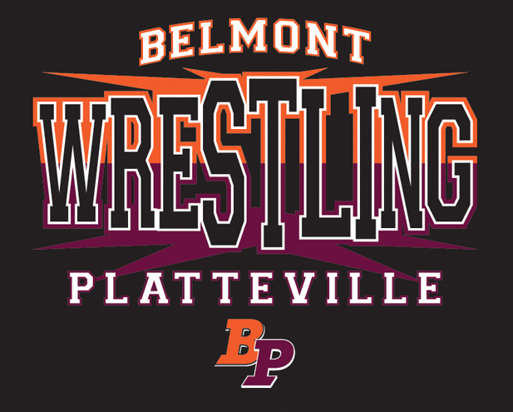

BELMONT-PLATTEVILLE
MIDDLE SCHOOL
WRESTLING
2017
“Practice without improvement is meaningless.” - Chuck Knox

“Once you've wrestled, everything in life is easy.” - Dan Gable

Middle School Coaching Staff
Jacob Crase
Jeff Crase
Mark Johnston

Varsity Head Coach
Andrew Campbell
BELMONT-PLATTEVILLE MIDDLE
SCHOOL WRESTLING
2017 Expectations

The following is a basic list of expectations for all wrestlers at the middle school level. All wrestlers should follow these general expectations for the entire season. The skills listed are what all wrestlers will be able to do by season’s end. The skills are needed to make the step to the high school level and be successful at the middle school level.

General Understandings
*Dedicated work ethic
*Willing to listen, follow directions and take corrections
*Desire to wrestle hard
*Wrestle aggressively
*Have fun
Skills
*How to execute 3 or 4 different takedowns
*How to execute at least 2 escape moves
*The knowledge of at least 2 pinning combinations
*Be able to wrestle hard for a 3-minute match
*Be able to counter basic takedowns and breakdowns
More Expectations and Rules
As your coach, I expect and demand the following:
*Showing respect to other wrestlers and coaches
*Listen and learn
*Remember that wrestling is not only an individual sport but also a team sport
*Give your all at every moment whether at practice or in a match

Absence, Tardiness and Behavioral Policies:
Tardiness — Not being at the designated place in proper attire at the designated time. Be at practice and ready to go before the start.
Absence — Not showing up at a practice or match.
Excused Absence or Tardiness — A telephone call or personal notification is required before all functions, matches and practices.

Disciplinary Actions at Practice:
1st Unexcused absence - conversation with coaches
2nd Unexcused absence - disciplinary action at practice
3rd Unexcused absence - disciplinary action at practice, one match suspension
4 or more absences - suspension from team

*We only have 22 Practices - Missing a single practice is 5% of the entire season!

Meets:
- All wrestlers should be well dressed the day of a match.
(This means dress pants, collared shirts or sweaters)
- Wrestlers must be ready and assembled by the designated bus departure time.
- Everyone takes the bus to the matches.
- Parents/Guardians can sign their child out after the meet is over.
- You are expected to cheer on your teammates and watch the meet.
(no messing around)

Other Guidelines:

*All wrestlers are expected to be exceptionally well-behaved in the classrooms and hallways of the school, and are expected to follow the Code of Conduct.
Wrestlers who fail to do so are subject to in-practice discipline, suspension or dismissal.

*Remember, you are representing our team and schools; we must strive to make a positive impact.

*Any excuse for missing a practice or match should be brought to the attention of the coaching staff before it happens. (e-mail or call)

*Wrestlers are responsible for taking care of and returning all equipment issued to them.

*The school district and the coaching staff are not responsible for personal belongings.

*Nobody should have to worry about a suspension because of poor grades. Turn in your work on time and make sure it is done well. Above all, show respect for your teachers and parents.
*The grade-check policy for the school you attend will be enforced.

Respect:
Coaches:
Respecting coaches includes listening to and following instructions from the coaches. Your coaches deserve your respect because they have sacrificed many things for your benefit. They paid the price before you, serving countless hours to the sport through competing and coaching. Most of all they care for you and want you to be successful.
Teammates:
Respecting teammates means that I work to help those on my team get better. It also means that I give every teammate encouragement, honor and consideration. Your teammates deserve your respect because they are working by your side doing everything that you are. Teammates who know that they are respected will wrestle better and that performance benefits everyone on the team, both in the practice room and in competition.
Opponents:
Respecting opponents means that I give my best every time I step on the mat. It also means that I handle myself with dignity in victory or defeat. Your opponent deserves your respect because he is working hard like you and remember that many under respected opponents have shocked those that have thought too highly of themselves.
Self:
Respecting ones self means that I take care of my mind and body through the proper nutrition, hygiene and avoiding anything that could be harmful to me or detrimental to my performance. There are many times in life when you are the only one that you can rely on, wrestling is a great sport for learning about this. People that don't respect themselves often find that failure is waiting for them in times of adversity

Our goal is to come together as a family and support one another while representing our schools and program to the best of our ability.

If you need to reach me for any reason, I work at the Platteville High School: (608) 342-4020 or my cell (608) 732-5554.

I can also be reached by email jcrase@platteville.k12.wi.us.

Welcome to the Belmont-Platteville Wrestling Family!

