Roll Call: Terry Johnson, Josh Colvin, Sean McCabe, Don Huemoeller, Travis Steele, Jaimie Schuster, Shannon Callahan, Adam Welch, Jason Stoffel, Jay Stark, John Klimek
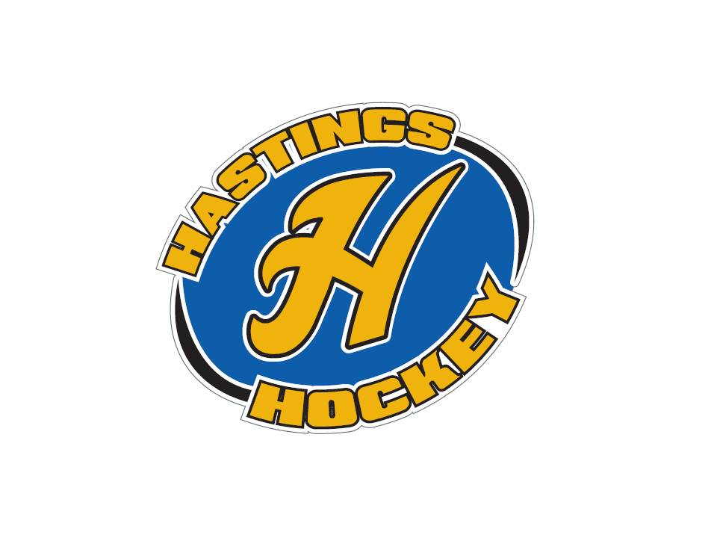

Not in attendance: Matt Zaruba, Adam Hoffman, Jesse Viall, Jim Foster, Tom Johnson, Bernadette Schaffer
- Approval of Agenda - motion made by Josh, seconded by Don; motion passed
- Approval of Minutes – motion made by Don, seconded by Sean; motion passed

Coordinator Reports
- Referee – John Klimek
Nothing to report
- Registrar – Shannon Callahan
Nothing to report
- Technology – Jay Stark/Randy Kruse
Registration is up for Tournaments and Players coaches will be live end of month
- Tournament Director – Jim Foster
Not in attendance
- Sponsorships – Terry Johnson
Working on golf tournament
- District 8 – Jesse Viall (not in attendance/Terry reported)
Next D8 meeting is the 17th and Jay will go
President’s meeting in July discussed SSP & Sibley merging @ BantamAA
Players on the high performance teams are excused absence from Hastings (applies to three players in program at Bantam level)
Designation of teams changed from Mite, Squirt, Peewee, etc., to ages U8, U10, U12, U14, etc.
- Goalie – Josh Colvin
Inventoried equipment and everything looks good
$500 out of pocket if need be to purchase additional equipment
Interest in talking to the squirt level to see if can get more goalie interest; bring a high school goalie
Goalie clinics for winter
- Secretary – Bernadette Schaffer (not in attendance)

Officer Reports:
- President – Terry Johnson
Hockey night and golf
Push golf registrations
Apparel store to open in September
Wed the 7th set for hockey equipment handout for mites
- Vice President – Jay Stark
Picture day Nov 12th (Bantam AA needs to be rescheduled because of conflict)
Start of ice scheduling; will be connecting with auto ice
Peewee – 4 teams
Bantam – 4 teams (no interest in 2 B2 teams)
Girls – 5 teams
Oct 29-30 U10-U12 Girls preview
- Treasurer – Jaimie Schuster (Approval of the Financial Statements)
Motion made to approve financials – motion made by Josh, seconded by Don; approved
Payments made for registered tournaments (report sent to travel level directors)
Directors and/or coaches/team manager responsibility to request any additional checks needed for gate fees owed

Director Reports:
- Volunteers – Terry Johnson
Meeting for managers before jerseys handed out
1 manager at the super/mighty mite levels
Coaches/board members have to register as USA Hockey Volunteer
- Director of Hockey – Adam Welch
Squirt parent meeting at beginning of season to explain USA Model and re-emphasize why we run the level as an in house program
Discussion continues around getting kids to stay in association and play for Hastings
- Operations – Matt Zaruba (not in attendance)
- In-House Girls – Adam Hoffman (not in attendance)
- Travel Girls – Travis Steele
Rescheduled three tournaments
U15 will lose 2 girls to HS program; 2 girls quit (one due to injury)
- TerMites – Tom Johnson
Total of 19 registered to date; 12 new to program
- Mighty/Super Mites – Josh Colvin
Flyers handed out at Raider Nation events
Equipment concerns; may need to purchase more sets
Bring a Friend to Skate 9/30
Motion made to approve addition of a Coordinator for Recruiting made by Josh, seconded by Adam; motion passed - Terry in charge of appointment
Stick donation from membership as equipment provides everything but sticks
- Squirts – Jason Stoffel
Move jersey unveiling night to Nov 4
Kid from Prescott playing in River Falls - parents need to get waiver to skate in Hastings
- Peewees – Sean McCabe
29 Registered players
- Bantams/ Jr. Gold– Don Huemoeller
25 Registered players

Old Business: Nothing to report

New Business:
- Registration
Only 40% of girls are registered (traveling) 35 of estimated 70
- D8 level commitments
- Dibs
Will be up 9/1
Coaches Registration page will be up 9/1

Board Comment
Hockey Day in Hastings 1/28
Raffle will be held on Hockey Day (announce winners at game?)
Membership Comment
Adjournment meeting adjourned at 9:23 pm – motion made by Josh, seconded by Travis

Next Meeting: September 11th, 2016

