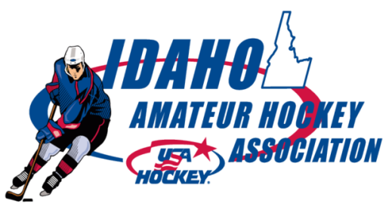


REFEREE IN CHIEF: 2016 Fall Report to IAHA

Bobby Noyes: Idaho State Supervisor of Officials

Seminars: We are offering 11 seminars this fall.

Sept 11 level 1, 2 & 3 Boise
Sept 24 level 1 & 2 only CDA
Sept 25 level 1 & 3 only Boise
Sept 25 level 1, 2 & 3 Lewiston
Sept 25 level 3 only CDA
Oct 8 level 1, 2 & 3 McCall
Oct 9 level 1, 2 & 3 Idaho Falls
Oct 29 level 1, 2 & 3 Sun Valley
Oct 30 level 1 & 3 only Boise
Nov 5 level 1, 2 & 3 Moscow
Nov 19 level 1, 2 & 3 Salmon

News: Sue Halpern of Dallas continues as the women’s Officiating Director for the Rocky Mountain District. Sue is here to assist all female officials in development and is excited to assist in any possible way. Her email is: halpern@mindspring.com

Rule 601 Abuse of Officials and other Misconduct: The District wants better and more consistent enforcement of this. Across the District and the Nation; recruitment is down and retention is down. This is true for all youth sports. A major component of this trend is the abuse and disrespect officials are subject to while performing their duty. While coaches or players may disagree with a call, the officials have Rule 601 at their disposal and it should be used appropriately.

Skin in the Game – It is important playing associations and the affiliate have some interest in officiating and the growth, development and relative success of the officiating program. Officials do not “grow under rocks”, or “on trees”; youth officials need encouragement to officiate from those outside of officiating. Adult officials require value to their experience to offset the life balances they may be making choices about.
Dangerous Hits, Injuries and Other Game Issues – With the increased knowledge of the potential damage of repeat concussions to players it is important all involved in our sport do their best to educate and avoid concussion events. In addition, the District wants all dangerous hits called strictly. Err on the “safe” side and assess a major when violent. Hits that make an official “wince” should be penalized at the most severe level the rule book allows. It is clear that we must send the message that intimidation fouls are not acceptable. Injuries as well should err on the side of safety. If there is any doubt, blow the whistle. We are not doctors and we should not try to diagnose injuries to decide whether or not to continue play. If there is any level of concern, blow it down.
Coaching seminars - Had an email discourse with Jim DiSanza on an “official segment” at all coaching seminars, 20 or so minutes, so coaches have a better understanding and appreciation for the perspective and efforts of on-ice officials.

Respectfully Submitted by Bobby Noyes

