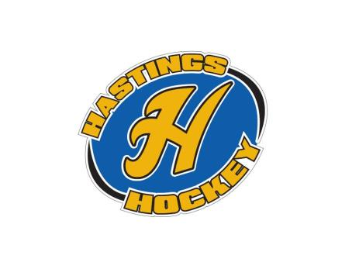Hastings Hockey Boosters JANUARY 2016 Monthly Meeting Agenda Green Mill Champions Room
January 3, 2016 at 8:00 p.m.

Roll Call: Joe Harris, Brooks Savage, Terry Johnson, Don Huemoellor, Adam Welch, Josh Colvin, KC Erredge, Tom Johnson, Travis Steele, Adam Hoffman, Jay Stark, Joe Stark, Bernadette Schaffer, Ryan Stoffel, Brain Dooley, Matt Zaruba, Randy Kruse, KC Erredge, Joe Kuhn, Jay Stark

Not In Attendance: Jeff Plank, Shannon Callahan

▪ Approval of Agenda Motion made by Matt Zaruba, seconded by Joe Kuhn motion passed
▪ Approval of Minutes Motion made by Ryan Stoffel, seconded by Travis Steele motion passed

Coordinator Reports
▪ Referee – John Klimek not in attendance
If you have any issues until the 10th, please get ahold of Jesse Viall, or Jeff Elliot
▪ Registrar – Shannon Callahan not in attendance
USA hockey is currently shut down, but there are a few coaches who still need to do modules
▪ Technology – Jay Stark/Randy Kruse
nothing to report
▪ Tournament Director – Jim Foster not in attendance
Got Sibley to join in Sugar and Spice Tournament
We NEED someone to step up and take this position – there is a stipend for this position
▪ Sponsorships – Terry Johnson
Nothing to report –
We have about 20 bread and butter sponsers – Joe would like to see some plaques to give to these sponsors to hang up.
▪ District 8 – Brian Dooley
Less of a chance for the modules coming back on –
Opt out by the 31st for Peewees
HP 14, 15 in the spring
Steve – talking about U8 girls
Difference in USA hockey and MN
Rak is going to meeting this month – going away from the Peewee and Bantam ranking system
We will need someone to take this position for next year, meet on Tuesday or Wednesday once a month for 12 months
▪ Goalie – Josh Colvin
Back to normal
Good with equipment – in house teams have had a few issues
Looking for shooters at goalie clinics – please check the website for times
▪ Secretary – Bernadette Schaffer
Nothing to report

Officer Reports:
▪ President – Joe Harris
Dedication to Sliv went well, waiting for the plaque to go up
▪ Vice President – Brooks Savage
Trying to fill in a few gaps for a few teams
▪ Treasurer – K.C. Erredge (Approval of the Financial Statements)
Financials aren’t ready yet
Director Reports:
▪ Volunteers – Terry Johnson
Nothing to report
▪ Director of Hockey – Adam Welch
Nothing to report
▪ Operations – Matt Zaruba
Nothing to report
▪ In-House Girls – Adam Hoffman
Things going well
Will need a director for next year
▪ Travel Girls – Travis Steele
Nothing to report
▪ TerMites – Tom Johnson
Nothing to report
▪ Mighty/Super Mites – Josh Colvin
Some parents aren’t happy with times of practices
▪ Squirts – Ryan Stoffel
Winter Carnival went well, parents seemed happy
Practices going well, coaches doing well
▪ Peewees – Joe Kuhn
All teams are in for tournaments
▪ Bantams – Don Huemoeller
A coach had to be asked to step down due to some inappropriate behaviors at a tournament.
▪ Jr. Gold – Jeff Plank – not in attendance
U16 won their last tournament, busy schedule
Parent from a different town complimented our organization on how efficient we are, and how welcoming the parents here are
Old Business:
New Business:
▪ 2016 Election Date and Ballot Slate – Appointment of Election Officers (J. Harris) Monday February 8th from 5-9
Positions open this year -
president – 1 year term
vice president
treasurer
director of hockey
girls in house director
squirts director
peewees director
termites director
Motion to pass the election made by KC, seconded by Travis – motion was passed
Don, Josh, Matt Zaruba, Terry, Travis, and Bernadette will be at elections
▪ Handbook Revisions (J. Harris)
Went through handbook and made revisions
Board Comment
Membership Comment A member (M. Schauer) commented on director of hockey and whether they should be in charge of hiring coaches, so there was a discussion on the wording and that there is no “1” person who is in charge of hiring.
Adjournment
motion made by Travis, seconded by KC– meeting was adjourned at 9:53 pm

Next Meeting: February 8, 2016

