BJSA Wrestling Field Trip

BJSA will be attending the University of Nebraska-Lincoln vs Northwestern University Wrestling Dual Meet on Friday, February 12th at the Devaney Center in Lincoln Nebraska.
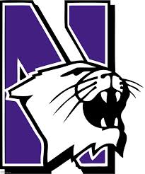
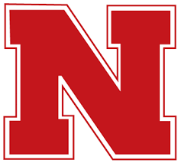


Just the Facts….

When: Friday, February 12th, 2016
Departing Time: Leaving BJSA at 6:00pm SHARP!!!
Leaving Lincoln once dual is complete
Arriving Time: Approximately 10:30pm at BJSA
Please make arrangements to have rides
once we arrive back to Bellevue.
Transportation: Taking Yellow School Bus
Cost: $10.00 per person (Adults/Kids)
Includes ticket to dual/Bus Transportation
Food: On your own. Please bring a small amount
of money for refreshments at the dual. We
will not be stopping before or after the dual.
Registration Deadline: Monday, February 4th NO EXCEPTIONS!

Total number of people attending: Adult_____ Youth_____

I hereby give my permission for my child to participate in the BJSA Field Trip to Lincoln, Nebraska to attend the UNL vs Northwestern Wrestling Dual Meet at the Devany Center on the Campus of the University of Nebraska. I release BJSA from all liabilities due to accident or injury and I do myself assume this responsibility. I also grant permission to BJSA Officials to authorize and obtain medical care from any licensed physician, hospital, or medical clinic should my child become ill or injured while participating on the field trip.

_______________________________________ _____________________
Parent/Guardian Date

