The 2025 Porter Parent Football Association (PPFA) Newsletter – Week8
The LTHS Porter Parent Football Association (PPFA) is a volunteer group dedicated to enhancing the football experience for players. Our goal is to foster a positive, memorable environment for each player, achieved through support for both the players and coaches. The PPFA funds its efforts through various fundraising initiatives, including spirit wear, player sponsorships, and volunteering.
- Twitter @LockportFootba1 - Facebook @ LTHSFootballBoosters  - Lockportfootball.com
Every Week
Varsity Players Pasta Dinner – Every Thursday @ Cooms Corner.
Week8 Pasta Dinner (Cooms Corner): 10/16 @ 4:30pm **Parent Volunteer and/or Dessert Donation**
** Ask-a-Porter ** - 10Q with Drew Silzer
Game Schedule/Results
Varsity: Porters vs Metea Valley: Fri 10/17 @ 7:00pm Game Preview
Porters over Carl Sandburg on 10/10 (28-7) Game Recap
Sophomore: Porters @ Evanston: Sat 10/18 @ 10:00am Porters lose to Carl Sandburg on 10/10 (21-28)
Freshman A: Porters vs Metea Valley: Fri 10/17 @ 5:00pm Porters A over Carl Sandburg on 10/11 (19-0)
Freshman B: Porters @ Oak Park: Sat 10/18 @ 11:00am Porters B over Carl Sandburg on 10/11 (16-0)
News and Notes
PPFA Board Meeting: 10/21 (Tuesday) @ 7:00pm – LTHS (Porter Room)
Save-the-Date: 10/31 - State Playoffs (first round)
**Lost and Found** Missing a PPFA 2025 Newsletter? Click HERE

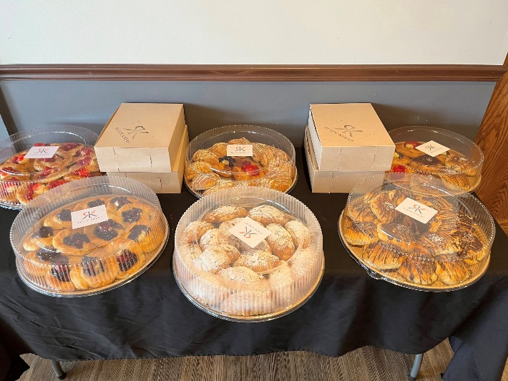
Thank you to the Kruczak Family for donating all of the breakfast pastries this past week. We appreciate your generosity!
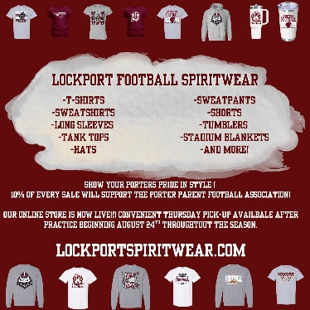
Order your 2025 Lockport Football Spirit wear HERE
Helpful Links
Spirit Wear Game Digital Tickets IHSA Football Info 8to18

