Minnesota State High School League
WRESTLING SKIN CONDITION REPORT

PHYSICIAN RELEASE FOR WRESTLER TO PARTICIPATE WITH SKIN LESION

PRIVATE/CONFIDENTIAL DATA

Name: |  | Date of Exam: |  | School:
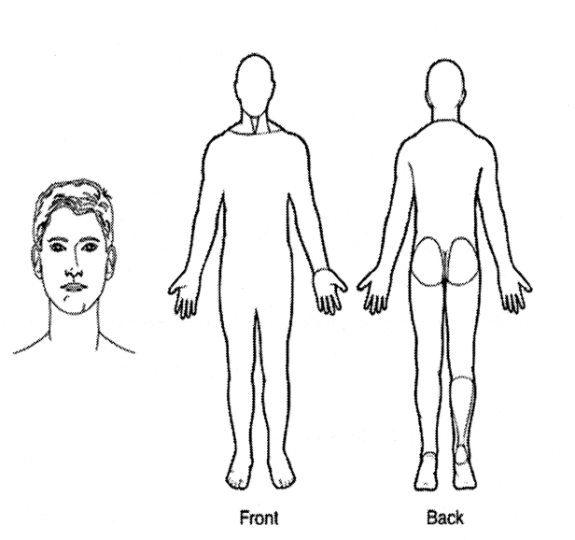
Mark Location AND Number of Lesion(s)
Diagnosis:
Location AND Number of Lesion(s):
Medication(s) used to treat lesion(s):
Date Treatment Started:
Earliest date may return to participation:
Form Expiration Date:

Physician Signature:
Physician Name (Printed or Typed): |  |  |  | Office Phone #:
 |  |  | (M.D. or D.O.)
Office Address:

Note: To ensure medical instructions and MSHSL rules are being followed, this form should be faxed to the Activities Director at the student’s school.

Note to providers: Non-contagious lesions do not require treatment prior to return to participation (e.g. eczema, psoriasis, etc.) Please familiarize yourself with NFHS Rules, 4-2-3 and 4-2-4 and 4-2-5 which states:
“ART. 3 . . . If a participant is suspected by the referee or coach of having a communicable skin disease or any other condition that makes participation appear inadvisable, the coach shall provide current written documentation as defined by the NFHS or the state associations, from a physician stating that the suspected disease or condition is not communicable and that the athlete’s participation would not be harmful to any opponent. This document shall be furnished at the weigh-in or prior to competition in the dual meet or tournament. Covering a communicable condition shall not be considered acceptable and does not make the wrestler eligible to participate.”

“ART. 4 . . . If a designated on-site meet physician is present, he/she may overrule the diagnosis of the physician signing the physician’s release form for a wrestler to participate with a particular skin condition.”

“ART.54 . . . A contestant may have documentation from a physician indicating a specific skin condition such as a birthmark or other non-communicable skin conditions such as psoriasis and eczema, and that documentation is valid for the duration of the season. It is valid with the understanding that a chronic condition could become secondarily infected and may require re-evaluation.”

Once a lesion is not considered contagious, it may be covered to allow participation.

Below are some treatment guidelines that suggest minimum treatment before return to wrestling:

Bacterial Diseases (impetigo, boils): To be considered "non-contageous," all lesions must be scabbed over with no oozing or discharge and no new lesions should have occurred in the preceding 48 hours. Oral antibiotics for three days (72 hours) is considered a minimum to achieve that status. If new lesions continue to develop or drain after 72 hours, MRSA (Methicillin-Resistant Staphylococcus aureus) should be considered.
Herpetic lesions (Simplex, Fever blisters/cold sores, Zoster, Gladiatorum): To be considered “non-contagious”, all lesions must be scabbed over with no oozing or discharge and no new lesions should have occurred in the preceding 48 hours. For primary (first episode of Herpes Gladiatorum), wrestlers should be treated and not allowed to compete for a minimum of ten (10) days. If general body signs and symptoms like fever and swollen lymph nodes are present, that minimum period of treatment should be extended to 14 days. Recurrent outbreaks require a minimum of 120 hours or full five (5) days of oral anti-viral treatment, again so long as no new lesions have developed and all lesions are scabbed over.

Tinea Lesions (ringworm scalp, skin): Oral or topical treatment for 72 hours on all skin. Oral medication for 14 days on scalp.
Scabies, Head lice: 24 hours after appropriate topical management.
Molluscum Contagiosum: May compete if treated and covered.

Parent Signature Required: |  | Revised 6/3/13

