
Waukesha West
Girls Volleyball
Player/Parent
Handbook 2015
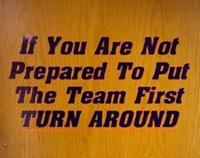

Table of Contents
Welcome letter
Coaches Contact Information
Communication - Website, Twitter, and Group Me
Program Philosophies, Goals, and Expectations
Parent Expectations
Attendance
Practice
Games/Tournaments
Bus
Playing time
24 Hour Rule
Conflict Resolution
Jerseys
Injuries
Drinking and Drugs
Captains
Cell Phones
Grades
Parent/Player Volunteers
Fundraising
Spirit wear
Signature Page

Welcome!
Dear Players and Parents,
The entire coaching staff would like to extend a huge welcome and congrats to the players as they have made a girls volleyball team! Each player worked hard at tryouts to secure a spot on the team, and you each have a great opportunity in front of you. All of us coaches see something in you as a player, athlete, and person. We believe that you will make a great addition to the team, no matter what you role is. We as coaches are very excited to get this season officially started! To the parents, welcome aboard and THANK YOU! We look forward to a great season with each of the families.

Sincerely,
The Waukesha West Girls Volleyball Coaching Staff
Coach Duley (Varsity) Coach Jordan (JV) Coach Schleicher (Freshmen)

Coaches Contact Information

Coach Duley (Varsity)
Cell Phone: 920-539-2430
  - Please do not call after 9pm, unless it is an absolute emergency.
Email: aduley@pio.carrollu.edu

Coach Jordan (JV)
School Phone:
Email: jjordan@waukesha.k12.wi.us

Coach Schleicher (Freshman)
School Phone:
Email: kschleiche@waukesha.k12.wi.us

Communication - Website, Twitter, and Group Me
The three main sources of communication between coaches and parents/players will be the West Girls Volleyball Site, Twitter, and Group Me.

West Girls Volleyball Site
This will be updated by Coach Duley regularly. This is where mass amounts of communication will take place. Any announcements for the entire program will be put up on there. To get to this site, go to www.waukeshawestathletics.com and select Girls Volleyball under West Teams. Please visit this site weekly to ensure that you are up to date on the most current information.

Twitter
Twitter is another form of communication that will be used to send out mass information. We will update followers on matches and tournaments. As well as send out any other information needed to be sent out. Each player should follow @WestGirlsVball and parents are welcome to as well! There is a link to the twitter page on the Girls Volleyball website.

Group Me
Group Me is how the coaches will be contacting all of the players on the team. It is a free app that creates a group and can send to many users at a time. Even if you don’t have a smart phone you can use this. It will come through as a text message and you can even reply to the group. Please do not use this during the school day. Remember to use appropriate language. All coaches can see what you wrote and who wrote it. If it becomes an issue there will be consequences as the coach sees fit.
Girls Volleyball Program Philosophies
The program’s philosophy is to provide an atmosphere that harbors the athlete’s growth in volleyball, leadership skills, education, and life skills. As coaches we want to create well rounded student athletes. We not only want them to succeed on the court, but also in school, and in life as well.
Program and Team Goals
Each team will set goals before the first official practice. They will set individual and team goals. It is essential that the goals are challenging but attainable. Coaches will go over this more with each team and individual on that day.
The Volleyball program’s goal every season is to improve every individual in all aspects of the game. To cross train players in different areas and to increase their knowledge and love of the game.
Expectations of Players
As student athletes the coaches will hold you to the highest standards. We expect that you are working hard in school to keep up grades, acting appropriately outside of the gym, and working hard in the gym. When at practice or at a game we expect that you are putting forth the maximum amount of effort that you physically and mentally can handle. This means that every drill no matter how easy or hard you are working as hard as you can. We expect that you will not give up on yourself, but not give up on your teammates as well. You should work hard not only to better yourself, but to better the team. This means that the word “can’t” is not allowed in the gym. If you are caught saying the word “can’t” you owe coach 5 pushups saying I can. With a positive I can attitude the team will be better and go farther.

Expectations of Parents
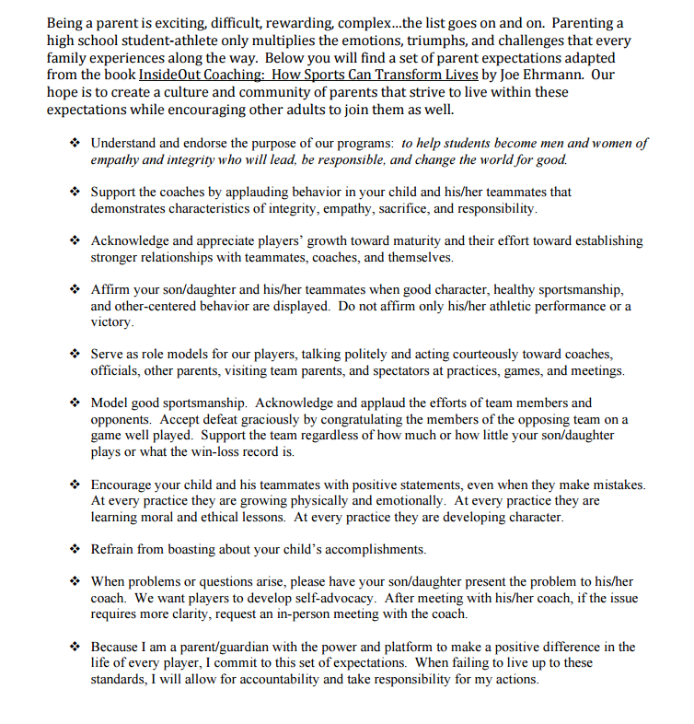
Parent Expectations are taken directly from the Parent Guide.

Attendance
Practice Attendance
Attendance is Mandatory at every practice; there will be very few exceptions for this. You will be allotted 3 unexcused practices before you are dismissed from the team. Excessive excused practices combined with unexcused practices will be handled at the discretion of the coach. However, these allotted misses are not allowed before a match or tournament (see below).
Unexcused Practice
An Unexcused practice is when a player misses for any reason that is not excused, or if the player does not inform the Coach of an excused practice before practice starts.
Examples: If a player goes to a football game instead of practice or if a player has a Doctor’s appointment, but doesn’t tell the Coach until the next day.
Excused Practice
An excused practice is when a player misses for one of the following reasons; Doctor/Dentist appointment, Illness (went home sick/didn’t go to school/was not in school for the last 3 classes or 50% of the day), funeral, or something required for a class (makeup test, field trip, extra help).
While these things are excused please try to book appointments or help from a teacher before school or after volleyball. If the player does not tell coach before practice that she will be missing she will be marked unexcused. You must have a signed note from your teacher that you were getting help, or a Doctor/Dentist’s note to hand to your coach the next day.

Attendance Cont.
Attendance before a Match/Tournament
Attendance before a match or tournament is essential. You are not only hurting yourself, but your teammates by not showing up the practice before a match or tournament. By missing before a match you put yourself in a position to be beat out by another player for playing time. It is Coaches discretion on playing time if you miss before a match or tournament.
Showing up Late to a Practice
If you will be late to a practice you must have a note from you Doctor/Dentist or teacher. Being late to a practice because you were getting taped by a trainer (get taped before practice starts), or hanging out with your friends after school is not acceptable.
Consequences for Habitual Poor Attendance/Tardies
- After a players first unexcused absence they will not start the following match/tournament.
- After two unexcused absences there will be sit down meeting with coach, athlete, and parent. Athletic Director will be notified.
- After three unexcused absences the player will be asked to leave the team.

Coaches have the discretion to modify consequence as they see fit especially if there are multiple tardies and excused absences.
Practice
Practice is where every player gets the most touches and is very important in improving individual/team skills and team chemistry. This is where the Coach will make decisions on who is starting, playing time, and playing certain positions. It is essential to the team that each individual player works hard every practice, is on time/at practice, and helps with the set up and take down. Any College or Olympic player can agree that practice is where they fine tuned their skills.
Each practice the team will be challenged in different drills and games. Sometimes there will be a scrimmage between the teams, during these scrimmage the teams will have different goals to try and better the team.

Practice Attendance
Please be on time/at each practice (see attendance policy).

Set up/Take down
The courts need to be set up by the time that practice starts. If practice starts at 3:30pm the net will be set up by 3:30pm not 3:31pm.
Everyone should be helping with this. If not everyone helps, the coach will assign jobs to each person. It is your teams job to ensure that the net is set up properly so that there are no safety issues.
The Jv and Freshmen teams are responsible for the setup of the nets on practice nights. The Varsity and boys team is responsible for taking down the nets on practice nights. There will be some exceptions that this may change, see your Coach if there is an exception.

Practice Cont.
Practice Attire
Volleyball shoes, knee pads, water bottles, and practice t-shirts are required at every practice. You need to be properly equipped for practice so that you can participate in every drill. Your team will decide which color practice tshirt or “fun tshirt” they will wear to practice that day. Cut offs (that show a bra), sports bras, tank tops are not considered proper practice attire and the players will be asked to change if they are wearing it.

Lockers
Each player is required to have a locker in the girls athletic locker room. They should keep these lockers locked at all times. Please keep belongings (backpacks, cell phones, etc.) in these lockers and do not bring them out to gym.

Weights/Conditioning
In order for our program to get bigger, faster, stronger and to compete at a high level with our competiton, a half hour of weights/conditioning will occur at every practice. Each team will do this in addition to their 2 hour practice. On the online schedule this is not added on due to gym reservations. Please manually add on an extra half hour. Please see your coach with questions.
Freshman and JV will end at 6pm on most nights, coaches will notify you with exceptions.
Varsity will end at 8pm on most nights, coaches will notify players with exceptions.

Games/Tournaments
Attendance at all Games and Tournaments is mandatory (see attendance policy for details).
Home Games
Each team is responsible for setting up the nets for home games. The boys will be practicing until 4:30pm. At 4:30pm the Varsity/JV net and the Freshman net will need to be set up. This needs to be done by 4:45pm, no exceptions. It is essential that everyone from the team helps with this so that it is done quickly and efficiently.
- Varsity is responsible for the net and net height on both nets.
- JV is responsible for the poles for both nets, and bringing down the curtain and putting up the basketball hoops (ask your Coach how to properly do this).
- Freshmen are responsible for the pads, antennas, game balls, and flags for both nets.
Before a Match:
JV and Freshman teams need to be dressed and on the court by 5pm.
Varsity need to be dressed by 5pm as well, even if you aren’t line judging.
Watching the other teams:
Any Varsity player that isn’t line judging is expected to watch the Freshman and JV games until the JV court has a score of 15.
JV (that aren’t line judging) and Freshman are expected to watch the entire Varsity Match.

Per the WIAA – All players line judging must be wearing tennis shoes! This is for the safety of the players and for the line judge.

**Homework can and should be done during this time while watching the games**
Games/Tournaments Cont.
Away Games
Leaving West:
Each player is expected to be on the bus by the departure time. If you are not on the bus the bus will leave without you (see the bus policy for details). If the bus leaves without you and you get a ride to the game from your parents you will sit the first game or more at your coach’s discretion.
Before a Match:
JV and Freshmen are expected to be on the court by 5pm.
Varsity needs to be dressed and on the court by 6:40pm (discuss with coach pre-game rituals and jersey colors).
Watching the other teams:
Varsity is expected to watch the Freshman and JV games until the JV court has a score of 15, then go get changed.
JV and Freshman are expected to watch the entire Varsity Match.
**Homework can and should be done during this time while watching the games**
Leaving the site:
All players are expected to ride the bus home (see bus policy for details).

Games/Tournaments Cont.
Home Tournaments
Please make sure you have water/Gatorade to stay hydrated. Also make sure you either have food/snacks to eat or have money for buy food. Make healthy decisions while at tournaments to ensure that you will be able to play your best.
Players are not allowed to leave a tournament to go out and get food. They must remain at the facility.
Other teams that do not have a tournament this day will be expected to sign up to help out (see volunteering for more details).
Away Tournaments
Leaving West:
Each player is expected to be on the bus by the departure time. If you are not on the bus the bus will leave without you (see the bus policy for details). Please be dressed in spandex, jersey, and warm up (if applicable) before getting on the bus. If the bus leaves without you and you get a ride to the game you will sit the first match or more at your coach’s discretion.
During a Tournament:
Please make sure you have water/Gatorade to stay hydrated. Also make sure you either have food/snacks to eat or have money for buy food. Make healthy decisions while at tournaments to ensure that you will be able to play your best.
Players are not allowed to leave a tournament to go out and get food. They must remain at the facility.
Leaving the site:
All players are expected to ride the bus home (see bus policy for details).
Bus Rides/Policy
All athletes must be on the bus by the leave time or they will be left behind. Coaches will let you know ahead of time what time the bus is leaving. It is your responsibility to be on the bus before that time to insure you do not miss the bus. If you need to get taped by the trainer do it immediately after school before you get on the bus. Coaches will not wait for you.
If you miss the bus you need to get a ride from your parent(s) to the game/tournament. You will sit the first game of first match. The time sat is up to your coach and may also factor in how late you were/how frequent this occurs.
2 Way Bus vs 1 way Bus
A 2 way bus will take you to the tournament and back. This is the case if we are leaving Waukesha. If we are traveling to North, South, or CMH there will be a mandatory one way bus. The 1 way bus will take you to the facility, however, it will not take you home. You are required to find your own way home, Coaches cannot give you a ride. Please figure out your ride situation before that day to ensure you will have a ride and can get home.
Parents taking you home
If there is a special circumstance and your parents need to take you home after an event that is a 2 way bus, they need to get permission from the West Athletic Director. You will need to contact him at least 48 hours in advance, or you will not be allowed to ride with your parents and must be on the bus. Permission will be granted in very rare situations. Plan on riding the bus every time there is a 2 way bus.

Coaches must stay and wait for every athlete to be picked up. As a courtesy to the coaches please make sure you are timely. If it becomes a habit that the same athlete is always being waited on, coaches may request a meetin with your family.

Playing Time
Playing time is based off of ability, how the girls play together, attitude, attendance, and hard work. The girls that will “get the job done” are the players that will be on the court. Coaches will make the best decisions for the team for that game/match/tournament. While winning isn’t everything it is something that we are striving for, and we will put the girls out there that we believe will do that.
There are many factors that go into deciding who is on the court and what position they are playing. If the player has a concern or question about either of these please contact your coach directly. As a player you should be asking your coach what you need to improve on/work on to get the playing time or positioning you desire. If the player feels that their concern is not being addressed the player should ask to have sit down meeting with the coach and Coach Duley. Please note that the 24 hour rule is in place and should be taken into account before addressing the coach about playing time.
Parents, as much as we would love to discuss your child with you, we as coaches believe that your daughter should learn to advocate for herself. It is a very important life skill that we as coaches want the player sto learn. We will not discuss playing time with parents, we would be happy to discuss (with the player present) things she needs to improve on. If the player has a concern about her playing time she is always welcome to come and discuss it with her Coach. If after discussing with Coach what needs to be done to see the court more and the player is still not satisfied we can invovlve the Varsity Coach or Athletic Director in the conversation. Conversations about playing time will not be dealt with over the phone or email, it must be done in person.
24 Hour Rule
Players may not ask the coach about playing time, why they didn’t play, etc. within 24 hours of the match/tournament. This is so that all parties involved have time to cool down. If a player asks the coach before 24 hours the coach will let the player know how they can discuss with the coach after the 24 hours are up.
Conflict Resolution
This has been taken directly from the Parent Guide.
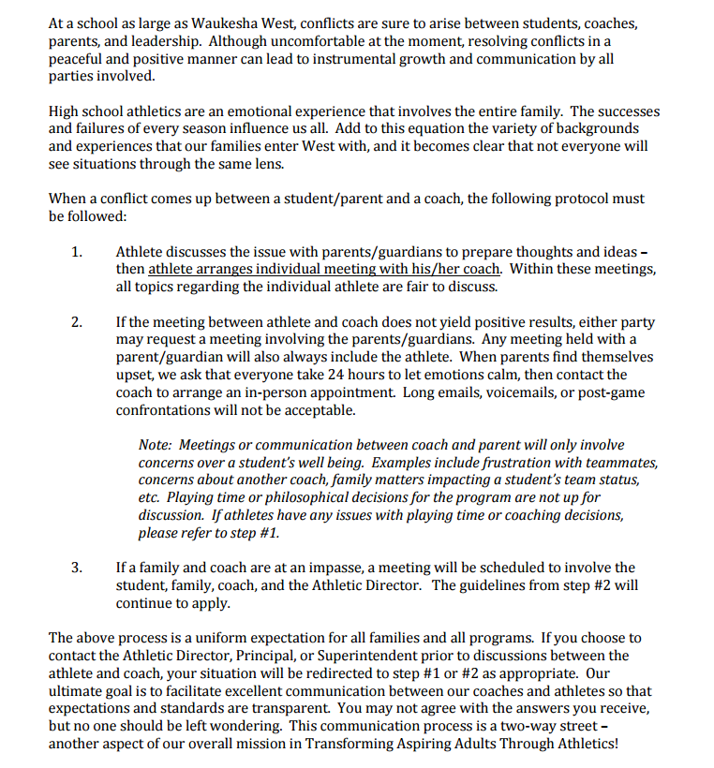

Injuries
Any injuries that occur during practice or during a game will be handled by the Athletic Trainer or if serious enough by emergency medical staff.
Any major injuries (broken bones, concussions, etc.) that would not allow you to play should be discussed with your coach and Athletic Trainer. You will be required to be cleared before you are allowed to practice. We want you to be fully healed before you try to come back and play. Play while injured will only make the injury worse and recovery time longer. Please be smart. Talk to your coach or Athletic Trainer if something is bothering you.

Seeing the Trainer
The trainer’s room is not a place to hang out during practice. It is a place to seek medical assistance. If you need to get taped or have physical therapy done by the trainer it must be done before practice/match. This is not an excuse to be late to practice; you have plenty of time before practice and matches to see her. Discuss with your coach if there is an issue.

Drinking and Drugs
The following Drug and Alcohol policy is taken directly from the Co-Curricular code:
A participant will be suspended from interscholastic athletics and/or activities for the following reasons:
1. Possession or use of tobacco including chewing tobacco.
2. Possession, use, distribution or sale of illegal drugs or controlled substances, including "look alike" drugs as defined by Wisconsin State Law.
3. Possession, consumption, or sale of intoxicants including all fermented malt beverages, (including beer, non-alcoholic beer, malt liquor) wine and all intoxicating liquors as defined by Wisconsin State Law.
4. Failure to leave an environment in a reasonable amount of time in which alcohol and other drugs are being used illegally.
5. Attending a party, gathering, social event, or being in a motor vehicle where the student was aware or should have been aware that alcohol or drugs were being illegally consumed by minors, school age students, college students or persons under 21.
6. Conduct, in or out of school, including any criminal act, misdemeanor, or serious municipal violation, which makes students unqualified to represent the ideals, principles, and standards of their school, community and the Wisconsin Interscholastic Athletic Association.
7. Any of the other offenses listed in Appendix B under “unacceptable conduct”.

Drinking and Drugs Cont.
Alleged violations of the Rules of Conduct may be presented to the Athletics and Activities Director or his/her supervisor or designee by a parent, coach, advisor, student, teacher, administrator, school district employee, law enforcement officer, or other responsible community member. Unless impractical or untimely, all alleged violations must be submitted in writing, must be signed, and must state the essential supporting details of the alleged violation. The Athletics and Activities Director shall determine the validity of the alleged violation, and shall take the following action:
1. Give the student oral notice of the alleged violation.
2. Provide the student an opportunity to present his/her version of the incident.
3. Give the student an explanation of the information, which the school authorities have received, that may support a finding that he/she has violated the Rules of Conduct.
4. The Athletics and Activities Director will have communication with the parents.
5. The Athletics and Activities Director must make a determination as to whether the student has violated the Rules of Conduct. If it is determined that the student has violated the Rules of Conduct, the Athletics and Activities Director shall provide the family with written notice of this suspension and the reason for said suspension.
6. The students and parents shall have the right to appeal. You have seven (7) days to appeal upon notification from the school.

Drinking and Drugs Cont.
Penalties – Athletic
· First Violation: Suspension from participation for up to 20% of the entire season's contests (refer to Appendix A).
· Second Violation: Suspension from participation in 50% of the entire season's contests (refer to Appendix A).
· Third Violation: Suspension from participation for one calendar year from the date of notification.
· Fourth Violation: Permanent suspension from participation in high school athletics and activities.
In all cases, the student will be suspended immediately from participation in the above stated number of contests in the current sport. If the student is not participating in athletics at the time of the violation (or insufficient contests remain in the current season) the suspension shall be enforced at the beginning of the next sport season in which the student participates. Any student who attempts to make up his/her suspension through involvement during another sports season, must participate in that sport for its duration after the suspension has been served in order to fulfill the disciplinary requirement. During suspension, athletes will be expected to attend all scheduled practices and team meetings unless otherwise directed by the activities director.
Dually Participating Students
When a student is involved in both athletic and major activities, consequences must be given in the athletic area. Consequences imposed in athletics may be taken into account when imposing activity penalties.

Drinking and Drugs Cont.
Honesty and Cooperation Clause
Students involved in co-curricular athletics and activities shall be verbally counseled about honesty before and during disciplinary procedures. Since honesty is expected, any finding of dishonesty during disciplinary investigations or during disciplinary procedures may result in an extension (up to doubling) of any penalty authorized in this guideline. All students are expected to cooperate with investigations. If a student does not cooperate, as determined by the administration, they could be subject to suspensions from athletic/activity events and/or school.
Violations Requiring Additional Penalties - Drugs
Any code violation that involves the following will result in an extension (up to doubling) of any penalty authorized in this guideline: organizing, hosting, or having gatherings where drinking or use of controlled substances takes place; selling, providing, or distributing alcohol or controlled substances, or; using anabolic/androgenic steroids, or human growth hormone.
Appeal Procedure For Co-Curricular Activities and Athletics
The sequence of appeals will be directed to the building principal, then to the superintendent or his/her designee. The building principal and superintendent or his/her designee may uphold, modify or reverse a penalty imposed by the athletics and activities director following an appeal. An appeal must be submitted in writing (letter, e-mail, and/or fax) and must include a reason(s) for the appeal. The appeal must be submitted to the building principal within seven (7) days upon notification of suspension from the athletics and activities director at the school. After receiving the decision from the building principal, an appeal to the superintendent or his/her designee must be received within seven (7) days. The penalty for an offense will begin immediately upon conclusion of the investigation

Drinking and Drugs Cont.
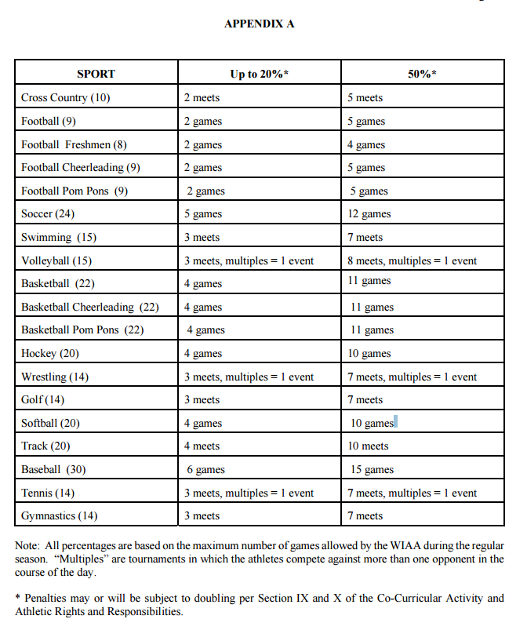

Drinking and Drugs Cont.
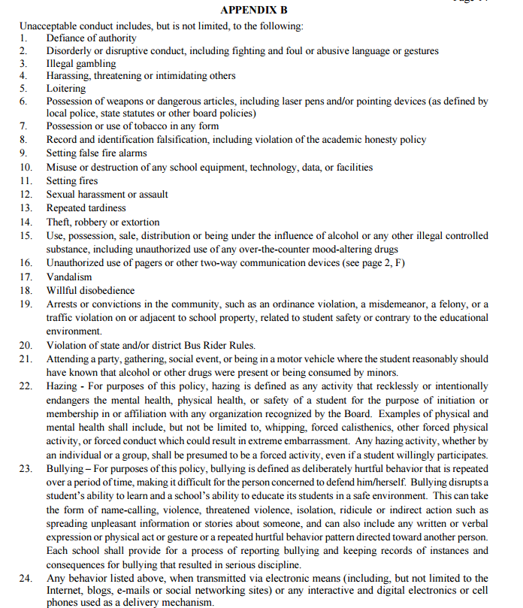
Jerseys
All Jerseys will be handed out at the parent/player meeting before the season begins. At this meeting the player and parents are asked to fill out a jersey checkout form. There they will list any damages on the jerseys. The coach will sign off of these damages. If you do not list damages and get them signed by a coach you will be responsible for the damages. If there are any additional damages made to the jersey throughout the season you will also be fined for those damages. The fines are listed next to each jersey. For Varsity players this also applies to the bags.
Freshman and JV players will be given 2 jerseys each, one long sleeve and one short sleeve jersey. Varsity players will be given 3 jerseys, two short sleeve and one long sleeve, and a bag each.
Washing
Each jersey needs to be cold washed and hand dried. I recommend letting them dry on a hanger so they do not get wrinkly. If the jersey gets put in the dryer it will shrink and you will be charged! If there are any questions please see the jersey tag or the coach.

Captains
Captains will be picked within the first week or two of practice. It doesn’t matter if you were a captain last year or never been a captain before. Coaches will get input from each player on the team through a survey. They will look over the survey, evaluate every player and chose captains from there. Being a Captain is a privilege that should not be taken lightly, and can be revoked at any time at the coach’s discretion.
Cell Phones
Cell phones are not allowed to be used in locker rooms per the School District’s policy. You are allowed and should store them in your volleyball locker. Cell phones are allowed on the bus and should be used to call/text home before we arrive at West. Cell phones do not belong at practice. Any cell phone found in the gym being used will result in a consequence for the player and team, as seen fit by the coach. If it becomes a habit a sit down meeting with the parent may be necessary.
Grades
These athletes are most importantly students first. Per the Co-Curricular code every student athlete must maintain a GPA of a 2.0, with no more than 1 F during that quarter to remain eligible to play. If you have any questions about the grade policy see your Coach or the Athletic Director.
In order to make sure that our athletes are maintaining their grades and doing their work, Coaches will be performing weekly grade checks. Grade Check Wednesday - every Wednesday before practice the athletes will present their District IPad to the Coach and show them their grades.
If coaches are concerned about grades getting too low or the athlete has concerns we will discuss a plan with them and involve a parent if necessary.

Parent/Player Volunteers
All parents and players are expected and required to volunteer. The amount that each player and parent needs to volunteer may vary with each team. All expectations will be discussed at the parent player meeting and are subject to change at any point.
Parents – Will help run concessions for all home matches and some tournaments. For some tournaments running the basket raffle may also be required. There are also a couple instances where parents will need to line judge (middle school night and playoff matches). Parents will also be asked to host or co-host a team dinner during the season.
Players – Will be line judging home matches and tournaments. For tournaments keeping the score and book may also be necessary.
JV and Varsity players are also required to assist at the fall middle school camp. There will be a flyer sent around about this.
Parents (sometimes players) if you signed up for something and you can no longer make it, it is your responsibility to switch with someone. Please notify the Varsity Coach of the conflict and who you are switching with.
As Coaches we understand this is a lot to ask of the players and coaches, however, we would not be able to continue our program without your help with these duties. If you have any questions about volunteering please contact your coach.

Fundraising
Fundraising is how we are able to fund our program. It benefits the entire program and not just the Varsity level. It is important to realize that we believe that every team is important and each team is getting something out of the fundraiser.
This year we will be doing a Calendar fundraiser. Each player is required to sell a certain number. People that buy the calendar do not need to be present to win, so you can sell it to your relatives in other states! It will be discussed at the parent/player meeting how many calendars each player needs to sell and what the calendar is all about.
The fundraiser will fund the spandex with embroidered logo that every player receives; practice t-shirts, and Volleyball bags that will stay at the Varsity level for many years.
We appreciate your help fundraising and understand that it can be hard, but we believe we have come up with something unique, fun, and something that will sell!

Spirit wear
We will be going through Burghardt Sporting Goods for Spirit Wear. They are a local company out of Brookfield. All spirit wear is optional, however, some teams may decide to order something for warm ups from the site. There will be a link put up on the Waukesha West Girls Volleyball sight with all of the information (close date). Coach Duley will pick up the order early September and distribute to the girls at practice.
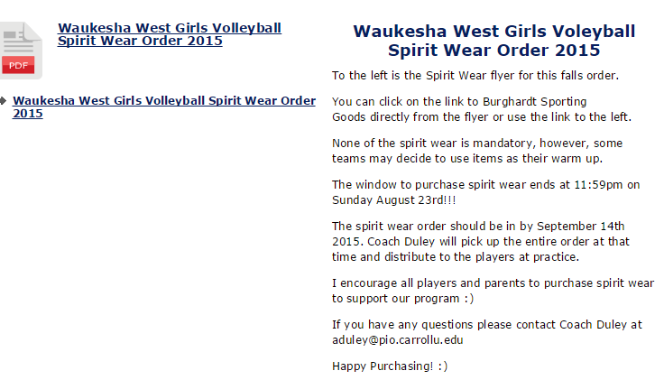

I have read and understand the Parent/Player Handbook and agree to follow these rules and regulations as well as the Athletic Code and Parent Guide. By signing this agreement, the player and parent signify they understand the rules and regulations. Rules included in this manual may only be the basic guidelines and other rules may be added throughout the playing season. I understand the communication procedures outlined in this handbook and will follow these procedures should an issue arise during the season. The coaches may have team rules in addition to the ones outlined in this handbook. As a player on that team you are expected to abide by them and the coaches will give consequences as they see fit.

____________________________________________________ _________________
Parent(s), Legal Guardian(s) Signature Date
____________________________________________________ _________________
Parent(s), Legal Guardian(s) Signature Date

____________________________________________________ _________________
Player Signature Date
____________________________________________________ _________________
Player Name (Printed) Team

This page is must be turned into the Coach before a player can compete in a match.

