If you’ve been granted editing rights to your team’s page, you’ll see a “light switch” button in the upper-right corner of the screen.



LAYOUT CONTAINERS
Layout Containers house your content and allow for formatting control as far as column styling. They can also be mirrored from one page to another.
STEP 1
To create a new "layout container" make sure you are in "Edit Mode" and select "Add Layout Container."
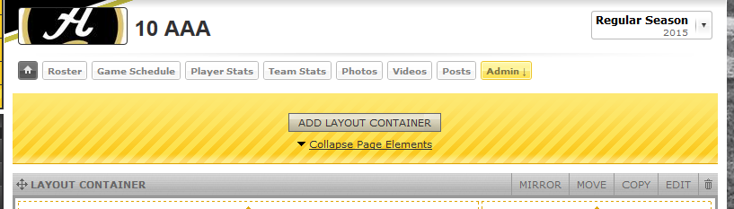
STEP 2
Select New Layout Container
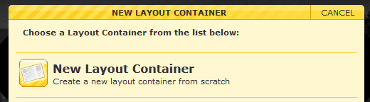
STEP 3
You can then select the column layout from the choices shown in image below. Then hit "Create Layout Container" to finish and it will populate on the page for you.

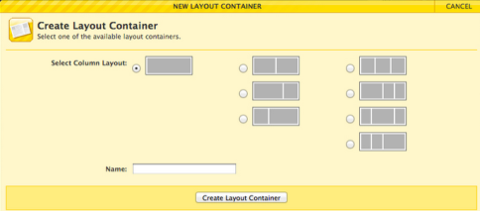
PAGE ELEMENTS
Page elements allow you to populate your team page with content such as text, images and links. There are many more options available as well.
STEP 1
Make sure you are in "Edit Mode" on your team page and click on the "add page element" icon wherever you would like to add one.
The collapsed "add page element" icon will read accordingly when you roll over it with your cursor (see letter A in below image).
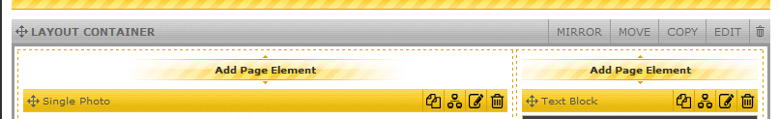
STEP 2
Choose the page element you want to use from the list that populates in the lightbox that appears.
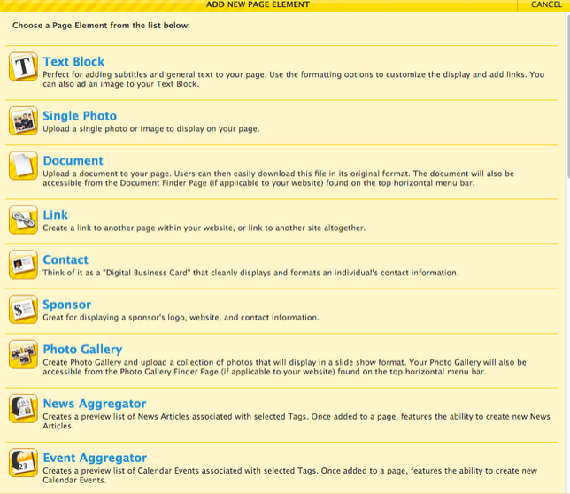

NEWS AND EVENTS AGGREGATOR
The use of these two "Page Elements" is highly recommended as they add neatly organized data stream displays to engage and draw further interest from general users. The "News Aggregator" is for News Articles, and an "Event Aggregator" is how one would add a Calendar Event to track things such as practice times or other non-game related scheduling.
News Aggregator:
STEP 1
To Edit the settings of the "News Aggregator" make sure you are in Edit mode on your team page and then select "Edit" on the top right of the "News Aggregator."

STEP 2
To add a new News Article, click on the New News Article icon
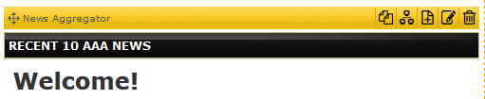
STEP 3
Enter the appropriate information in the new article window. You must change the Status to “Published” in order for your item to appear in the aggregator.
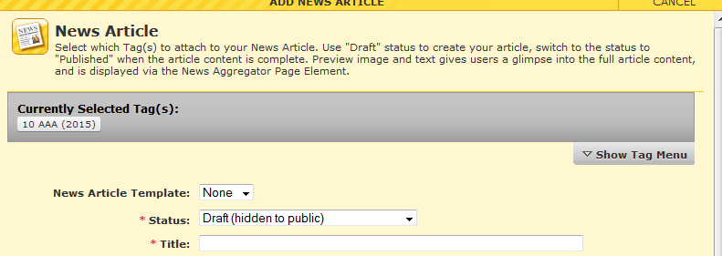

SCHEDULING – MANUAL GAME CREATION
STEP 1
Navigate to the Game Schedule page of the League/Team in question, and flip into Edit Mode. You should then see the option to “Add Game” in the middle of the display.
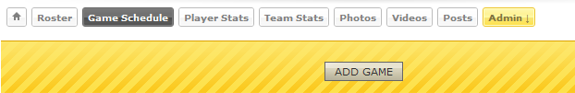
STEP 2
Once clicked into the “Add Game” interface, you will be able to select teams and configure settings for your game.
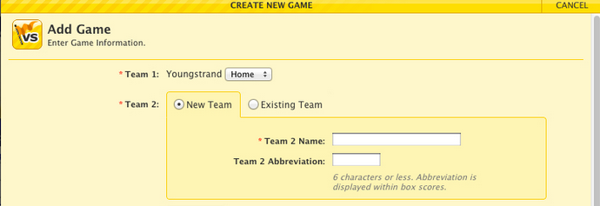

SCORING YOUR GAMES
STEP 1
Open your Game Schedule and click the QS hyperlink at the far, right side of your game.

STEP 2
Change the status of your game to Final, then enter the score of your game and click Save.
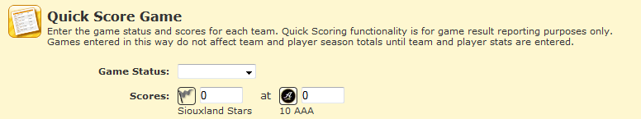

RSS/ICAL FEEDS
The Sport Ngin platform has always been crafted with ease of use in mind, so we have long put an emphasis on being flexible in the manner with which we make the data on our platform available to other applications such as RSS readers and iCal consuming calendars.
On any News/Event Aggregator, users can click to display the URL of one the data feeds the website contains in either RSS or iCal format. The RSS and iCal feeds presented in the light box will adjust accordingly as different tags are selected on the Aggregator/Calendar.
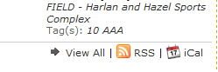

ROSTERING
STEP 1
To add a player to your team page roster, click on the roster button on your team page and select "add player."
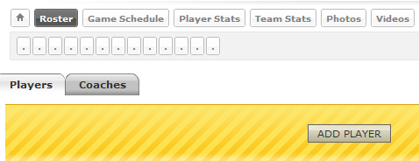
STEP 2
Select the method for adding your players.
Here you can use the Create New Player option, or you can try and use the Add Player from Network Member Directory to find their players. Either method is fine.
