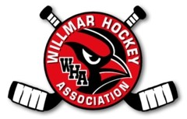
March 5, 2015

Members Present –Melanie A, Kent D, Tony A, Justin Bos
Meeting called to order at 6:00 PM

End of Year Banquet
- March 26 – Hoping for Middle School
- Idea not to have potluck – just cake & water/lemonade
Treasurer – Ice paid through Jan.
Try Hockey for Free – 33 kids participated – getting Mite gear
Off-Ice –
- Coordinate jersey return
- Goalie gear return
- Needs Rink Rat hours & tshirt sizes
Smith Open
- Need 2 parent volunteers from each team
Tournament
- Suggested if we have more ice on weekends to have more home games for teams not in the tournament
Girls
- Need to plan events
On-Ice
- Already thinking about coaches for next year – trying to have it set by July
March Ice – going well
D5 –
- USA Hockey & MN Hockey are wanting a Director of Hockey for every association – Paid training – would provide a point of contact for every association
New Board Members Needed – 8 Positions available (15 board members is ideal with 5 going off every year)

Meeting adjourned 7:30pm

