6:00 Dynamic warmups:
High knees, butt kicks, Frankenstein, Carioca, Side lunges, Cherry Pickers, Lunges w/ twists, Knee hugs, quad pulls, sprint to 2^{nd,} Sprint to 1st base
Arm Stretches
Arm circles forward/backwards, Cross body arm pulls, Palm to palm in front / behind, Chicken Wings, shakers
6:05 Grip Checks / Throw Progression: New Partner than last time (10 throws each) / Catcher Breakout (30m)
- One Knee Wrist Flips
- One knee: Just shoulder and elbow to throw, front side pulling down and in. Snap off all the way over the front knee Receiving the ball (position/two hands/transfer) Torso should collapse over thigh of left front leg, throwing hand should end up touching outside ankle of left leg.
- Torso Turns-10 each (body facing partner, rotating only the upper half of body sideways)
- Flamingo (right, left throw) Good analogy is partners are facing each other image a closed door; turn the whole body sideways to an open-door position. start with partners facing each other, right foot turns sideways to right, hips and rest of body turns to the right to generate hips and abdomen in the throw. Make sure the glove hand is pointing at target and being pulled towards the body as they throw the ball.
- Long toss- keep backing up
- Quick transfer game: first to 25 wins
6:25 Paddle Ground Ball Work / Short Hops
- Ground ball shuffle feet
- Ground ball shuffle and throw to 1B
- Catch & Throw
- Popups
Short Hop Work
6:35 Loop Drill:
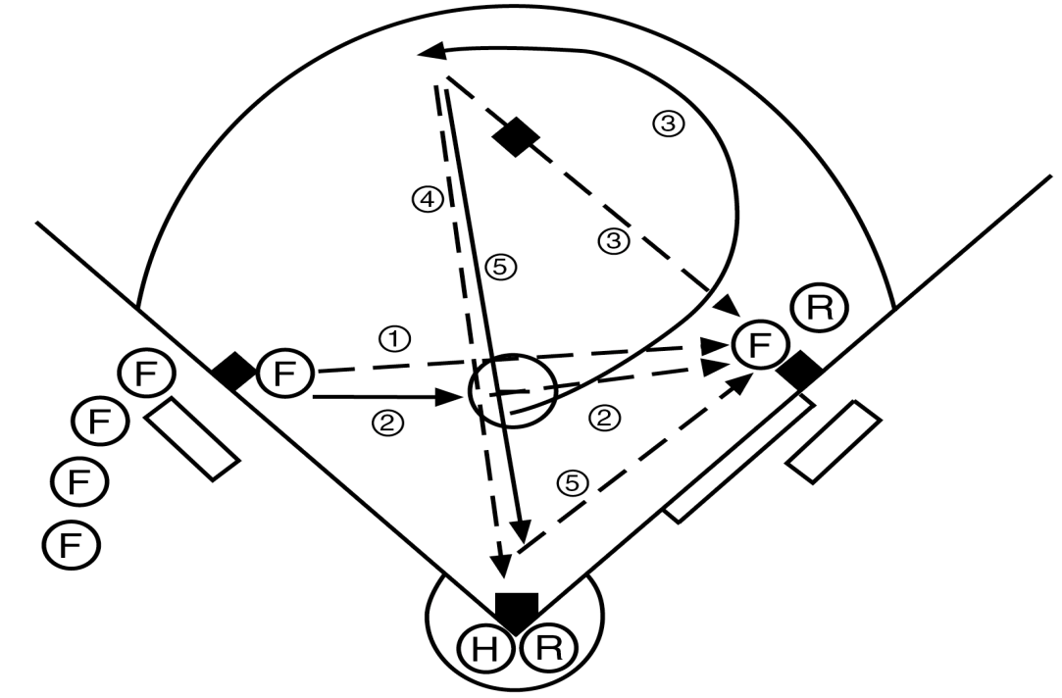
Procedure: There are players at first and third, a ball in the pitching circle, and a player catching with a fungo hitter at the plate. One player works through all of the plays that follow (see figure 11.15).
1. A ground ball is hit to the third baseman, who throws it to first base.
2. The player (third baseman) runs and picks up the ball in the circle and throws to first base.
3. The player then loops around second base toward the shortstop position and is hit a ground ball, which she throws to first base.
4. The player receives a ground ball at the shortstop position and throws it home.
5. The player charges the plate, and the catcher rolls a bunt, which the fielder throws to first base.
After each player finishes, she rotates to the next clockwise position. On-deck fielders wait their turn at third.
Variation: Begin at first base and throw the first three balls to third base. Reverse the loop so the batted ball is a backhand. The bunted ball is thrown to third base.

Split Infield Drill: 5 balls each then rotate 1 spot to the right
2B to 3B, 3B applies the tag at the base drops in the bucket
SS to 1B, drop into the bucket
SS to 2B, 2B TO SS, drops into the bucket
3B to 1B, drops into the bucket
Outfield Drills:
- Groundball, Flyballs x3, Pop Up, run in and dive for the ball
- Tweener Fly balls (Jim): Catching Fly balls between the outfielders
  - IMPORTANT THAT THE FIELDER IN FRONT RETREATS AND TRIES FOR A BALL OVER HER HEAD!!!!!
Outfielder yells “MINE,” other fielder yells out the other players name catching it-gives the fielder confidence that they aren’t going to run into anyone.
Progression 1: Regular Tweeners-Ball between both fielders one calls off the other
Progression 2: Start on Stomach facing coach, get up when the ball is in the air
Progression 3: start on Stomach facing towards outfield fence, get up when you hear go
- Find the Fence Defensive Popups
7:15 Bucket Game: 1st to 20 points Wins!
1 pt: hit bucket on the bounce, 2 pts on fly, 3 pts hit the mask, 5 pts knock the mask off the buckets
7:30 Hitting Drills / Bunting Drills: 10 Swings per station
Bunting: 8 balls every girl x2
High Tee
2 Tee Drill
Close Feet / Stride Tee
Front Toss
8:00 Relay Race

