CC: CIF Section Commissioners

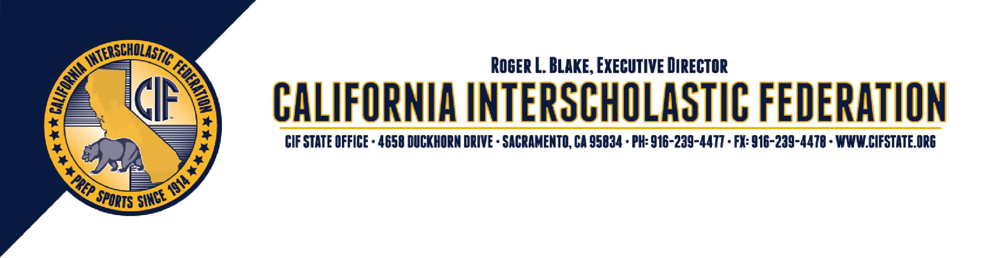
From: Duane Morgan, State CIF Wrestling Rules Interpreter Brian Seymour, Senior Director

Date:

August 1
, 2014

To:

Wrestling Officials’ Associations & Instructional Chairperson

Re: 2014-15 Rules Interpretation Meetings

You are requested to attend one of the wrestling rule interpretation meetings listed below. As the individuals and associations who are responsible for the training of high school wrestling officials, you know the importance of statewide consistency in the interpretation and application of the rules. These meetings are crucial to that endeavor, as well as to your work in instructing the officials who are members of your local associations.

Attendance at one of these meetings is mandatory for your association. The State CIF, supported by the ten sections, requires that the instructional chair, or designee, of each association attend this informational meeting. Fulfillment of this requirement is one condition of maintaining your association’s accreditation. Associations that fail to attend one of the meetings, their membership will not be eligible for post-season playoff assignments at the section and state level. If your association is a “multi-sport” organization, please be sure that your wrestling instructional chair, or designee, attends. As a reminder any official who is returning or will be nominated to work the 2015 CIF State Championships, must attend one of these clinics to be eligible to work the 2015 CIF State Championship.

Duane will present information received at the National Federation Rules Interpreters Clinic, including discussion of new rules and points of emphasis. The continuing role of officials and the State CIF sportsmanship program, “Pursuing Victory with Honor” will also be a topic of discussion so that officials are equipped to advance and enforce this very important statewide priority for all sports.

If you are unable to attend, or are no longer involved in the instructional work of your local association, please pass this letter on to those who have instructional responsibility in your area.

Saturday, September 27th | Tuesday, October 7th | Saturday, October 11th
Redwood High School 9am-12am | Oak Grove High School 7pm | Irvine High School 9am-12 noon
1001 W. Main St. | 285 Blossom Hill Rd. | 4321 Walnut Ave
Visalia, CA. 93291 | San Jose, CA. 95123 | Irvine, CA. 92604
Contact is Dave Watts | Contact is Duane Morgan | Contact is Randy Hartman
(559) 802-7305 | (408) 224-2994 | (619) 607-1498
SuperD64@gmail.com | dmorgan@cifccs.org | Randall.Hartman@CH2M.com
 | Saturday, October 25th
 | Natomas High School 9am-12 noon
 | 3301 Fong Ranch Rd.
 | Sacramento, CA. 95834
 | Contact: Don Martinez
 | (916) 807-4496
 | sawaprez@hotmail.com
If you have any questions please contact Duane Morgan at the CIF – Central Coast Section Office 408-224-2994 or at dmorgan@cifccs.org
AN EQUAL OPPORTUNITY ORGANIZATION • MEMBER NATIONAL FEDERATION OF STATE HIGH SCHOOL ASSOCIATIONS

AN EQUAL OPPORTUNITY ORGANIZATION • MEMBER NATIONAL FEDERATION OF STATE HIGH SCHOOL ASSOCIATIONS

