2017-18 WRESTLING COACHES PRESENTATION
RULES UPDATES
Questions: Contact Duane Morgan, dmorgan@cifccs.org
This presentation can be found electronically on CWOA.CA
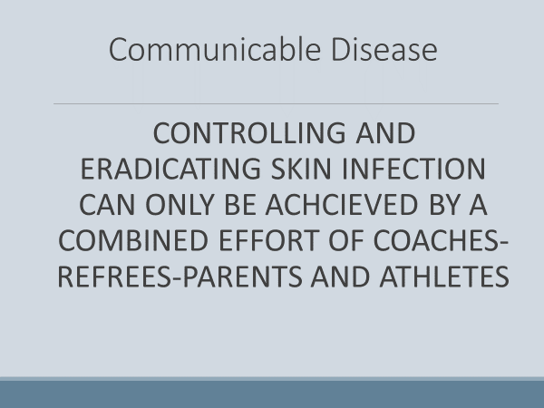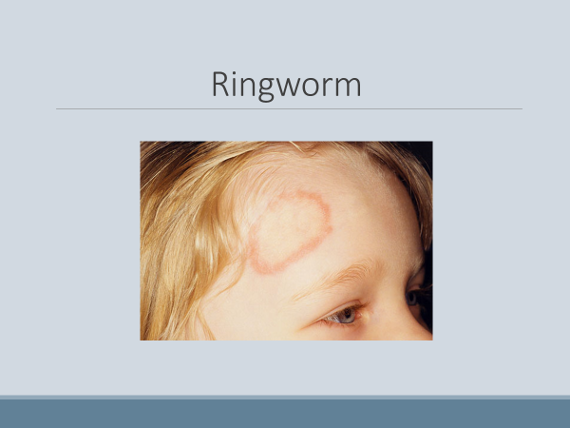
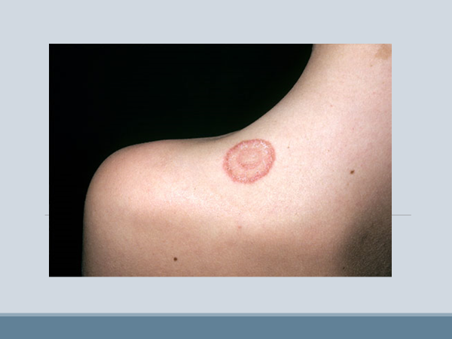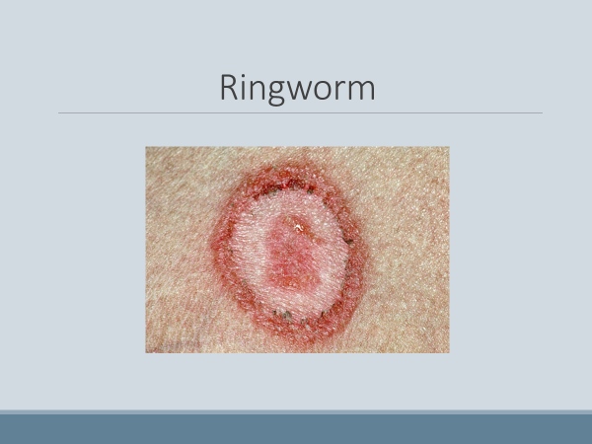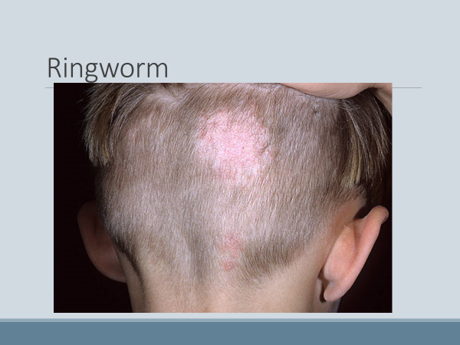
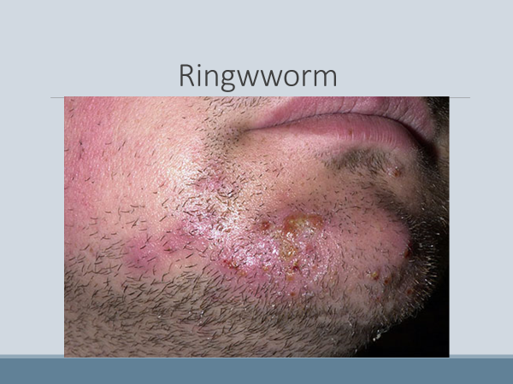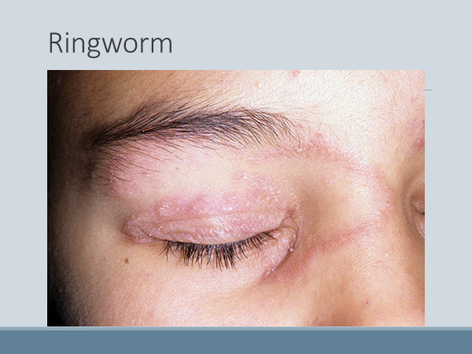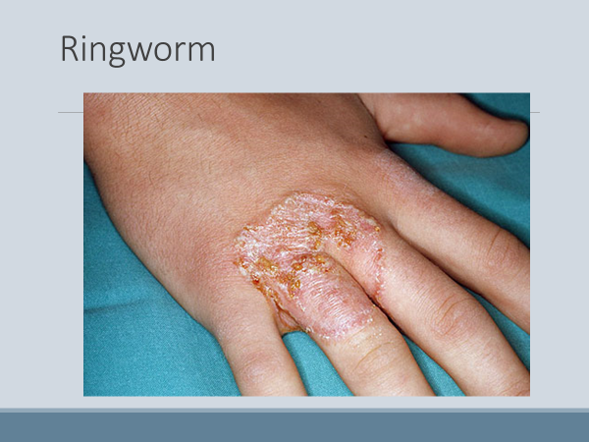
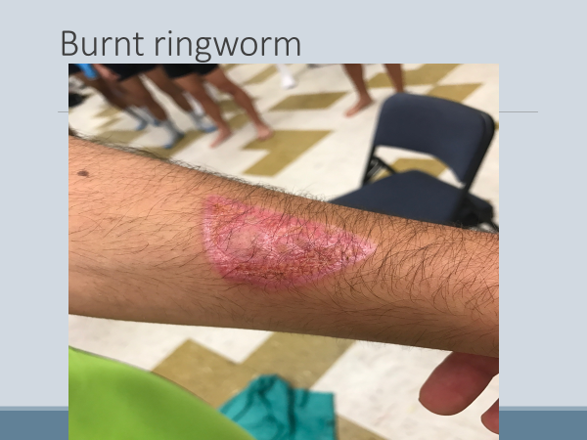
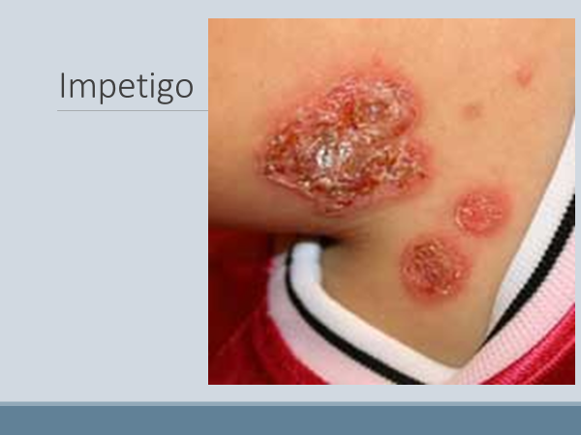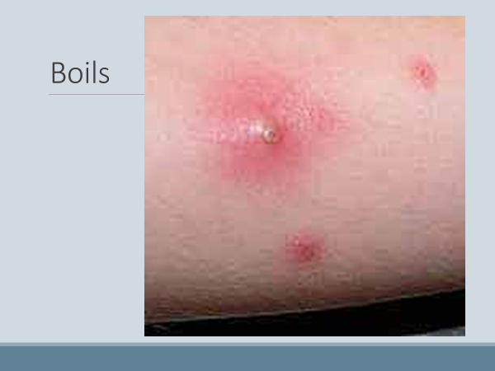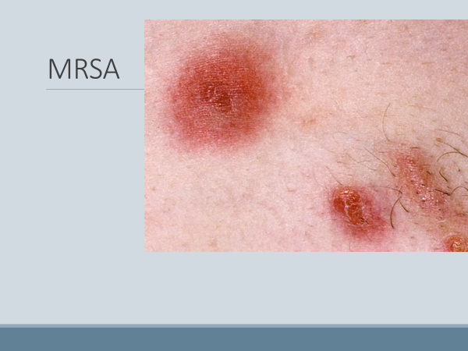
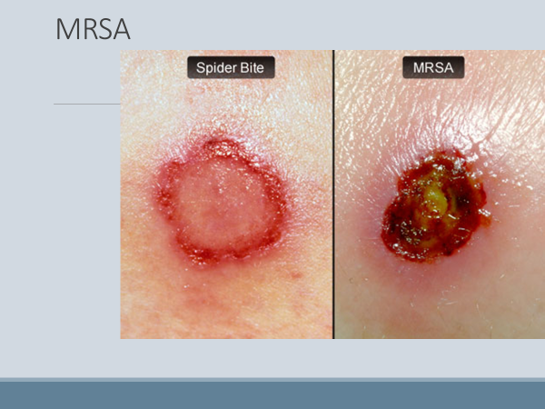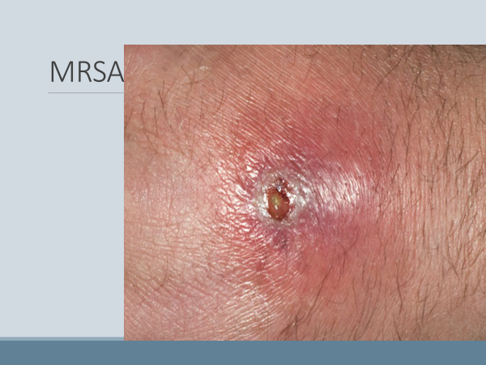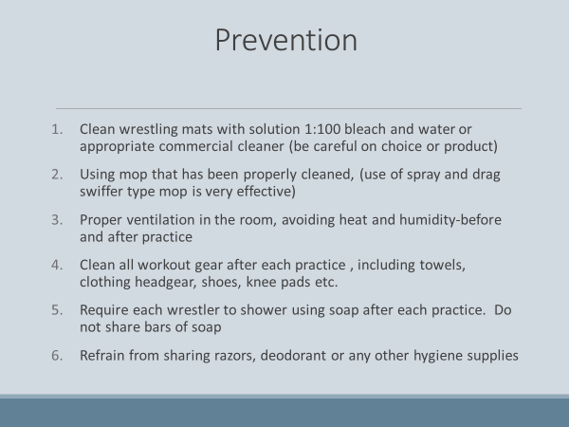
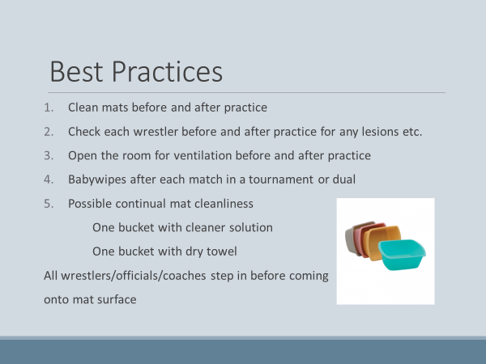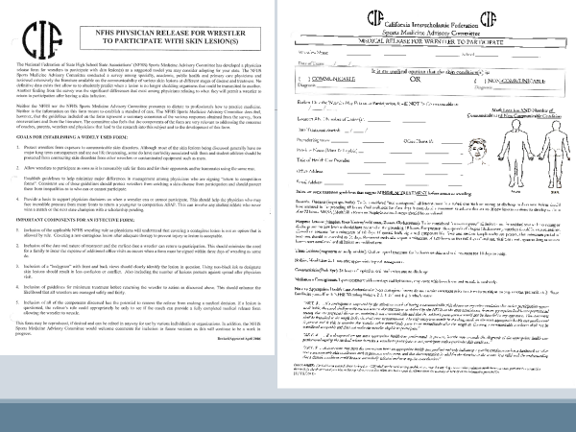
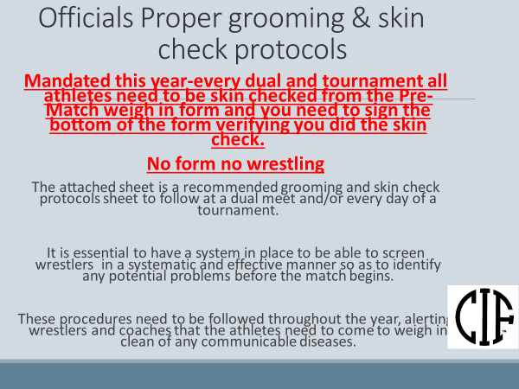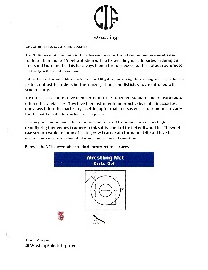
PRE MATCH WEIGH IN FORM
This is required at all dual meets and tournaments. Officials will ask for them to check off your wrestlers for skin check and will sign them for verification.
NO PRE-MATCH WEIGH IN FORM=NO WRESTLING

Wrestling Weight Management
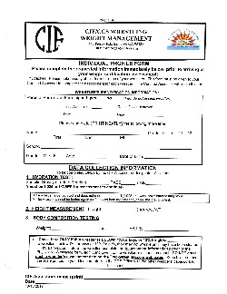IPF Needed for every Athlete
New method of measuring % Body Fat. ULTRASOUND WAND
CCS and CS are using method beginning in the 2017-18 Season.
Better read on % body fat

The BodyMetrix™ System is

Portable Affordable Accurate
SAME REQUIREMENTS:
IPF FORM and Pay $10
HYDRATION TEST
HEIGHT TEST
WEIGHT
HOST SITE MUST PROVIDE A SCALE
- Boys must wear either t-shirt and shorts or singlet
- Girls must wear with t-shirt and shorts or singlet-but must have a sports bra

NEW NFHS RULES
Uniforms:
- ALL UNIFORMS MUST BE SCHOOL ISSUED
- UNIFORMS CAN BE MIXED AND MATCHED FOR DUALS AND TOURNAMENTS
- TIGHT OR LOOSE SHORTS ARE ALLOWEDD AS LONG AS THEY WERE DESIGNED BY THE MANUFACTURER SPECIFICALLY FOR WRESTLING
- TIGHT FITTING SHIRT MUST HAVE A MINIMUM OF A 3 INCH TAIL AND MUST BE TUCKED INTO THE SHORTS AT ALL TIMES.

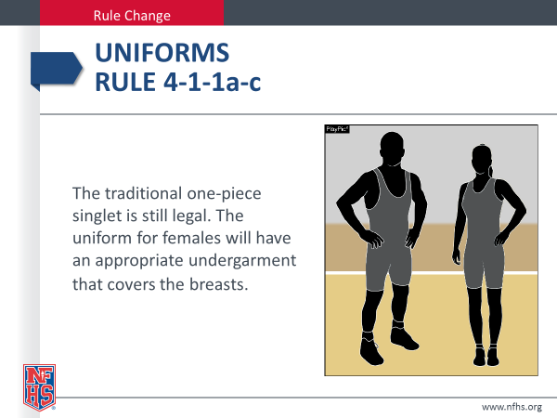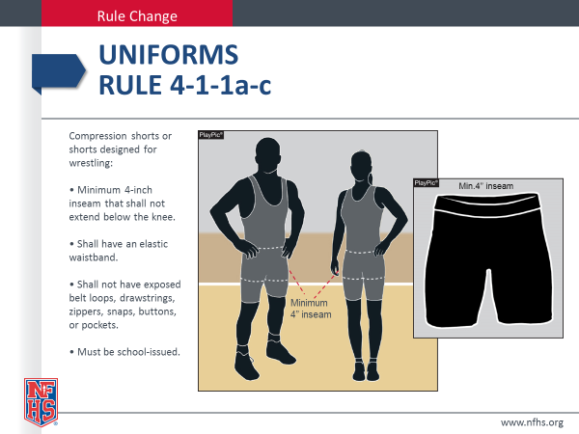
Old singlets still allowed Legal shorts allowed to be worn over singlet and by themselves/with a tight fitting shirt
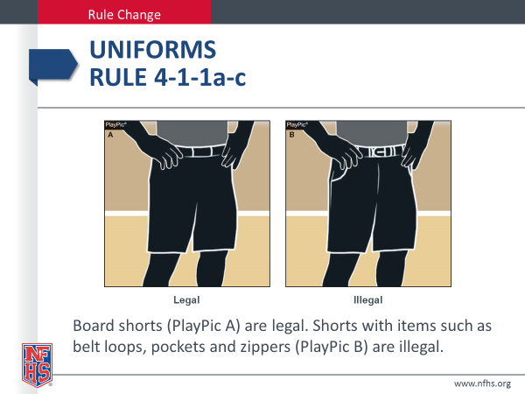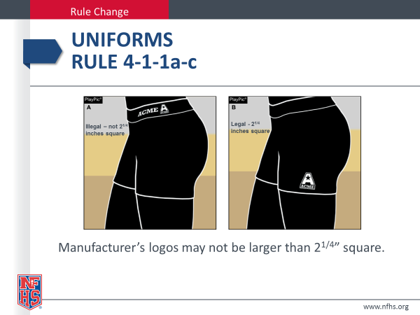
Shorts must have 4” inseam, no lower than the knees and no belt loops, belts, zipper, pockets rivets etc.

TIGHT FITTING SHIRT
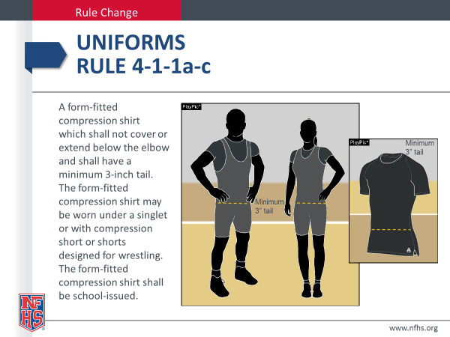

WEIGHT CUTTING AT THE SCALE
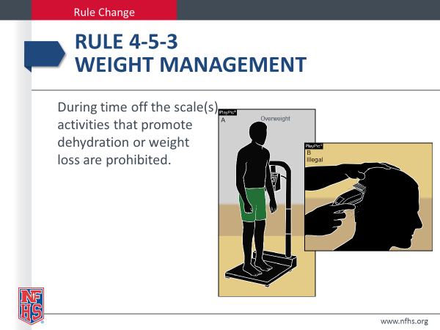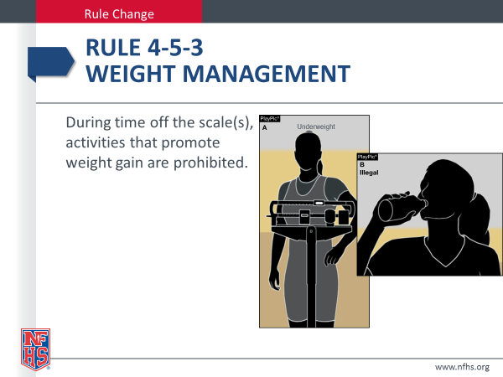

NEAR FALL AND FALLS SCORED OUT OF BOUNDS
