Changing Credit Card Information For Failed Payments

- Log into your OAA account


- Under your account, go to Registrations (Click on the drop down next to your login name)
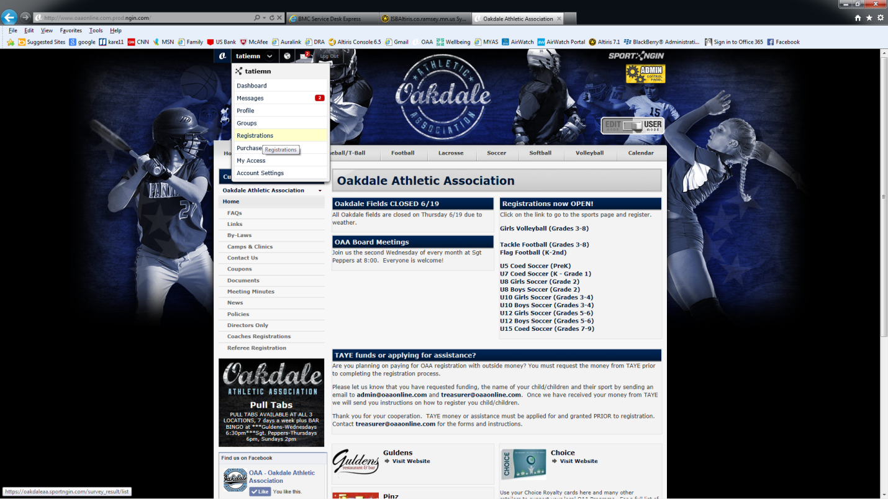
- Find the registration that had the failed payment

- Click on Order Details

- Under Payment Calendar, find the failed payment and choose Make Payment
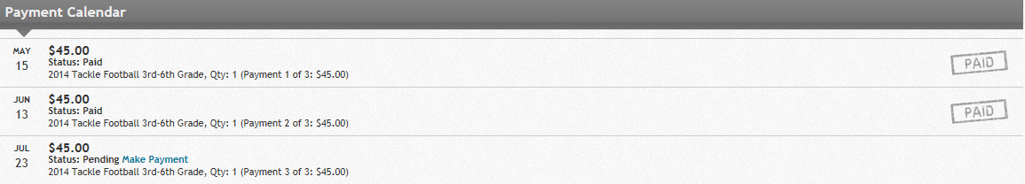

- Choose Enter New Card under Please Select Your Payment Method and enter your new information. Click Make Payment. (See picture on next page)
