Instructions for Completing the Online Referee Training Session

Login to Game Officials with the User ID and Password that you setup in order to register for the Referee training course:
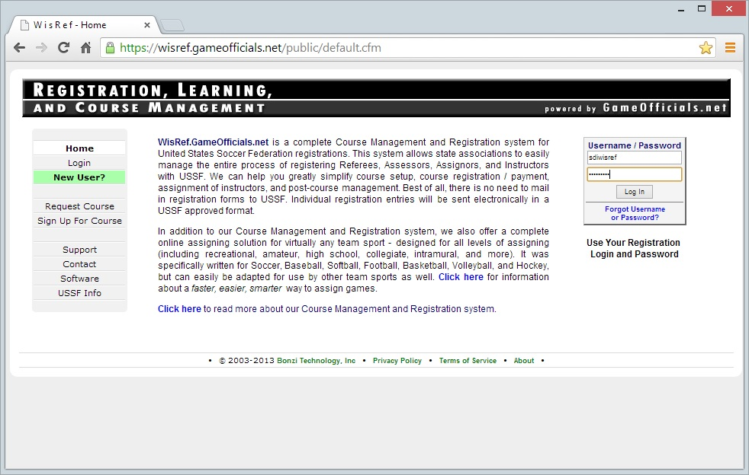
In the left hand navigation bar, click on the clink for “Confirmed Reg”:
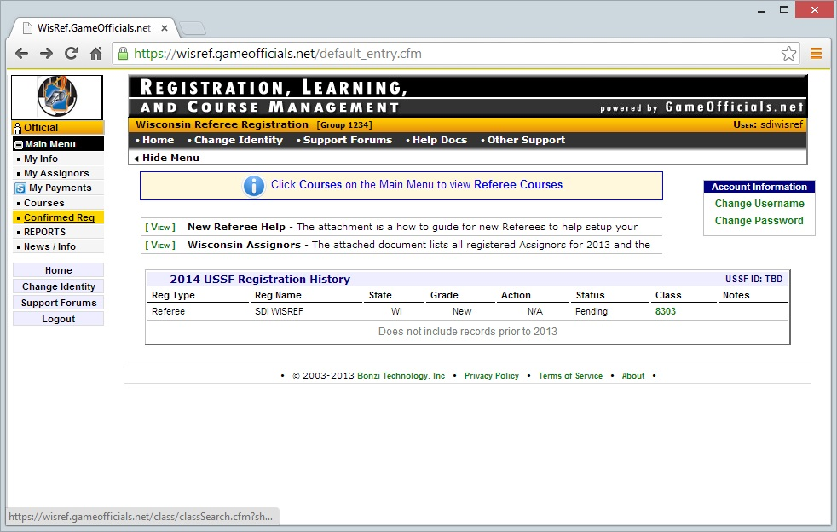
Click on the button titled “Load Session Tracker” to begin the online training course. This will open a new window:
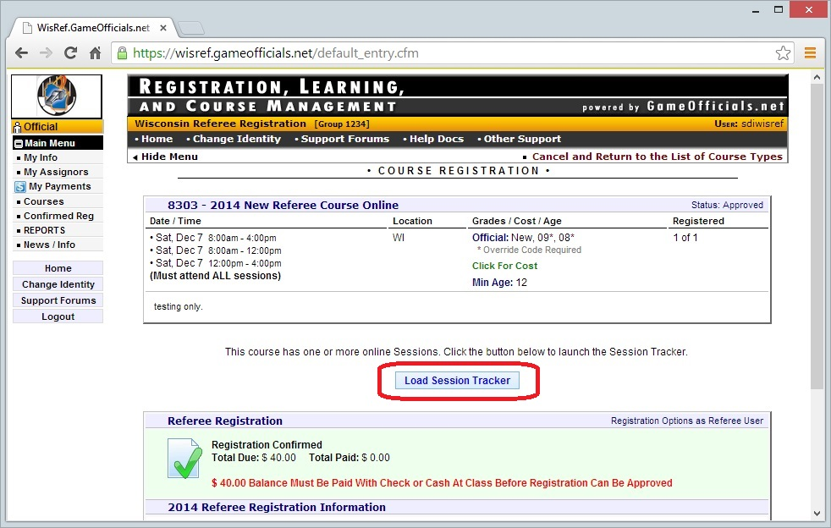
The Session Tracker will open showing you the three sessions that are a part of the New Referee training course. Click on the Session #1 which is the online portion of the course to begin: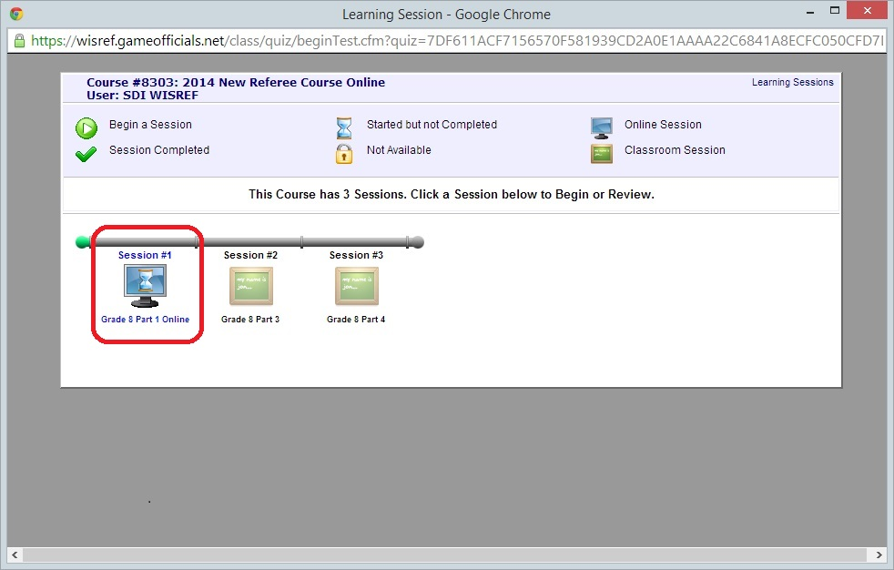
You will first be presented with the following welcome screen and course information. Click start Presentation to begin the training session:
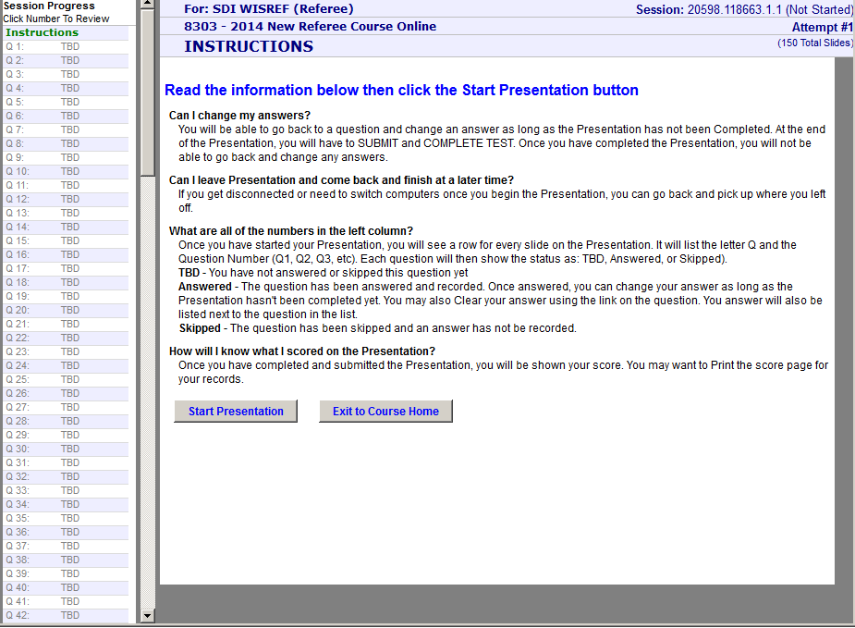
You will be presented with a course overview and instructions. Be sure to read this information carefully!! Click continue to go to the next slide:
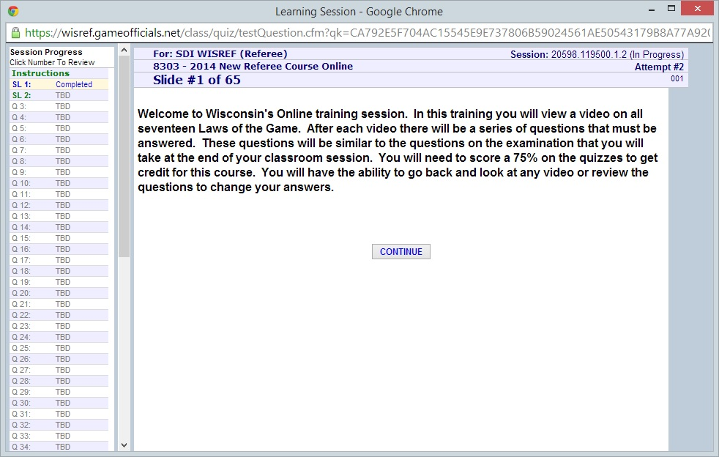
After reading through the instructions, you’ll arrive at the slide for the first lesson. Click the link to open the US Soccer Video. This will open in a new window.
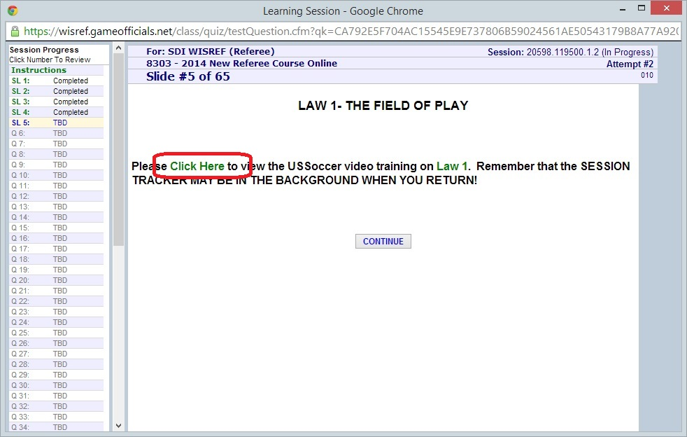
You will be prompted for your name, email and state in order to view the video. Note that the course number is not a required field.
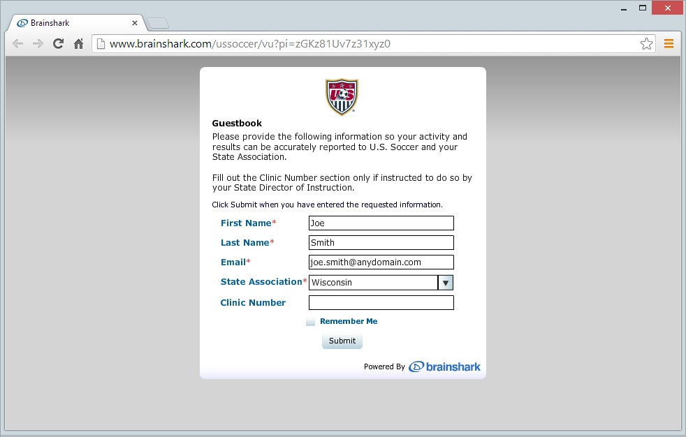
After you have completed viewing the training video, close the window and return to the Learning Session window. Click Continue.
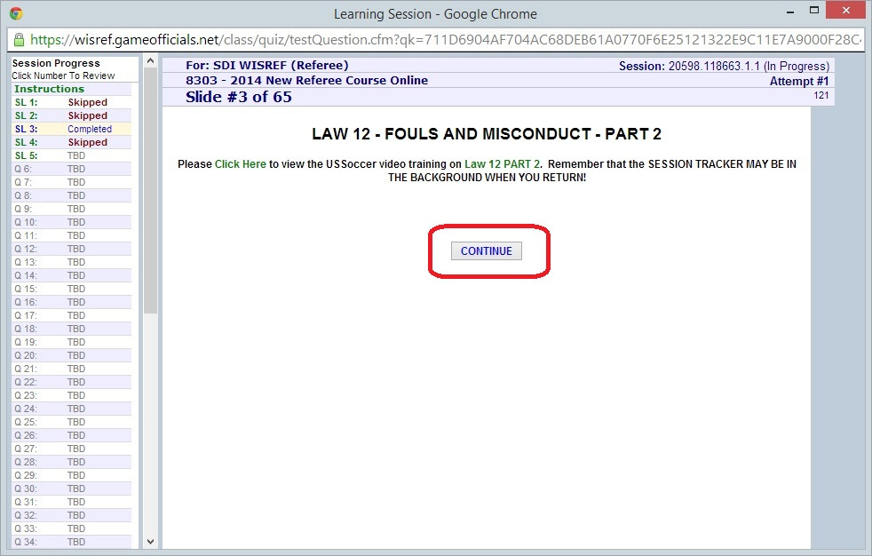
You will now be presented with quiz questions that will verify that you understood the material presented in the training video. Answer each question carefully and click “Save Answer” to continue to the next question:
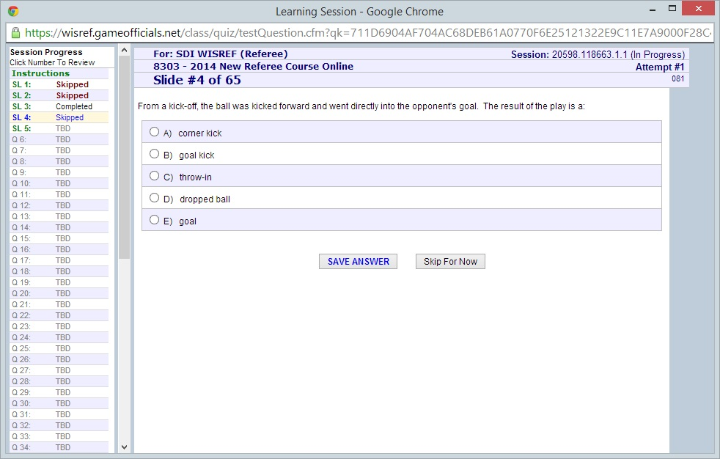
The rest of the session will operate the same way. You’ll be asked to view a training presentation which will then be followed by a few quiz questions to test your knowledge. Once you complete all of the lessons in the session you will be presented with the Session Summary screen:
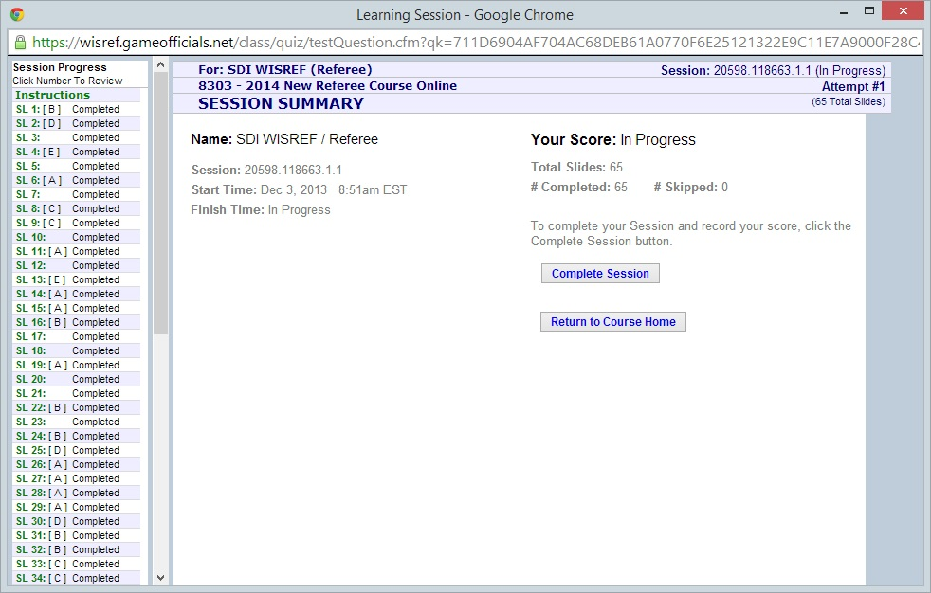
Note that you can use the links on the left side to return to any question or lesson that you’d like to review. When you feel comfortable that you’ve successfully answered all the quiz questions, return to the Session Summary page. Click on the complete session button to submit your answers to be scored. You will be presented with the following warning, click OK to submit your quiz answers for scoring:
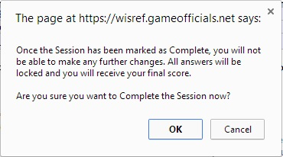
Once your scores have been submitted you will be shown the results of your quiz questions. Note that you must score a 75% or better on the quiz questions in order to be pass the online session and be able to attend to the onsite sessions.