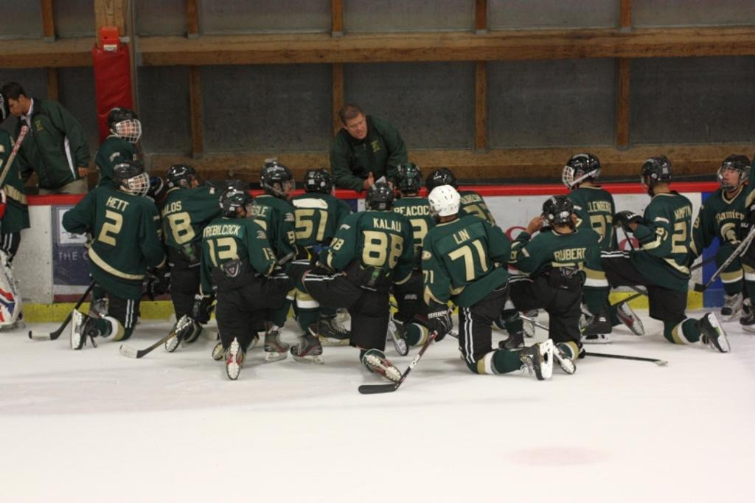


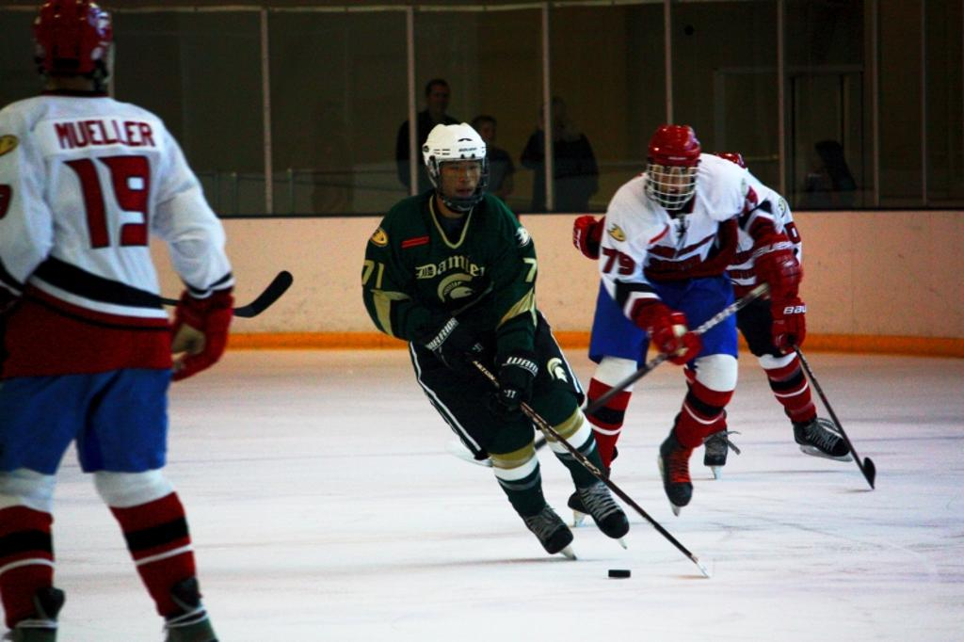


Tommy picked up and left with his family from Taipei, Taiwan to come to California in hopes of being able to one day attend UCLA. He is now playing his first season with Damien High School’s varsity ice hockey team as one of their defenders. At age seventeen, a junior in high school, Tommy shows a mastery of ice hockey both mentally and physically. He is a team player on and off the ice, and has already become good friends with all of his teammates. One of his fellow teammates, and co-captain of varsity, Adam Avalos, describes Tommy as a player that “always has a positive attitude, brings good vibes to the team, has a great senses of humor, and is definitely for the boys. He is a talented player and always strives to help bring our team to its fullest potential.”

Photo by Doug Peacock

Slamming into the boards by an opposing team’s player or racing down the ice waiting to catch a pass...the buzzer sounding as the puck hits the back of the net, and your teammates rushing over to congratulate you. This is what typical hockey games for the players of the ADHSHL are like. Hockey for these boys is not just a game; it is a way of life. No one exemplifies this attitude better than Yu-Wei “Tommy” Lin.

From Taiwan to California…Nothing can stop Tommy.
Tommy speeds down the ice during Damien’s game versus Edison. The game was a nail biter for Tommy and the rest of the Spartans when they went into over time tied at 4-4. The Spartans came out of the game victorious beating Edison 5-4 with a goal scored 52 seconds into overtime.
Can’t Catch Me!
Pg. 1

Meet Tommy
Photo by Doug Peacock
Coach Arnie Papin instructs his Varsity team between periods.
  - Article Written by Ryleigh Escoboza
( on left) Tommy leaves one San Diego player in his dust while he proceeds to take on the next one.

(on right) Tommy celebrates with his teammates after a well-earned goal.

Avalos, describes Tommy as a player that “always has a positive attitude, brings good vibes to the team, has a great senses of humor, and is definitely for the boys. He is a talented player and always strives to help bring our team to its fullest potential.”
Tommy’s story of how he started in ice hockey is very unique. He stated that, “ I was somewhere between the age of four and six when I was walking past a park where some kids were roller skating. The coach came over to me, asked me if I wanted to play, and that’s how I started roller skating and eventually began to play ice hockey.” He then went on to explain that the coach that had approached him was from New Zealand, and had helped to bring hockey to Taiwan. Tommy described the differences between ice hockey in Taiwan, and ice hockey here in southern California as being, “more physical in California and different strategically.” He also stated that, “ in Taiwan hockey is getting popular but it is not as good. It’s hard to get ice time.”
Like many young hockey players Tommy looks up to Nick Lidstrom and the NHL Redwings as his idols. When asked about what his favorite hockey related memory was he replied with, “when I went to the IIHF, International Ice Hockey Federation, tournament and competed against teams from Russia, Mexico, Korea, Japan, Bulgaria, New Zealand, and Belgium.” It is clear that Tommy has had his fair share of international experience with ice hockey, and is now ready to bring all of his knowledge onto the ice against the teams of the ADHSHL where his skills will be tested to the max.

Photo courtesy of paradiseinthewolrd.com

A look at Taipei
Taipei is located in Taiwan and is where Tommy calls home. Taipei is both modern and traditional. It has bustling streets, high tech transportation, but also has, ancient temples and other historically known landmarks.
The picture above is of Taipei 101, which is a tower, an observatory, and a mall all in one. It was once considered to be the world’s tallest tower. At an astonishing 1,167 ft high and weighing 705,130 tons it is considered to be one of Taipei’s golden gems of modern times. In it there are office buildings, a mall, a fitness center, restraunts, and so much more. It also contains two of the fastest elevators in the world that reach, “top speeds of 1010 m/min, observation deck visitors can whiz from Level B1 to 89 in 39 seconds”, according to http://skyscraperpage.com/cities/?buildingID=18.
All information used courtesy of http://skyscraperpage.com/cities/?buildingID=18.

