PRACTICE
It is important to understand that most players at this age do not register for soccer by their own choice. Parents are looking for exercise, fun, social interaction, and role models for coaches. Your challenge is to give them something to get excited about. Soccer should be as fun, imaginative, and interactive as possible!



TIPS
- Each session is geared around touching the ball as many times as possible.
- K.I.S.S.- Keep it simple stupid! They can only focus on one task at a time.
- Demonstrate all Directions - show them what you want.
- N 0 LAPS, N 0 LINES, N 0 LECTURES! Keep them moving... it's what they want.
- They have very short attention spans, so have a variety of games and activites ready.
- Team play and passing is an alien concept to these players. They may even steal the
ball from their own teammates. Don't worry about it; let them dribble til' their heart's content!

TYPICAL SESSION
- Street Soccer (2 v 2 or 3 v 3) = 15 minutes
- GAME! (pick from below)= 15 minutes
- 1 v 1 Get Outta' Here! = 15 minutes
- PLAY! 3 v 3 (Make it look just like the game)

GAMES FOR (K-1st Grade)

-<II(----

Get parents involved! They can play goalie, play with the kids, or kids vs. parents
games are always a blast!

----- ·= Run
- - - - - - - - - - = Pass or Throw

... ...

...
''

Ball Masterl
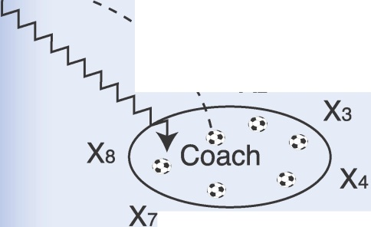
(Glorified "Fetch")

X2

X6 Xs
=Dribble

Catch the Coach!

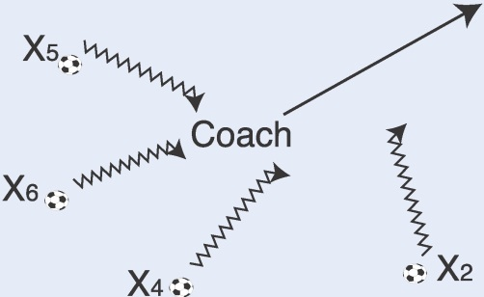
  - All players have a soccer ball
  - Coach runs away and players chase and try to tag the coach while dribbling their soccer ball

- Each player holds ball in hand
- Coach takes ball and throws it
- Player runs after it and dribbles back
- Go fast and repeat to keep ALL players moving!
- Players should try to keep the ball close to their feet
- Coach should challenge players.
This can be difficult for both!




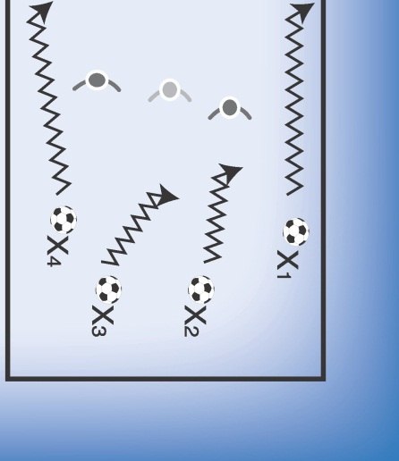

xxxx

0000

1v1 Get Outta' Here!
- Coach rolls out ball
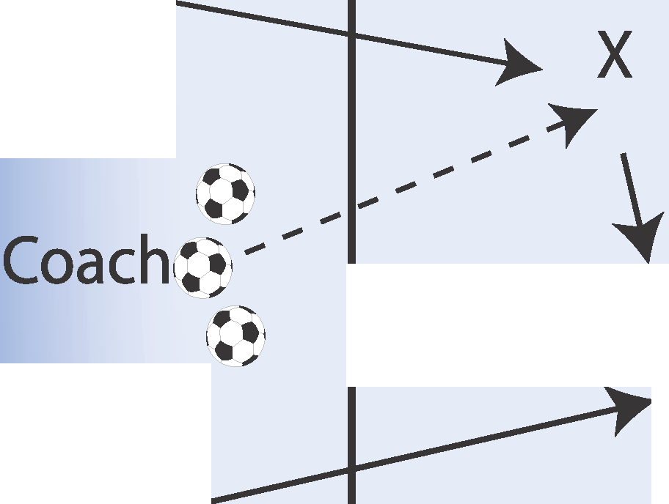
- 1st player from each line run out to ball
- Play 1v 1to goals
- When ball goes out, yell "Get Outta Here"
- Next ball goes into play
0 6. Do not vocalize "go;'
they should be focused on the ball instead!

Ships Across the Ocean!
- Players start on line w/ ball
- 1player starts in the middle
- Middle player, yells "ships sail" and players start dribbling
- Objective is to get to the other side without ball getting kicked out of bounds.
- Last player still in WINS!
Game 1: Players in middle act as crabs (all4's on back side) Game 2: Then crawling turtles Game 3: Then regular running

