Recreational Soccer
3 v 3 Coaching Manual
Kindergarten-1st Grade

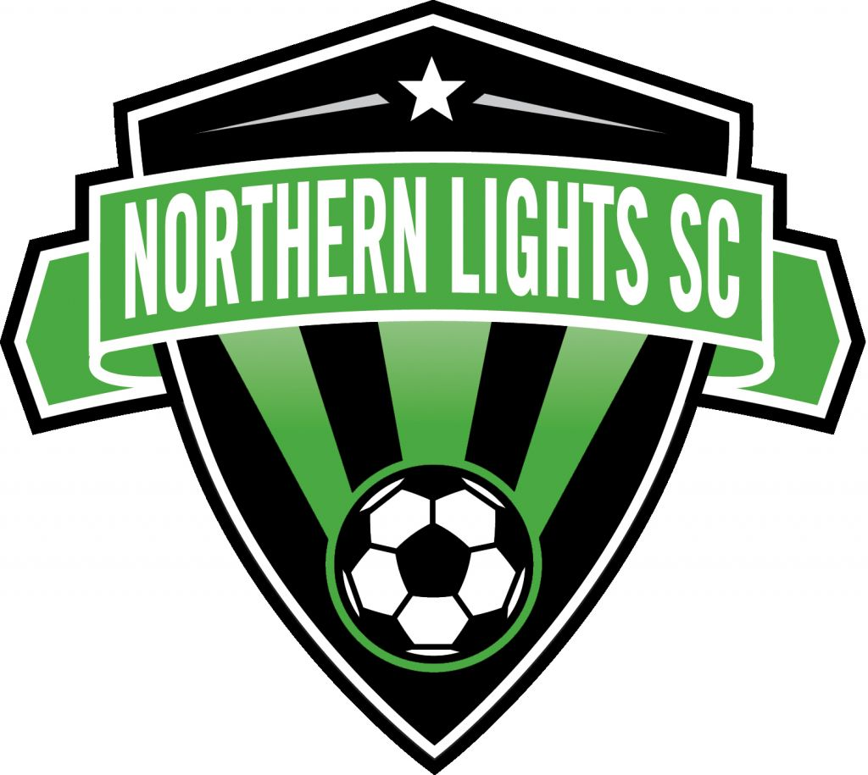

Northern Lights Soccer Club

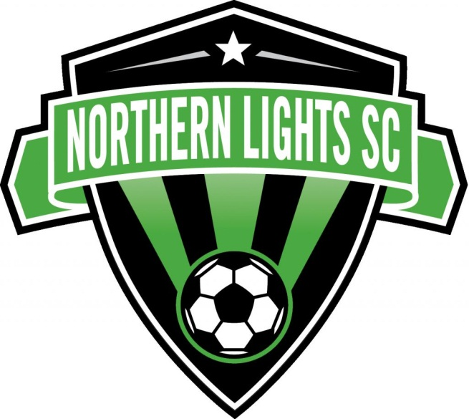

TABLE OF CONTENTS
Revised April 1, 2011

RECREATIONAL SOCCER INFORMATION. …………………………………………………………2-5

PHILOSOPHY AND BENEFITS……………. ……………………………………………………..……6-7

COACHING U4-U6 PLAYERS………………………………….…………………………………………8

GUIDELINES FOR HOW TO COACH MY TEAM? …………..………………………………….………9

COACHING POINTS FOR REFERENCE ………………………….………………………..…..………10

DO’S AND DON’TS OF COACHING………………………………………………………………….....11

GAMES………………………………………………………………………………………………….12-14

RULES…………………………………………………………………………………………………...15-16

MYSA National Background Check

Due each year is the online national background check as required by our affiliate, MYSA. This process replaces the former notarized paper form requirement in previous seasons. Please note that all coaches/assistant coaches must complete this process.

See below for instructions.

National Background Check Website: http://mnyouthsoccer.org/programs/backgroundcheck.cfm
Click on the “Client Log-In” tab
User ID: MYSNLS
Password: MYSNLS
- Click on the "Request" tab
- Type in your full legal name to authorize your electronic signature
- Complete all required fields noted with a red asterisk
- The required searches will automatically populate - do not make any changes/additions
- Click the "Continue" button
- Click the "Add/Edit Jurisdictions" button
- First Search Select: Felony/Misdemeanor, MN, and Statewide
- Second Search Select: Felony/Misdemeanor, MN and enter your county of residence
- Click on the "Add Searches to Order" button
- To complete the process, click on the "Agree and Submit Order" button
- Upon successful completion of the background check, you will receive a confirmation page to print for your records

PHILOSOPHY

Welcome to the Northern lights Recreational Soccer, where we provide each player (ages 4-13) the opportunity to play soccer in a supportive and rewarding environment that emphasizes fun and skill development.

Our Developmental Philosophy focuses on:
- Age-appropriate soccer instruction and field sizes
- A fun-filled learning and playing environment
- Coaching education and support

What benefits will our children experience in the Northern Lights Recreational League?
- Age-appropriate soccer instruction to develop skills
- Small-sided games that allow for more goals, more touches, more activity, more engagement and more fun!
- Non-pressure playing environment
- Enjoyment of the game through learning, movement, and play
- An end of season jamboree (Super Soccer Saturday)
- Fun, games, more fun and more games!

Northern Lights Soccer Association offers a Recreational Program based upon the guidelines of the United States Youth Soccer (National Organization), which gives kids a quality soccer experience through smaller fields, smaller teams and plenty of experience to handle and be around the ball.

At the Recreational level your child is able to enjoy the fun, excitement and exercise of outdoor soccer regardless of his or her experience. For those players participating in the recreational program who really excel amongst his/her peers, we encourage you to try our traveling (competitive) program, where your son or daughter will:

1. Compete with and against players at a higher competitive level.
2. Experience professional training throughout the winter, spring, summer, and fall.
3. Become a better soccer player!

For more details, please refer to our website at www.northernlightssoccer.org.

TRAINING PRIORITIES FOR U4-U6 PLAYERS

RECREATIONAL SOCCER RULES OF THE GAME (U4-U6) Revised April 11, 2011

Rules are based on the US Youth Soccer recommended modifications to the FIFA Laws of the Game.
FIFA Laws of the Game can be found at www.ussoccer.com/referees.

Law 1 – The Field of Play: Field Dimensions = 20 x 30 yards

Law 2 – The Ball: Size three (3)

Law 3 – The Number of Players: (3v3)
A match is played by two teams, with each team consisting of not more than 3 players. There are NO goalkeepers. If one or both teams have fewer than 3 players, make the best game you can (have fun, you can share players).

Substitutions: At any stoppage of play and unlimited.

Playing time: Each player SHALL play a minimum of 50% of the total playing time.

Law 4 – The Players’ Equipment: Conform to FIFA. Non-uniform clothing is allowed based on weather conditions, but uniforms must still distinguish teams.
The NLSC team uniforms must be worn; no look-alike T-shirts should be used. Non- uniform clothing is allowed based on weather conditions, but the NLSC jersey should be the outer layer.
All players must wear shin guards and socks that entirely cover them.
Tennis shoes (not slip-on shoes) are acceptable, cleats or turf shoes are optional.
No jewelry is allowed such as bracelets (including fabric bands), watches, neckwear, earrings (including small studs), or hair ornaments containing metal or hard plastic. Prescription glasses are permitted if secured with straps.

Law 5 – The Referee: No Referees for U4-U5 games. Teams may have one coach from each team on the field to guide and teach the players.

Law 6 – The Assistant Referees: None.

Law 7 – The Duration of the Match: 40 minute games. Four 10 minute quarters of running time. There shall be 2 minutes between quarters and 5 minutes between halves. Alternate the team kicking off each quarter.

Law 8 – The Start and Restart of Play: Conform to FIFA, with the exception of the opponents of the team taking the kick-off are at least four (4) yards from the ball until it is in play.

Law 9 – The Ball In and Out of Play:
No throw-ins for U4-U5 games. When the ball goes out of play across either sideline, a kick-in or dribble-in will take place according to the directions below. This will help keep the game flowing.

Instructions for kick-in or dribble-in: The player whose team gains possession of the ball places the ball on the touchline where the ball originally exited the field and either passes the ball back in to a teammate or dribbles the ball into the field of play. The ball is immediately in play once it is touched. No defender may be within 5 yards of the ball at the start of the kick-in or dribble-in.

No corner kicks for U4-U5 games. Instead, the ball is placed on the touchline and a player may dribble or pass it.

A Goal kick will be awarded when the ball crosses over the goal line and a goal is not scored after last being touched by the attacking team. The ball is placed on the end line and a player may dribble or pass it in. The defending team must fall back behind the center line at the start of a goal kick.

Kick-off from the center line when a goal is scored.

Other specifications for ball being out of play
The ball is considered out of play if it crosses completely over the goal line or sidelines.

A ball that bounces off of a goal post or cross bar remains in play. A ball that bounces off of the referee remains in play.

“Touched” is used in the descriptions below, not “played”. For example, if a red player kicks the ball and it touches a blue player before crossing the line, the ball is awarded to the red team.

At any time during the game if a team is having trouble and taking too much time to get the ball in play, either coach on the field can start the game by rolling a ball out into the field of play. This method will help keep the players playing and moving – as well as keep them psychologically engaged.

Law 10 – The Method of Scoring: Conform to FIFA.
A goal will be awarded when the ball passes underneath the cross bar between the goal posts and completely over the goal line, if no rule violations have been committed.
If the ball is in play, a goal is awarded to the attacking team regardless of how the ball crosses the goal line.
A goal can be scored from field play as well as directly from a kick-off and kick-in.
After a goal is scored, the game is restarted by a kickoff at the center of the field by the defending team.

Law 11 – Offside: None.

Law 12 – Fouls and Misconduct: Conform to FIFA with the exception that all fouls shall result in a direct free kick. The referee/coach/parent must explain ALL infringements to the offending player. No cards shown for misconduct.

Law 13 – Free Kicks: Conform to FIFA with the exceptions that all kicks are direct and all opponents are at least four (4) yards from the ball until it is in play.

Law 14 – The Penalty Kick: None.

