Game 1 Everybody's it Area 20x20 yard square
In a restricted area players attempt to tag as many different players as possible in 30 seconds.

Variations
Have the players tag a specific body part to give them the opportunity to turn away

Progression1
Players must tag as many players as possible without letting
anyone tag them

Progression 2

Ball each- Players must try to tag as many soccer balls with their
hands without letting anyone tag theirs

To be successful in this environment
players must turn away

Progression 3
Players must tag as many soccer balls as possible using their feet

Progression 4
Have only 2 players be the taggers and they must tag as many as possible Freeze tag

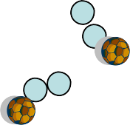The alphabet game

Progression 4
Area 20x20 One ball between 2
Players when in possession say the alphabet or count for the younger players. When the player in possession reaches Z or a certain number they get a goal.

Coaching
When the activity starts observe how the players run away with the ball. Demonstrate how to shield by moving around the ball and hiding it from their opponents.

Progression 1
The player in possession of the ball must walk

Progression 2
Players can now go for any ball

Progression 3
Reduce the amount of balls

Progression 4
Break the group up into two teams and have 1 team start with the balls. Which ever team ends up with the most balls wins

The Neighborhood Area 20x20 four 5 yard squares (houses) 1 Ball each Players dribble around the field and go in and out of the same door of a house

Variations
The coach can be specific about what surface must
touch the ball to get in and out( laces, inside outside)

Progression 1
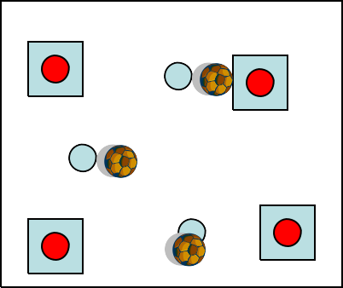Add dogs (defenders) who are restricted to a house who look to steal the balls off the players > if dogs steal the ball they throw their ball away

Progression 1

Progression 2
Add a dog outside the houses

Progression 3
When the coach yells who let the dogs out all dogs are free in the streets and the players are safe in a house

Objective: Try to get the players to understand when to dribble when to turn and when to shield

