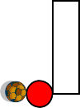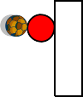
Final Game Activities

Coaching Goals: should the player dribble or not?
Organization  Area 30x20 3v3  Game is played with 3 balls to  increase repetition and create 1v1’s  If the ball goes out of bounds or a goal is scored restart with a dribble | Coaching Points Identify good execution Identify effort
Area 15x20 Goals everywhere  On the field there are 4 scattered goals and teams can score in any  Have the players choose where they want to put their goals  This will encourage players to change direction and also look at team shape | Coach should serve ball into different areas to create a different problem for the players to fix
Coach starts  Leave it – if the ball goes off the field the coach shouts “Leave it” and passes in another one  Coach starts the game by passing to the player in the most space | Spatial awareness  Identify one player as the starter and he/she dribbles the ball back in

