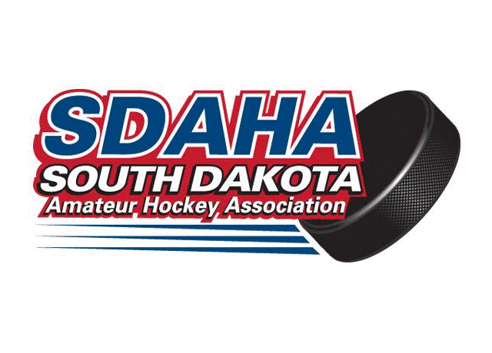
Team South Dakota Player Code of Conduct

Player: ____________________________ Team: ____________________________

The Team South Dakota Hockey Program believes strongly in the values of teamwork, sportsmanship and leadership through example. As a player in the Team South Dakota organization, my actions reflect not only on me, but also on my teammates, my coaches, my parents, my community, and the Team South Dakota program. I agree to abide by and follow the rules and guidelines below.

- Team South Dakota will follow all USA rules and guidelines as set forth by USA Hockey.

- I will play hard, but fair and within the rules.

- I will never bully a teammate or opponent, either verbally or physically. I understand that bullying includes taunting and excessive teasing, threats, cruel, demeaning and derogatory remarks, physical violence, vandalism of property, intimidation, and starting rumors, either verbally or electronically.

- I will not participate in hazing, either alone or as part of a group. Hazing is defined as conduct which is insulting, intimidating, humiliating, offensive, or physically harmful. Initiation rites of any sort are not permitted.

- I will not engage in any critical, negative or derogatory comments towards any player, coach, referee, off-ice official, parent, fan or any member of SDAHA or USA Hockey on any social media platform.

- I will not engage in fighting, even when provoked. I understand I will be disciplined for fighting.

- I understand that my behavior reflects on my teammates, my coaches and the Team South Dakota program. I will always be on my best behavior at games, practices, hotels and other team events.

- I will not complain about penalties or calls made by the officials and I will respect the referees at all times. I understand that they are in charge of enforcing the rules of ice hockey, and I will respect their opinions at all times. When called for a penalty, I will skate directly to the penalty box.

- I will show good sportsmanship at all times, both when winning and losing.

- I will always congratulate the other team and wish them good luck.

- I will be committed to developing as a hockey player. This includes attending practice, listening to and respecting my coaches, and always giving my best effort. I will arrive at practices and games on time and prepared. I understand that it is my responsibility to have all of my equipment packed and ready to play a game.

- I will never use or bring illegal drugs, non prescribed controlled substances, tobacco, or alcohol of any kind to Team South Dakota games, practices, trips or other Team South Dakota events. Use of any of these substances at any time, could result in disciplinary action or suspension from the Team South Dakota Program.

- I understand I must remain in good standing with my local association at all times during the hockey season to be eligible to participate in Team South Dakota activities. Good Standing is defined as being 1) up to date with all financial commitments, 2) up to date with all volunteer commitments, and 3) being eligible to participate in a local association game if the game were being held on the day of the Team SD Activity.

- Team South Dakota will follow all SDAHA guidelines following disciplinary penalties.

I understand that by signing this agreement I promise to uphold the Team South Dakota Player Code of Conduct. I realize that creditable evidence of a violation of this Code of Conduct may result in loss of ice-time, suspension for a portion of a game or a full game, or even removal from the Team South Dakota Program.

Player Signature: _____________________________________Date: ________________

Parent/Legal Guardian: ________________________________Date: ________________

REPRESENT YOUR TEAM AND SDAHA WITH PRIDE!!!

SDAHA Executive Board of Directors, August 11, 2021

